SECTION 10. LAND USE

- Land Use
Figure 98. Mars Hill Current Land Use
In 2012, Mars Hill remains predominantly agricultural, retaining its traditional village area and expanding recreational and other development of Mars Hill Mountain. Route 1 remains the major corridor crossing the Town, along with the Prestile Stream. The Bangor and Aroostook Railroad line has been abandoned and plans were made for an industrial area on the company’s property. The industrial area has seen only limited development.

- Village Area

Figure 99. Village Area Current Land Use
Commercial retail and service businesses and most homes in Mars Hill are still primarily located in the village area.

Since 1990, the Town and Utility District have systematic reconstructed utilities and improved pavement on a number of village streets, including Grove, Institute, Silver, Mill, Highland, Park, Benjamin, Sylvester, School, Hansen, Maple, and ACI.
Shortly after adoption of the previous comprehensive plan, the Town completed Project Beautification (1990-1991). The project included improving Main Street and concluded with placing flowers in barrels and planting trees on Main Street and siting a picnic table, benches, and trash receptacles at Prestile Park. In addition, the Town and American Legion Post 118 worked together to install a veteran’s monument installed at the Park. Unfortunately, the project was discontinued for lack of interest in ongoing maintenance.
The Town has permitted very few residential subdivisions since 1992. In the mid-1990’s, the Town approved 9 residential lots off the Bell Hill/Country Club roads. In the first decade of the 2000’s, the Town approved 3-4 residential lots north of the Bell Hill Road intersection with Country Club Road. In 2012, the Town approved a 14-lot subdivision off Clark Road. Lot sizes range from 2.27 acres (one of 5 lots that front directly on Clark Road) to 4-8 acres for the lots in the interior of the subdivision and 22.5 acres for the lots that face the Presque Isle Road. The smaller lots are being marketed in the $10,000 range, the mid-sized interior lots are going for $10-12,000 and the two larger parcels fronting on Presque Isle Road are being sold for $20-25,000. A right-of-way extending from the new subdivision road to the Presque Isle Road was approved as part of the subdivision.

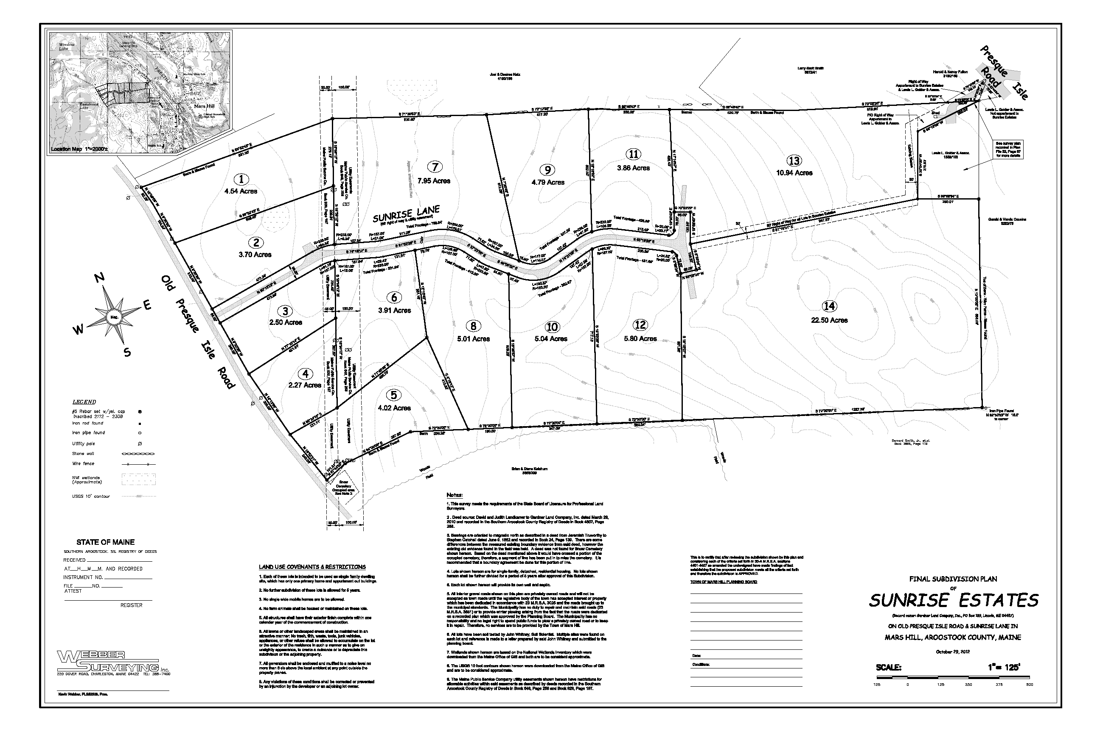Figure 100. Clark Road Subdivision

- Land Use Analysis

Figure 101. Mars Hill Land Use, 2012
Use Types | # Parcels | Acres | % Total Acreage | Largest Parcel | Smallest Parcel | Average Parcel
Residential | 489 | 1,425 | 6.3% | 92.0 | 0.02 | 2.9
Multifamily | 8 | 19 | 0.1% | 5.7 | 0.08 | 2.3
Commercial | 54 | 25 | 0.1% | 4.8 | 0.02 | 0.5
Commercial-Recreationª | 10 | 820 | 3.6% | 320.0 | 0.20 | 82.0
Agriculture-Related | 10 | 110 | 0.5% | 100.0 | 0.02 | 100.0
Agriculture | 139 | 12,078 | 53.3% | 413.0 | 0.05 | 86.9
Forestry | 101 | 7,149 | 31.5% | 226.0 | 0.66 | 70.8
Industrial | 8 | 34 | 0.2% | 19.0 | 0.47 | 4.2
Social-Institutional-Civic^{b} | 42 | 248 | 1.1% | 104.0 | 0.02 | 5.9
Utilities | 7 | 8 | 0.0% | 5.0 | 0.04 | 1.2
Undeveloped Land | 9 | 232 | 1.0% | 90.0 | 10.00 | 25.8
Vacant Residential | 50 | 59 | 0.3% | 5.5 | 0.02 | 1.2
Unknown^{c} | 41 | 46 | 0.2% | 20.2 | 0.01 | 1.1
Water | 2 | 47 | 0.2%
Road & RR ROWs | 4 | 366 | 1.6%
total number of parcels | 974 | 22,665
ª no link to assessing data for 1 lot, coded by communication with Town
^{b} no link to assessing data for 3 lots identified as cemeteries
^{c} no assessing data
Source: Mars Hill Assessing Data, 2012

- Residential Land Use

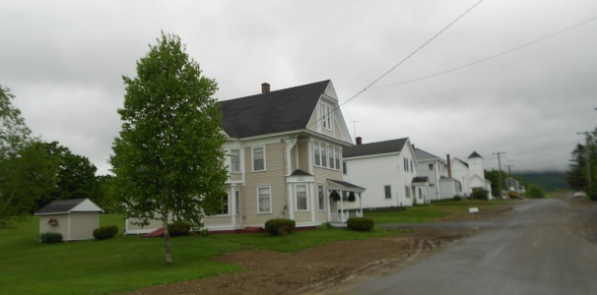
There are over 500 residential parcels, both occupied and vacant, making up 1,484 acres or 6.6% of the Town’s total acreage. The largest parcel is 92 acres; the smallest is approximately 1/5th of an acre (8,712 sq ft); and the average is approximately 2.75 acres. While residential land use is concentrated in the village area, there is still a fair amount of residential development in the rural areas of the community, including both farmsteads and scattered residential properties with limited connection to natural resource-based industries. Note the number of small lots fronting West Ridge and Country Club roads and emerging along Fort, Kearny, White, and Smith roads. If this pattern of residential development continues, the frontage of the Town’s roads will eventually be developed, potentially negatively impacting road capacity and the rural character of the community.

There are 8 multifamily residential parcels making up 19 acres with an average size of 2.3 acres and making up 0.1% of Mars Hill’s total acreage.

On April 21, 2013 Bruce Hussey and Steve Hitchcock drove the areas in Mars Hill which could help provide house lots in support of the target of increasing population by 500. They looked at land currently zoned Residential 1 (R1), Residential 2 (R2), and Rural Farm (RF) areas that are contiguous to the residential zones. They provided the following information to assist the Comprehensive Plan Committee in its discussions about potential house lots.
Figure 102. Land Available for Development of New Homes
Location | Acreage | Current/Potential Zone | Development Considerations | Potential New Housing Units
Blaine Line/Clark Road | 10 acres | R1 (8,712 sf lot for sewered areas) | some limitations | 20 lots
Clark Road New Development |  |  |  | 14 lots recently approved
Presque Isle Road (Rt 1) to Clark Road south of Route 1 | approximately 68 acres | RF (1 acre) | some steep hills | 34 house lots, considerably more if rezoned to R1
Fort Road (1A) to West Ridge | 30 acres | R1 (8,712 sf, but assumed 2 du/acre | sewer can be extended from intersection; hilly, but ½ is buildable | 30 lots
Existing R2 Zone on Fort Road and East Ridge Road | 40 acres rezoned | R2 (18,750 sf for sewered lots; 22,500 unsewered); eastern half could be rezoned to RF and remainder to R1 (8,712 sf for sewered lots; 22,500 unsewered) | some limitations | 40 lots at 1 du/acre, considerably more if developed at minimum lot size
Boynton Street Backland | 60 acres | R1 | some limitations | 30 lots
Infill |  |  |  | 20 lots
Total |  |  |  | 188 lots
Source: Bruce Hussey and Steve Hitchcock, 2013 windshield survey.

The total for potential house lots was estimated at 168, with approximately another 20 house lots in and among existing house lots in the built up area, for a grand total of 188 house lots. Assuming 4 people per new house Mars Hill would need 125 lots to achieve the targeted population increase of 500 citizens. Assuming 3 people per new house Mars HIll would need 166 lots to achieve the target. With one zone change from R2 to R1 on the East Ridge/Fort Street parcel, the targeted growth can be.

- Commercial Land Use

There are 54 commercial parcels in Mars Hill, ranging in size from under 0.02 to 4.8 acres, the average size is a half acre.


In 1993, the Mars Hill IGA had opened and the Rideout’s IGA and Graves Shop & Save closed. Further changes came to Main Street in 1996 when Katahdin Trust renovated the Masonic Hall, the Good News Bookstore was torn down, and Sargent Truck Brokers purchased and improved the former Graves Supermarket property and the Mars Hill Pharmacy purchased the former Fenderson Hardware property. More changes came in 1997, when the Mars Hill Motor Company buildings were demolition to make way for a new drugstore and Papa’s Discount opened its doors. 2006 was designated as the “year of the building boom” in the Town Report with a variety of construction projects in the community, including construction of the Dollar Store, the first new retail store in Mars Hill for many years; Sargent Trucking added significant new office space; and renovation of the Motel was started. Less new development has taken place in the village since 2006, although the new Maine Savings Bank branch office, Mars Hill Savings Bank of Maine, a photographic shop, and a several other new and relocated businesses opened on Main Street. The Northern Lighthouse, a residential in-home entity that deals with troubled children, which was opened in the 1980’s/1990’s, has expanded over the years to accommodate additional residents and clients.
When commercial-recreational acreage is added to totals for commercial properties, the acreage increases to 845 or approximately 3.7% of the Town’s total acreage. As might be anticipated, commercial-recreational parcels are far bigger with the smallest parcel approximately 2/10th and the largest 320 acres.

In 1993, the Big Rock Ski Area was revitalized with a new chair lift and snowmaking equipment was installed in 1994. In 2000, Maine Winter Sports Group purchased Big Rock from Wendell Pierce and pledged to spend approximately more than $1 million to upgrade the facility, keep downhill skiing affordable for local skiers, and lowered the price on season tickets and day passes. In 2001, the Mars Hill Country Club opened nine new holes at the golf course. In addition, the Town opened a new cross country ski trail that extends from the High School across private land to Big Rock and the Central Aroostook Ski Club was formed. In the late 1990’s/early 2000’s, the Libra Foundation acquired Maine Winter Sports. In 2004, Big Rock underwent major expansion with a new lift, new trails, a beginners area, additional snow making capacity, and creation of a snowboard park. In 2006, a tube park was added to the facility. Also that year, Maine Winter Sports declared itself tax-exempt, which reduced annual tax revenues for the Town by $27,000.

- Industrial Land Use

There are 8 industrial parcels in Mars Hill, most in the village area, along the former railroad yard. The largest industrial parcel is approximately 19 acres, the smallest just under a half acre, and an average of 4.2 acres.

Figure 103. Mars Hill Industrial Area Subdivision

In 1992, the Town worked with the Northern Maine Regional Planning Commission to prepare an industrial area development plan for the property and in 1998, the Town secured a grant from the State Planning Office to formally subdivide the industrial area to allow further development of the area if the opportunity arises. The subdivision plan was prepared by BR Smith Associates. The industrial area is primarily occupied by potato storage, processing, and distribution facilities.

On April 21, 2013 Bruce Hussey and Steve Hitchcock drove around the industrial zone between Park Street, the Blaine town line, and the Prestile Stream. Approximately 70% of this area was occupied by operating potato storage/handling/shipping facilities plus several businesses such as waste management and site work/trucking. They determined that that the remaining area could be used for industrial development. They also recommended that an analysis of this property should be performed to more fully determine the potential for additional development.

- First Wind Facility
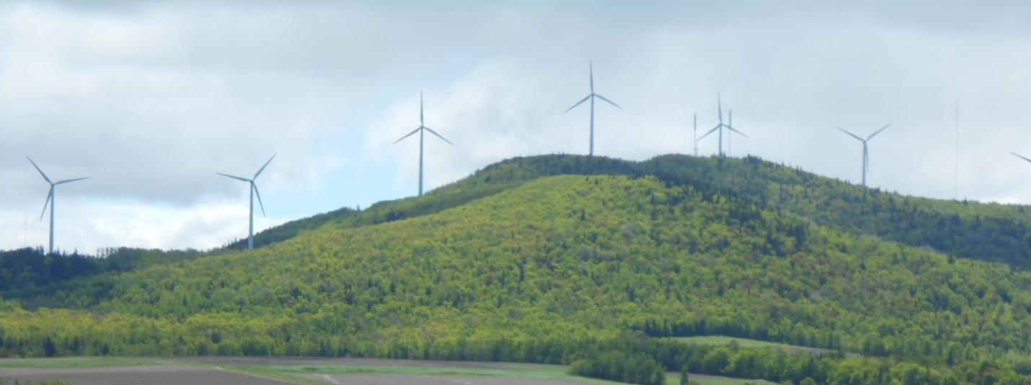
In 2003, Evergreen Wind Power, a subsidiary of First Wind , proposed to locate a 28- turbine, 50 megawatt wind farm on Mars Hill Mountain, after public hearing town council voted to support project, to create the first utility scale wind project in New England. In 2004, First Wind secured a site location of development permit from the State, but the Audubon Society of Maine appealed the decision based on insufficient bird studies. The appeal was denied, but the project was delayed. In 2005, the Town Council approved a tax increment financing (TIF) district agreement to help finance the facility. In 2006, First Wind completed a $50 million plus wind farm on Mars Hill Mountain.
Nearby residents expressed concerns about noise being generated by the wind farm and eventually an agreement was negotiated between affected land owners and First Wind.

- Pine Tree Development Zone
Three linear and interconnected Pine Tree Development Zones are designated in Mars Hill – from the Town Center north, then westerly to Mars Hill Mountain, along the ridge line of the Mountain, and along a spur that extends east and north for a short distance.
The state created the Pine Tree Development Zone (PTDZ) program to offer eligible businesses reduced state taxes for up to ten years if they create new jobs in certain business sectors or move existing jobs in those sectors to Maine. According to the Maine Department of Economic and Community Development, over 300 Maine businesses participated in the program in 2011, with reimbursements from thousands to hundreds of thousands of dollars for taxes paid on new employees. Because Mars Hill is among the Tier 1 Municipalities, eligible businesses that locate within the Pine Tree Development Zone benefit for corporate tax credits, sales and use tax exemptions for both personal and real property, withholding tax reimbursements of 80%, and reduced electricity rates for up to ten years.

- Agriculture and Forestry

There are 139 agricultural parcels, making up more than half of the land in Mars Hill (53%). The smallest parcel is 0.05 of an acre, the largest is 413 acres, and the average is about 87 acres.

When agriculture-related businesses are added to this category, there are 149 parcels, making up about the same percentage of land (53%). The largest parcel remains the same, though the smallest is about 0.02 acre.


In 1995, the Town made a $30,000 loan to developers from its revolving loan fund as seed money for a new potato processing facility – hoping for construction in 1996. In 1996, the Town created a $1.4 million TIF district agreement with Freshway to help finance a waste treatment system for the facility. Freshway obtained a $400,000 Economic Development Grant from the State Department of Economic and Community Development. The Freshway plant was up and running in 1997.

In 2000, a large $1 million potato washing plant and state of the art potato storage facility in the industrial area, capable of putting out 40-50 trailer loads of potatoes per day was designed to meet the needs of the Frito Lay’s Potato Chip plant. The Town provided a TIF to support financing of the project.

In 2004, Fresh Way expanded its plant to add more cooling capacity to its mash line and additional new dry and refrigerated storage to accommodate a larger volume of manufactured product. It also requested and the Town Council approved a revenue enhancement TIF to support the proposed expansion.

In 2005, Fresh Way changed ownership. The new company is Naturally Potatoes a Basic American Foods Division, LLC (largest manufacturer of dehydrated potatoes in US).
In 2006, Basic American Foods started a $500,000 addition to their offices and a new laboratory. Also that year, McCrum Farms built a large atmosphere controlled new potato storage facility.

There are 101 forestry parcels, making up nearly a third of the land in Mars Hill (31.5%). The smallest parcel is 0.66 acre, the largest is 226 acres, and the average is about 71 acres.

- Undeveloped Land

There are 9 undeveloped parcels scattered throughout Mars Hill, making up 232 acres or 1% of total land area. The largest undeveloped parcel is 90 acres; the smallest is 10; and the average is nearly 26 acres.

- Land Use Ordinances

Mars Hill adopted its Comprehensive Plan in 1992 shortly after the State Planning Office (SPO) found it consistent with the Planning and Land Use Regulation Act (also known as the Growth Management Act). In 1995, the Town adopted revisions to its zoning, subdivision, and floodplain management ordinances and worked on revisions to its road opening ordinance.
In 1996, the SPO found Mars Hill’s zoning ordinance consistent with its Comprehensive Plan. Then in 1998, SPO notified the Town that it had received one of the few Certificates of Consistency awarded as part of the Growth Management Program.

In 2000, the Town updated its zoning ordinance, land use permit table and definitions, revised some technical review standards and added others. In 2005, the Planning Board put forward and the Town Council approved adult entertainment ordinance. In 2009, Mars Hill updated zoning ordinance for clarification, added setback requirements for new buildings constructed with a metal roof, amended requirements for lot surveys when construction is proposed on the setback line, rezoning of lots 90 and 91 on map 13 from R-1 to Commercial. The Planning Board and Code Enforcement Office report that they have no concerns about current ordinances.

Figure 104. Current Mars Hill Zoning

- Building Permits

Figure 105. Building Permits
Year | Building Permits | Comments
2000 |  | Gameroom and Recycling Center, Potato Wash and Treatment Plant, shed to store snow groomer, new construction at Big Rock Ski Facility
2001 | 25
2002 | 23
2003 | 45 | Record number of permits, First Wind
2004 | 34 | some for large projects, completed permit process for First Wind , permits issued for Hiram Adelman Memorial Fire Station, 72 X 100’ building on land donated by Milton Adelman and Vince Bernier, 2 expansions of Freshway, Big Rock Ski expansion Phase I (children’s adaptive center, maintenance building, new trails, two new lifts, snow making equipment)
2005 | 33 | reissued permit for First Wind
2006 | 50 | the Dollar Store, McCrum constructed a large atmosphere controlled potato storage facility, Basic American Foods added an office and laboratory facility, First Wind completed a $50M plus wind farm on Mars Hill Mountain – first of its type in the State
2007 | 24 | Marsh Hill Savings Bank of Maine added to DT
2008 | 36 | many for storage sheds and home additions and improvements, several new homes
2009 | 33 | 4 new homes and new businesses opened on Main Street, a few older homes that were in disrepair were demolished
2010 | 33 | construction, renovations, new business openings and existing business relocations
2011 | 26
Source: Mars Hill Town Reports, 2000-2011

- Issues and Implications

- One of the reasons Mars Hill has been able to keep a handle on municipal expenditures is because of its compact development form which allows for shorter trips to travel to deliver services. At the same time, the Town has identified the need for new subdivision lots to supply the need for newly constructed homes as a draw for new residents to the community. Often when folks come from away, they bring their “baggage” about more urban areas and overlook living or building a home within a village area such as is found in Mars Hill. They tend to buy oversized lots, though they do not work the land, on major roads like West Ridge and Country Club. Over time, this incremental development strips out town roads, eating up their capacity and forever changing the rural character of the community. Furthermore, this dispersed development undermines the expressed goal of branding Mars Hill as the “most walkable town in Aroostook County.” To be walkable, a community needs compactness and proximity of homes to businesses and community institutions.

Furthermore, Mars Hill just approved its first residential subdivision in many years. While sited within walking distance of the developed village area, the parcels range from moderate (2 plus acres) to very large (22 plus acres).

Should Mars Hill encourage new compact development that reflects the existing pattern of the village area? Should Mars Hill encourage more large lot subdivisions like the Clark Road Subdivision? Should the Town let the market dictate new development patterns? Should the Town require large lot subdivisions to be designed such that they can be further subdivided and provide additional roads to create a more fine grained, compact pattern of development similar to what currently exists in the village?

- Some of the residential development in the rural parts of Town is a result of farming parents carving off lots for their children. The current ordinance requires a minimum lot size of 1 acre in the Rural Farm District. Historic development patterns in rural areas tend to cluster buildings closer together. Should the Town consider modifying its regulations to maintain the overall allowed density, but reduce the minimum lot size for individual parcels? This would allow farmers to carve off smaller lots for their children, thus reducing the amount of land diverted from cultivation to residential development and better preserving the rural character of the community.

- What should the Town do to work with Maine Winter Sports/the Libra Foundation to manage Big Rock in the Town’s interests?

- What does the Town need to do to promote development at the industrial area? Is there a need for further investment? What areas are occupied by what groups? What areas are not occupied? What areas are developable? Are there any areas, concerns, impacts from existing development in the area that might conflict with siting a new business like a call center in the same area? Should and how can the Town work with regional economic development organizations to draw appropriate development to the park?

- Does the Town have any agreements with First Wind that are coming up for renewal, whereby the Town might be able to negotiate a better situation/increased revenues?

Plant barrels used in Project Beautification are stored at the Prestile Dam Park.
Tax increment financing, or TIF, is a financing mechanism available to Maine municipalities and the Unorganized Territory to capture and leverage new property taxes within a district and invest part of all of those taxes into locally-approved activities and projects to provide new employment opportunities, improve and broaden the tax based, and improve the general economy of the State. Each district and related development program requires approval of the local legislative body and may include a credit enhancement agreement (CEA) between the eligible entity and a company or developer. Following approval by council, town meeting, or commissioners, the state Department of Economic and Community Development (DECD) reviews the proposed district and development program for statutory compliance. After approval by DECD, management of the district and program is the sole responsibility of the eligible entities.
The term of the TIF was 20 years, expiring in 2025. As part of the TIF, the Town bills First Wind annually and keeps $500,000 of the revenue paid by First Wind, which is used to “enhance” the tax rate. The Town then cuts First Wind a check for the remainder, which is used to pay down the debt service for the project.

