SECTION 8. AGRICULTURE AND FORESTRY

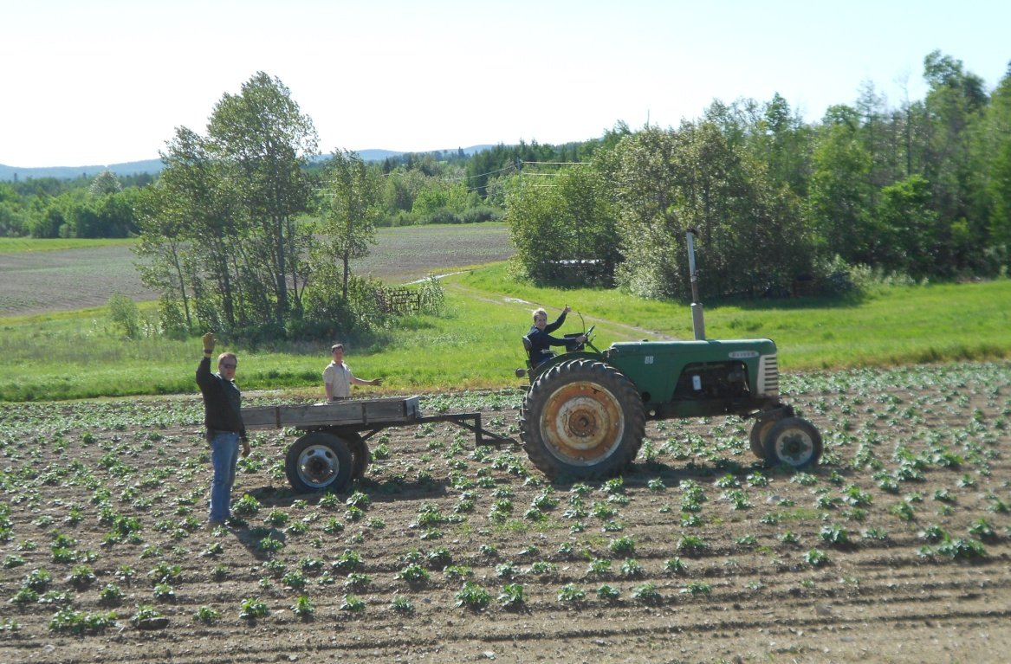

- Farms and Farmland
Figure 82. Mars Hill Agricultural Resources
Agriculture plays a major role in Mars Hill both in terms of the amount of land dedicated to agricultural use and in terms of the economic impact of agriculture within the community. Though trends in farming and land ownership patterns are changing, Mars Hill’s community identity has historically and continues to center on farming. In recent years, there are fewer, bigger family farms growing mostly potatoes and some broccoli. In addition to potatoes and broccoli, barley and other grains are rotated on land and some farmers grow a small amount of soybeans. Farmland in Mars Hill is highly valued and there has not been much conversion to other uses.

- Aroostook County Agriculture

According to the 2007 Census of Agriculture, which provides data by county only, the agriculture cluster in Aroostook County employs 3,000 people on farms, in equipment and chemical supplies, wholesaling, transportation, and food processing. Potatoes remain the top crop with almost 64,000 acres planted in 2007 and 81,803 acres planted with forage, barley, and oats combined, together grossing $146.4 million in 2007. The food processing industry has invested heavily in modern equipment and increased productivity, while farmers’ investments vary widely depending on the operation.

Also according to the 2007 Census of Agriculture, the number of farms in Aroostook County is growing, while the size of farms and number of farmers who rely on farming for their primary occupation are shrinking (Figure 82). Some of these numbers appear to counter what is occurring in Mars Hill and across the County, where it seems fewer farmers are consolidating acreage into fewer, larger individual farms. However, the numbers do reflect the national trend of a shrinking number of farmers who can rely solely on farming for income, and an increasing number of small farms with total sales of less than $1,000, though the income levels overall are increasing (Figure 82). The 2012 Census of Agriculture should provide further definition of the trends in either direction. Because the Census of Agriculture uses confidential surveys, more specific information is not available.

Figure 83. Trends in Farming in Aroostook County
Aroostook County | 2007 | % Change | 2002 | % Change | 1992
Number of Farms: | 1,246 | +15 | 1,084 | +23 | 884
Land in Farms (acres): | 375,568 | -4 | 391,675 | +17 | 334,040
Average Size of Farm (acres): | 301 | -17 | 361 | -4.5 | 378
Market Value of Production: | $146,516,000 | +21 | $121,158,000 | -1 | $122,767,000
Number of Farmers as Primary Occupation | 437 | -9 | 481 | -26 | 647
Source: USDA Census of Agriculture, 2007; NMDC, Crest Regional Narrative, 2007

Figure 84. Number of Farms in Aroostook County by Value of Sales
Value of Sales | 2007 | 2002
Less than $1,000 | 706 | 552
$1,000 to $2,499 | 59 | 76
$2,500 to $4,999 | 52 | 46
$5,000 to $9,999 | 67 | 51
$10,000 to $19,999 | 79 | 52
$20,000 to $24,999 | 19 | 16
$25,000 to $39,999 | 36 | 27
$40,000 to $49,999 | 10 | 14
$50,000 to $99,999 | 29 | 33
$100,000 to $249,999 | 49 | 73
$250,000 to $499,999 | 57 | 71
$500,000 or more | 83 | 73
Total Farms: | 1,246 | 1,084
Total farm production expenses ($1,000) | 110,936 | 96,884
Average per farm ($) | 89,034 | 90,885
Net cash farm income of operation ($1,000) | 43,089 | 28,447
Average per farm ($) | 34,582 | 26,686
Source: USDA, Census of Agriculture, 2007 and 2002

There is a move in the region to develop a USDA certified slaughterhouse which could positively impact beef producers in the region. This infrastructure may add value to hay lands in the future as well as provide an opportunity for beef producers to sell local products.

- Mars Hill Assessment Records

According to Maine Revenue Service records, in 2011 there were approximately 109 acres of cropland and 1,030 acres of woodland on 12 parcels enrolled in the current use taxation program for farmland. The value of cropland in 2011 was $33,050, with the woodland valued at $130,935. This is down from 129 acres of cropland and 1,039 acres of woodland in 2006. The values in 2006 were $38,925 for cropland and $92,077 for woodland.

- Agricultural Soils
Prime Farmland Soils and Farmland Soils of Statewide Importance are identified by the US Natural Resource Conservation Service (NRCS) and data for Mars Hill are presented in Figures 84 and 85. Approximately 57% of the soils in Mars Hill are important for farming, or nearly 13,000 acres of land. As indicated on the map, these soils are distributed throughout town, with large concentrations in the northwestern and south central areas. Much of this land is cleared and utilized for agriculture, but there are forested areas of “banked” soils.

Figure 85. Prime Farmland Soils in Mars Hill, Maine
Symbol | Soil Name | Acres  (rounded) | % of Mars Hill
CgA | Caribou gravelly loam, 0 to 2 percent slopes | 38 | 0.17
CgB | Caribou gravelly loam, 2 to 8 percent slopes | 4,712 | 20.94
MaA | Machias gravelly loam, 0 to 2 percent slopes | 5 | 0.02
MaB | Machias gravelly loam, 2 to 8 percent slopes | 65 | 0.29
MhB | Mapleton shaly silt loam, 0 to 8 percent slopes | 1,190 | 5.29
SgA | Stetson gravelly loam, 0 to 2 percent slopes | 56 | 0.25
SgB | Stetson gravelly loam, 2 to 8 percent slopes | 531 | 2.36
Wn | Winooski silt loam | 2 | 0.01
Total Prime Farm Soils: |  | 6,599 | 29.33
Source: USDA NRCS Web Soil Survey and Maine Farmland Trust

Figure 86. Farm Soils of Statewide Importance in Mars Hill, Maine
Symbol | Soil Name | Acres  (rounded) | % of Mars Hill
BeB | Benson silt loam, 0 to 8 percent slopes | 33 | 0.15
CgC | Caribou gravelly loam, 8 to 15 percent slopes | 2,336 | 10.38
CoA | Conant silt loam, 0 to 2 percent slopes | 73 | 0.32
CoB | Conant silt loam, 2 to 8 percent slopes | 2,095 | 9.31
CoC | Conant silt loam, 8 to 15 percent slopes | 61 | 0.27
MhC | Mapleton shaly silt loam, 8 to 15 percent slopes | 1,388 | 6.17
SgC | Stetson gravelly loam, 8 to 15 percent slopes | 165 | 0.73
ThB | Thorndike shaly silt loam, 0 to 8 percent slopes | 10 | 0.04
ThC | Thorndike shaly silt loam, 8 to 15 percent slopes | 29 | 0.13
Total Farm Soils of Statewide Importance: |  | 6,190 | 27.50
Source: USDA NRCS Web Soil Survey and Maine Farmland Trust

- Local Farming Issues
In terms of local issues related to farming, the availability of land for residential development has become more of an issue in recent years. Farmers have been proactive about acquiring land from retiring farmers, leaving little land available on the open real estate market. There are some people who believe that more land for residential development is needed, along with a wider range of housing stock. Naturally Potatoes and SuperSpuds employ approximately 120 Mars Hill residents and are two of the top employers in the community. If additional food processors or other industries or businesses want to locate in Mars Hill, having an adequate supply of a range of housing options will be critical. If new areas for higher density residential development are identified, it might be wise to locate such development closer to the town center and services and avoid the loss of important farmland.

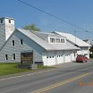
Advances in machination and technology have led to reductions in the number of workers needed to successfully operate large farms and farm product processing facilities of all types. Where seasonal workers are needed, migrant workers are increasingly more common due to the shrinking availability of local youth who traditionally filled this need. There is an active Future Farmers of America chapter at the High School, but additional opportunities for engaging local youth in farming are needed.

Farmers are represented on the Town Council and local committees, and have not rallied around any particular municipal issues or policies in recent years. There have been few nuisance complaints related to agriculture and informal recreational access to farmland for hunting is abundant, though several farmers have restricted access in recent years. Unauthorized ATV use is an issue in some locations.

Many residents have private vegetable gardens and locally grown produce is available at farm stands throughout the region. The high school has initiated an agricultural program including an on-site farm. The Town might investigate the workings of the Presque Isle School District for lessons learned as a model for an agricultural program that is tied to the school food system and a farm market. Mars Hill’s program could use additional support from the community, local farmers, and local institutions like the supermarket and nursing home. At some point, a local Farmer’s Market may make sense.

One ongoing issue facing Mars Hill farmers relates to water quality in the Prestile Stream watershed, where uncovered farm fields from the late potato harvest to spring planting and inadequate stream buffers contribute to a reduction in stream water quality. Christina Reservoir and 15.8 miles of Prestile Stream, which originates at the outlet of the Reservoir and terminates at the Mars Hill Dam, have both been listed as “impaired” by the Maine Department of Environmental Protection (DEP) because of nonpoint source pollution carried in stormwater runoff. The Prestile Stream is also identified as one of the 27 highest priority watersheds among the 55 streams listed on DEP’s Nonpoint Source Priority River & Stream Watersheds. Approximately 10% (4,345 acres) of the Upper Prestile Stream’s watershed (a total of 68 square miles – 43,434 acres) is in Mars Hill.

In 2002, the Central Aroostook Soil and Water Conservation District (CA-SWCD) brought together a 40-member Steering Committee to write a watershed management plan. This plan was completed in 2005. Its primary recommendations were funding and outreach, assessment and monitoring, and nonpoint source action.

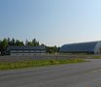
In 2008, the Maine Department of Environmental Protection (DEP) contracted with FB Environmental Associates of Portland to conduct a Total Maximum Daily Load (TMDL) Report of Prestile Stream (& Christina Reservoir). The Prestile Stream TMDL study was based on sampling data collected between 1999 and 2006. The Report found that elevated nutrient loading and sediment accumulation contributes to the excess algae growth in the stream. Excess soil runoff provides sediment that contains a mixture of inorganic and organic material that stimulates algal growth and contributes to the hyper-abundant populations of macroinvertebrates.

Agricultural land encompasses the largest land area in the watershed, making it potentially the greatest contributor of silt and nutrient enrichment to the Steam. Sources of nutrients include bare agricultural land, removal of riparian vegetation, poorly designed and/or maintained roads and culverts including gravel/farm roads, paved roads, and logging roads, use of fertilizers, and animal/pet waste. Expansion of agriculture and development activities has the potential to increase runoff and associated pollutants.

According to the TMDL study, “Cropland [which covers 6% or 20,028 acres of the watershed] is by far the largest estimated source of sediment and nutrients to Prestile Stream and its tributaries, accounting for a predicted 96% of the total sediment load within the Prestile Stream watershed…Cropland is also estimated to be the dominant source of phosphorus...while nitrogen loading is attributed to both groundwater and cropland.” The Report recommends a comprehensive subwatershed approach to manage “all potential nutrient and sediment sources with a major emphasis on implementing Best Management Practices [BMPs] on agricultural land.” Of particular concern is harvesting crops such as potatoes in the late fall, with no winter crop covering the bare ground until spring planting, leaving fields vulnerable to soil erosion from thunderstorms and heavy rain which carries nutrients and sediment to the Stream.

The 2008 study resulted in the Upper Prestile Stream Watershed-Based Management Plan, which was completed in 2009 and calls for many actions to be undertaken over the next decade. Reducing runoff and nutrient impacts to Prestile Stream will require the support of local farmers to use best management practices to improve the riparian buffers and reduce nutrient run off. The Central Aroostook Soil and Water Conservation District can provide technical assistance as it continues to help implement the Management Plan, and the town could partner with CASWCD to work with local farmers. Additional funding for specific implementation strategies is needed.

The Town may want to consider potential impacts of land coming out of the Conservation Reserve Program (CRP) on water quality in the Prestile Stream, although conversations with local farmers suggest that as more acreage is acquired, cultivation is shifted from marginal lands to areas with fewer environmental constraints.

- Forestry
Figure 87. Mars Hill Forestry Resources
The forest products industry in Aroostook County employs about 3,500 people in timber harvesting, lumber and paper mills, biomass plants, trucking and railroad transport, equipment and chemical supplies. The industry is at a down point in its economic cycle because of weak overall demand and international competition (largely from Canada). The bright spots are hardwood veneer production, panel products, and cedar wood products. The potential for biomass production from wood pellets is also evolving. In the short term, this cluster would be helped by cost relief and in the longer term, by strengthening the rail system and diversifying new products and markets.
In 2007, there were 168 primary processing mills, 77 portable sawmills, 46 loggers and brokers, 23 concentration yards, and 11 mills that burned some form of wood for energy.
In Mars Hill, the forest industry is mostly small woodlot harvesting partly because so much land is agricultural. There is a pallet factory on Fort Road that has been in business since around 1994. G.R. Timber Holding, LLC is currently harvesting approximately 86 acres it owns on Clark Road. This area is close to downtown and might be suitable for residential development.
- Local Forestry
Figure 88. Summary of Timber Harvest Information, Mars Hill (acres)*
YEAR | Selection harvest | Shelterwood harvest | Clear cut harvest | Total Harvest | Change of land use | Active Notifications (#)
1991 | 146 | 20 | 0 | 166 | 0 | 4
1992 | 130 | 0 | 5 | 135 | 5 | 6
1993 | 130 | 0 | 0 | 130 | 0 | 2
1994 | 298 | 4 | 6 | 308 | 0 | 7
1995 | 148 | 20 | 0 | 168 | 0 | 7
1996 | 100 | 128 | 1 | 229 | 0 | 7
1997 | 155 | 0 | 4 | 159 | 4 | 7
1998 | 413 | 0 | 0 | 413 | 3 | 12
1999 | 325 | 0 | 0 | 325 | 0 | 20
2000 | 397 | 20 | 0 | 417 | 0 | 22
2001 | 237 | 0 | 0 | 237 | 0 | 13
2002 | 57 | 0 | 0 | 57 | 0 | 6
2003 | 170 | 70 | 0 | 240 | 0 | 9
2004 | 225 | 33 | 0 | 258 | 6 | 13
2005 | 291 | 4 | 0 | 295 | 0 | 21
2006 | 722 | 14 | 0 | 736 | 103 | 26
2007 | 306 | 0 | 0 | 306 | 0 | 24
2008 | 79 | 30 | 0 | 109 | 34 | 13
2009 | 138 | 0 | 0 | 138 | 20 | 8
Total | 4,467 | 343 | 16 | 4,826 | 175 | 227
*Data compiled from Confidential Year End Landowner Reports to Maine Forest Service.
Source: Dept. of Conservation – Maine Forest Service

Figure 89. Tree Growth Current Use Tax Program, Mars Hill
 | 2011 | 2006
Parcels (#) | 17 | 16
Softwood (acres) | 139 | 207
Mixed wood (acres) | 316 | 201
Hardwood (acres) | 651 | 692
Total (acres) | 1,106 | 1,100
Value (dollars) | $99,818 | $97,869
Source: Maine Revenue Service; Town of Mars Hill

- Issues and Implications

- Is there a need for more regional cooperation in transporting and marketing local products? Are local or regional products available at the grocery store and served in the schools?

- How can the community better support the agriculture program at the high school?

- How can Mars Hill balance the need for land for agriculture with the need for land for residential development? How active does the Town want to be in tackling this problem? Is the community willing to focus energy and funds for such efforts? Should the Town pursue USDA Rural Development grant funds for infrastructure, (such as to bring sewer and water to a particular site or develop sidewalks) to help spur residential development?

- Should the town inform new residents that farming is important to the town and that there will be noise, dust, equipment traffic and the like so they understand this coming in?

- Farming has changed dramatically in the past 20 years and even in the past 10 years. Who would think that planters and harvesters would be guided by GPS and that some would spray by helicopter? It is certain that the industry will continue to change. How will it change and how can we prepare and take advantage of this?

- Farm operations and inadequate stream buffers along the Prestile Stream have created water quality issues and there places where the riparian area needs to be expanded or enhanced. What can farmers do to reduce phosphorus, nitrogen, and sediment in stormwater runoff? How actively should Town work with farmers to address issue? Should it actively partner with CASWCD to seek funding to support such initiatives and implement the 2009 Management Plan?

The National Agriculture Statistics Service uses the information only for statistical purposes and publishes data only in tabulated totals. The report cannot be used for purposes of taxation, investigation or regulation.
This number was estimated for the 2002 Census of Agriculture and might partially account for the apparent increase if it was estimated low.
Farmland current use taxation is a different program than Tree Growth. Woodlands associated with farms enrolled in the farmland program are not eligible for Tree Growth reimbursement.

