SECTION 6. CULTURAL RESOURCES



- Mars Hill Cultural Resources
Figure 68. Mars Hill Cultural Resources
- Updated History

Potato farming grew from its use for starch in 1878 to include certified seed and table stock. During the 50’s and 60’s there were over 100 farmers in Mars Hill raising families and making a living on farms as small as 50 acres. Most families had several children and farmers employed “hired hands” to tend crops. In the fall both elementary and high schools recessed for about a month when parents and children picked potatoes. Many men worked throughout the winter racking, packing, and shipping potatoes.
Over the past 20 years, consolidation, mechanization, and crop rotation have changed the makeup of farms dramatically. Presently there are about eight farmers who work all the farmland in Mars Hill. Approximately half are large acreage and the rest are smaller. A portion of the tilled land in Town is operated by people from outside the community and some local farmers have substantial land in other towns.
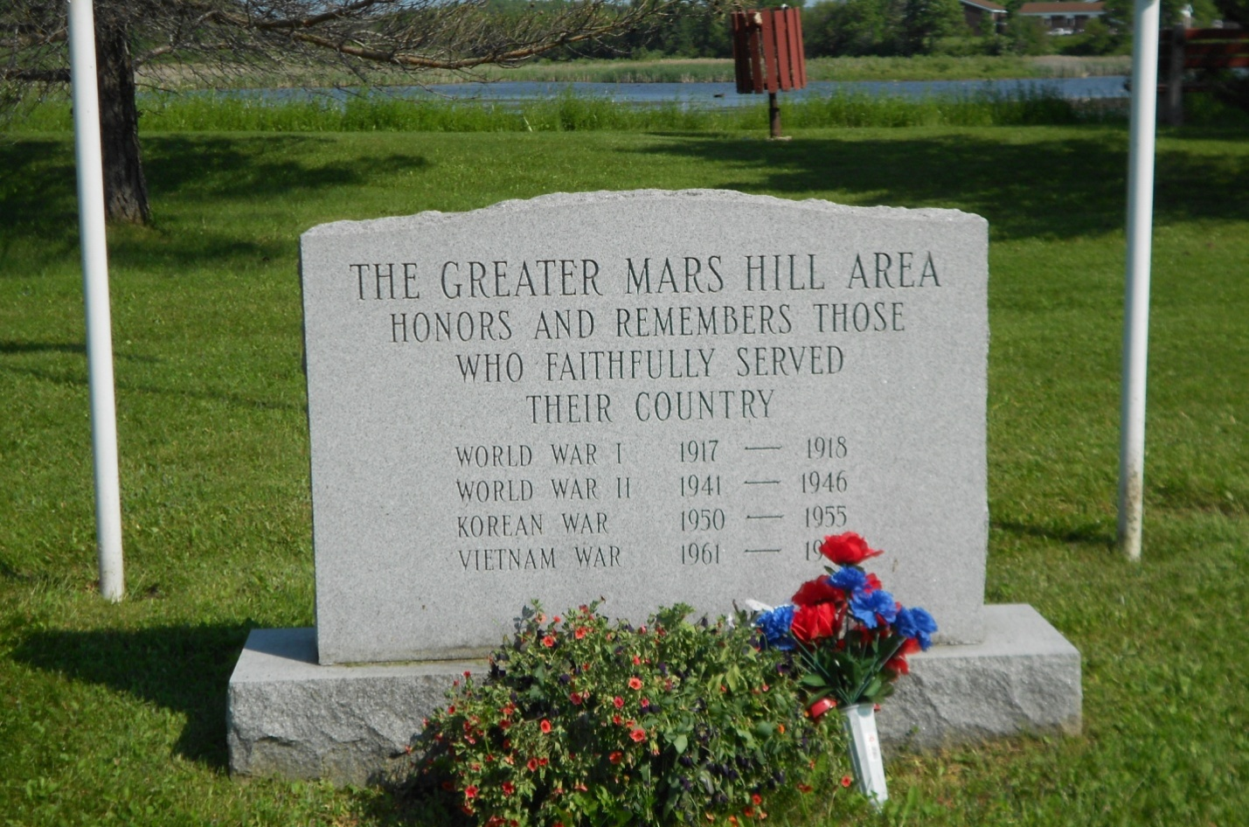
Tilling, planting, cultivating, and harvesting equipment have become very large and more automated. Larger farms, with the most advanced equipment, can work crops much more quickly than in the past. A small farm in 1960 might have grown 50 acres of potatoes and taken all fall to harvest them. The mechanized equipment of today can harvest this acreage in one morning.
All potato farms rotate crops between potatoes and a combination of barley, grain, and clover on a two to one basis. There is some indication that this may change to a one to one basis for best crop results.
The foregoing all combines to reduce the number of local folks working on farms, living on their own farms, and reduces population in general and more importantly in schools.
The landscape of the Town also changed significantly in 2007 with the addition of 28 wind power turbines along the top of Mars Hill Mountain. The generated power is directed to the overall power grid and sold as a commodity. No power is fed directly to any Town residence or business. This was the first wind farm in Maine and has become a permanent part of Mars Hill’s landscape.

- Walter T.A. Hansen Memorial Library

The Walter T.A. Hansen Memorial Library was established after a local businessman, Walter Hansen, provided a substantial financial contribution in his will. The wood frame and brick veneer structure was constructed in 1951. It has several larger rooms for book display and reading and several smaller rooms for meetings, storage, and offices. The library is managed by a Board of Trustees with five members. There are two librarians on staff.
The Library serves Mars Hill and Blaine as well as “D” and “E” Plantations. Patrons include 730 adults, 361 juveniles, three schools, and three other libraries.
There are 14,500 books in the Library’s collection with 710 new titles added in 2011. During 2011, the Library circulated 3,763 materials, including 23 magazine subscriptions. The Library also offers an interlibrary loan program wherein books from other libraries are secured for patrons.
Over the years there have been many improvements to the facility both inside and out; however, the building and grounds have aged significantly, including the heating and lighting systems. The roof and the brick veneer in addition to the pavement and landscaping had deteriorated badly. The Library is in the final phase of spending approximately $20,000 from USDA and Steen and Tabitha King grants to upgrade electrical service, insulate exterior walls, and providing new lighting.

- Big Rock Mountain Ski Area

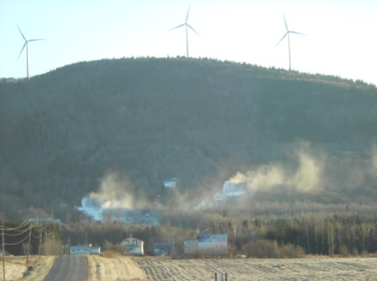
The former Mars Hill Ski Area is now owned and operated by the Libra Foundation and is now called the Big Rock Mountain Ski Area. Big Rock continues to include 300 acres and has three ski lifts. Big Rock added a snowboarding facility and trail in 2011. The area also now has snow making capability.

- School Recreation Facilities

The Central Aroostook Junior-Senior High School continues to own and maintain two ball fields, two soccer fields, and a gym. In 2009, the School District started a weed control and fertilizing program on the fields, which are also aerated annually. Recently, the District started using an absorbent, biodegradable product to mix with the soil to make the field softer and dry out better. The District uses one soccer field for games and the other for practice, because practice tears up the game field too much.
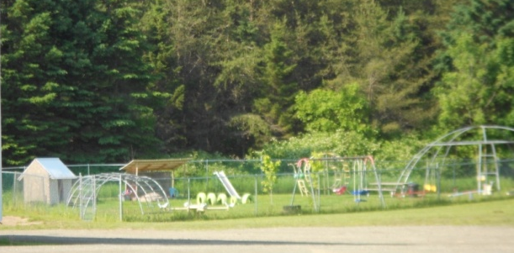
The Fort Street Elementary School has one softball field, one basketball court, two playgrounds, and a gym. The playground and fields get the same fertilizing and weed control program as the Junior-Senior High School.

According to John York, all the fields are in good shape. There is adequate capacity in all our fields at this time with no major capital needs.
The gyms are also in good shape. The elementary gym floor was redone several years ago.
- Prestile Stream Dam and Park

The Prestile Stream has been dammed at Mars Hill for many years. The Pond was a significant focus of recreational activities in the 40’s and 50’s. Many remember horse racing on the frozen Pond in the winter. A number of people from Town and the general area kept horses and raced them throughout the area using sulkies. There was ice skating in winter and bon fires here and there.
In early spring when water was running high, local men would assemble a group of several canoes with outboards and go upstream toward Westfield. When the water receded to normal levels and the fiddleheads came up in May, folks would pick them and start to fish in the Pond and stream. The Prestile Stream was fished a great deal by locals and somewhat by fishermen from away.
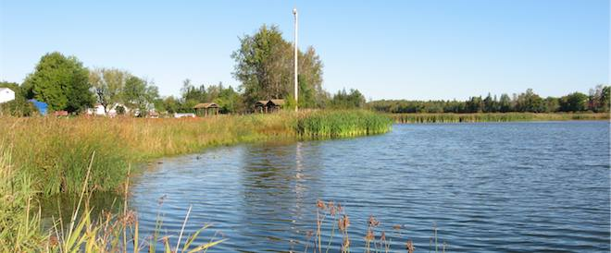
The Prestile Stream at times in the past has enjoyed national fame because of its wild trout fishery. There have been highs for this natural resource such as in the 50’s when the water flowed clear and clean and the Pond was generally deep and clean. There have also been lows such as during the 60’s when a sugar beet processing plant up stream polluted the stream to a wretched stench.
The greater Pond area is 27 acres and the current open water area is 9 acres. The difference is the area that filled in over the years because of natural sediment buildup in the calm water behind the dam. In the 60’s, most of the 27 acres was open water. The grassy area has grown since then.
The former dam washed out about 1975 during a heavy storm. The spillway could not handle the volume of water coming down stream and began to flow around the ends of the dam, eventually washed out the embankment, and destroyed the dam.
In 1984, a replacement dam and recreation area was constructed. It was designed with a larger spill way to accommodate water flow from a large storm. It was also designed without a fish way so that the section of the Prestile Stream from the dam upstream to the headwaters in Easton and Fort Fairfield could be maintained as a brook trout fishery only. Other species such as bass cannot pass up stream of the dam.
The entire width and height of the spillway is needed to handle 100 year design stormwater flow. However, the bottom of the spillway opening is approximately two feet below the level of water held back by the former dam. Wooden walls called “flash boards” were installed in the new dam to maintain the historical water level. The flash boards were initially designed and installed with hinges at the bottom and bolts at the top to shear and allow the flash boards to fall when it is necessary to provide for full flow.
The flash boards were problematic. They would not reliably hold back the intended two feet of water and spring ice and debris tore them from their anchors. Several heavier designs were tried but they also failed. Standing the flash boards up or installing new ones in the spring did not work either. If workmen tried to do the flashboard work with water flowing over the spill way, the slippery surface and flowing water became a safety problem. If the gate at the bottom of the dam was opened and the pond was drained enough to dry the spill way, it created an unsightly upstream condition and interfered with animal nesting. In 2003 the Department of Environmental Protection (DEP) and the Maine Department of Inland Fish & Wildlife (IFW) raised concerns relative to waterfowl nesting in the spring.
There are approximately 27 acres of water in front of the dam that is rated and mapped as high importance by the IFW and identified as significant wildlife habitat under the state’s Natural Resources Protection Act (see Figure 89 and discussion on page II.9-13 in the Natural Resources Chapter). IFW indicates that restrictions on the timing of flash board installation and removal is necessary as the most critical period for waterfowl and wading birds in Northern Maine occurs during spring and summer (April-July). This period is when birds are establishing breeding grounds, nesting, and having broods. In order to avoid major impacts on these critical habitats during this time period, IFW recommends the initiation of drawdown in lakes, streams, rivers, and ponds be no earlier than July 15th. The seasonal timing of the rising and lowering of water levels is important to numerous wildlife species since many depend on stable water levels when establishing nesting sites and food caches throughout the season. When water levels were raised prior to July 15th by adding flashboards and increasing water depth, many waterfowl species, primarily black ducks and mallards’ nests are flooded out during nesting and incubation. When boards are taken down, lowering water levels after October 1st, beaver lodges and food caches are left high and dry without allowing adequate time to be reestablished for iced up winter months. Fflash boards have not installed since about 2004 or 2005.
One possibility going forward is to remove the tree snags that wash down into the existing pond area in the spring, install the two foot high flash boards on June 15thand remove them on October 1st. Another solution may be to install hydraulic splash boards, estimated to cost $250,000.
Sediment has filled the current open water area so that the Pond has become quite shallow. The Pond was drained in the fall of 1993 and frozen sediment was trucked to and stored at the Transfer Station over the winter. In the summer, the sediment was spread over the Town’s closed landfill. Permitting for dredging today would involve the DEP, IFW, US Fish &Wildlife Service (USF&W), Army Corps of Engineers, and perhaps others. Sediments would have to be tested for contaminants and dealt with accordingly. It is likely that the permit process would be detailed and lengthy and that the cost of dredging and disposal would be high.
In the early 90’s the grassy area, which was formerly part of the Pond, was designated by USF&W as a significant Inland Wading Bird & Waterfowl Habitat. It is rated as a high nesting area and construction and disturbance within 250 feet is limited. Over the years an ever increasing number of ducks and geese used the Pond for resting, roosting, and nesting. Droppings from these birds have created a high nutrient load in the water, which causes algae blooms.
The Prestile Stream and Pond are used for canoeing, kayaking, and fishing. Some folks also enjoy watching waterfowl and other birds. Occasionally there are birds in and around the Pond that are quite rare in the area. They attract birdwatchers from afar. There may be potential to develop the Park with paths and boardwalks to attract people and business to Town. Collins Pond in Caribou and a wetland walk in Bangor may be worth looking at for examples.
Organizations such as Trout Unlimited, Ducks Unlimited, Pathways to America, and others might be a helpful in defining and funding a study of the Stream and Pond to explore potential for the future. The Town might also explore potential for a walking/biking path north to Westfield and Easton and South to Blaine and Bridgewater. Committee members see the pond as a huge asset that should be managed for the benefit of townspeople.
The Prestile Stream itself was well known as a fine trout fishery. It still is a good fishery but access is mostly through private land. If fishing is to be promoted to folks from outside, access must be developed and promoted.
The Park is generally in good condition, as is the ramp and picnic area. There is a building on the site that might be activated for community use.
Currently, a number of people canoe and kayak from Westfield to Mars Hill, then continue onto the border at Bridgewater. People also fish in the Pond, below the dam, and in the Stream where it is accessible. Some access is public such as at the landing in the pond area off Silver Street. Most access is informal and crosses private property. Future access needs to be addressed in the Comprehensive Plan. The Maine departments of Conservation, Transportation, and IFW provide programs to help municipalities secure and develop public access opportunities.
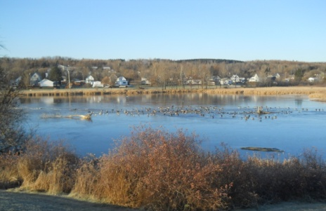
Prestile Stream and its tributaries are managed under General Law fishing regulations which means there is a daily bag limit of five brook trout and minimum length of six inches. There is currently no stocking in the Prestile watershed so the sport fishery is entirely supported by wild fish, which are highly valued by Maine anglers. Stricter regulation of the sport fishery is possible, but water quality degradation and other habitat issues may preclude significant improvements in trout numbers and size by regulation alone. If the Stream and Pond are promoted as a destination for outside fishermen, perhaps the Town should work with IFW to review catch and keep regulations and restoration efforts that may be necessary to maintain or expand fish populations.

- Mars Hill Recreation Program and Complex


The Recreation Center, the former high school building with its gym, and an outdoor swimming pool, which was constructed in 1973, are dedicated mostly to the Mars Hill Recreation Program and are an asset to the Town. According to Dave Collins, Mars Hill Recreation Director, some of the space is rented to a day care facility.
In the spring of 2013, the swimming pool was found to be in need of repairs and upgrades to bring it into compliance with state regulations. Cost estimates are being prepared. In the meantime, the pool will not be opened for the summer.

The following recreation programs are available to children and adults:
- Summer

- Tee Ball (Blastball)
- Minor League (ages 7-9)
- Major League (ages 10-12)
- Junior High School Girls Softball (ages 10-12)
- Pony League Baseball (ages 13-15)
- Senior High School Girls Softball (ages 13-15)
- High School League Baseball (Grade 9-12)
- Field Day for Fort Street Elementary School
- Hershey Track and Field
- Karate
- Pitch, Hit, and run
- Power Aid Youth Golf
- Open Swim
- Swim Lessons
- Summer Day Camps
- Summer Feeding Program
- Summer Soccer (Grades 3-6)
- Adult Canoeing and Kayaking
- Adult Gardening Club
- Adult Homecoming Days Festival
- Adult Informal Soccer
- Adult Karate
- Adult Lap Swim
- Adult Walking

- Fall

- After School Programs
- Field Trips
- Grades 1 and 2 Soccer
- Grades 3 and 4 Soccer
- Grades 5 and 6 Soccer
- Halloween Events/Programs
- Harvest Break Activities

- Winter

- After School Program I
- After School Program II
- Easter Events/Programs
- Elks Hoop Shoot
- February and April Break Activities
- Field Trips
- Friday Movie Lounge
- Grades 1 and 2 Basketball
- Grades 3 and 4 Basketball
- Grades 5 and 6 Basketball
- Indoor Soccer Leagues
- Karate
- Letters from the North Pole
- MRPA Hot Shots
- Ski 4 Life Program
- Wiffle Ball League
- Winter Carnival at Fort Street
- Adult Basketball
- Adult Community Theater Group
- Adult Indoor Soccer
- Adult Karate
- Adult Walking

The Recreation Department recently started a Day Camp for children from 8 am until 2 pm with breakfast and lunch. The Camp plans two craft or other activities in the morning and field trips in the afternoon. The Camp is expected to average 20 children per day.
The gym is heavily used by senior citizens for walking exercise throughout the year. In winter it is used more because of icy and snowy walking conditions outdoors. In March the gym and stage are used for several beauty pageants in Town, which are very well attended and important to the community.
The facilities have been improved in recent years, but have greater potential. The heating system and lighting systems in the building are being or have recently been upgraded. The Town does not have a fitness center and there is little weight training for high school students. The Town’s young athletes would be safer and would be stronger on the court and in the fields with better weight training.
While there is a rudimentary weight room at the Recreation Center, according to the Recreation Director, Dave Collins, it would take approximately $50,000 to raise the facility to the desired level.
The Department currently is seeking a $100,000 grant to restore the stage area.
The parking lot for the facility is gravel. Paving is estimated to cost approximately $100,000.
The Recreation Director notes that the Program offers some canoeing and kayaking activities for children, but has to go out of town. He notes that if the Pond were restored and deepened, the Program would provide these activities in Mars Hill.

- Walking/Biking Trails
There is an existing walking trail from the High School to the base of Mars Hill Mountain, who’s focus might be expanded to include winter cross country skiing. The Houlton-Presque Isle Rail Trail is located within the right-of-way for the former Bangor & Aroostook rail line and is currently used for multiple purposed, including for walking and ATVs, and snowmobiles.
Many younger people focus much of their recreational activity on walking, hiking, and biking. The Committee has discussed the value of developing and adding to the Town’s walking/biking path systems to provide a destination for incoming tourists and travelers. A walking path system along the river might attract people and be used a good deal.
The makeup of the people who came to the “run up the mountain” that Mark Shea organized last year were from out of town which is an indication of the potential for more recreational activity and business in Mars Hill. The Town might consider organizing bike and/or foot races around the mountain or elsewhere as part of its recreational mix and business attraction.
The International Appalachian Trail extends through Mars Hill and over the mountain.

- Mars Hill Country Club and Golf Course

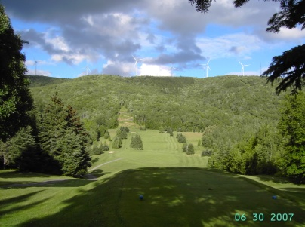
The Mars Hill Country Club is located at the base of Mars Hill. It includes an 18-hole golf course through rolling greens amidst stands of hardwood trees and small ponds. Mars Hill Country Club is one of very few clubs to be rated among the top 10% in Northern Maine by the New England Golf Guide.

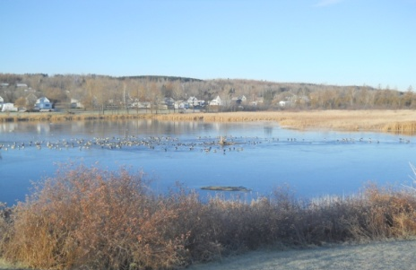
- Scenic Resources
Scenic features, including Prestile Stream and the Mars Hill Mountain, have not changed since 1991, except for placement of the wind towers and generators.

It is difficult to identify specific scenic areas to protect in Mars Hill as the entire community is scenic, including its compact pattern of development, surrounded by a landscape of working farms and rolling hills punctuated by wooded areas around Mars Hill Mountain (1990 Comprehensive Plan), streams, wetlands, and ponds, and Mars Hill Mountain itself with its ski and hiking trails. Views of the Mountain, agricultural fields, and forests are available from 90% of the streets and roads, particularly at high points throughout Town. People frequently ride around the Mountain to see moose and deer.
Some of the most highly valued scenic views are of agricultural fields and activities. Residents and visitors enjoy watching the cycles of agriculture – spring tilling and planting; greening up of potatoes, grains, soy beans, grasses, clovers, and fallow fields; blossoming; harvest; winter cover; and reappearance of soil in the spring; as well as the traversing of harvest equipment and working machinery throughout Town.
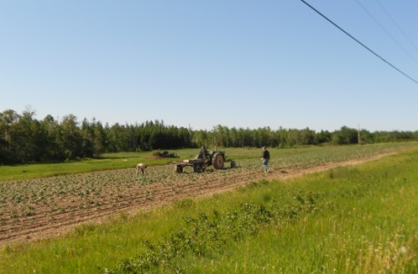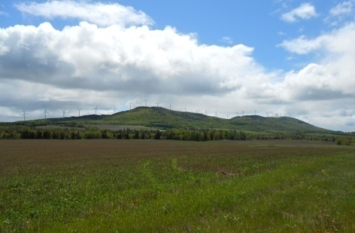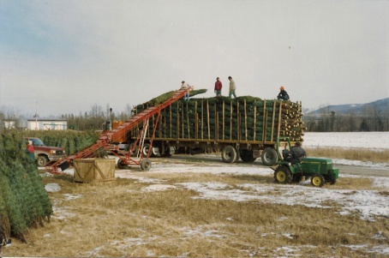
Mars Hill Mountain, including the Big Rock Ski Area and Evergreen Wind (identified by the community as “windmills”), is another ubiquitous view in Mars Hill. One can see the Mountain from almost everywhere in Town. Exceptional views of the Mountain can be seen from the easterly parking lot and sitting room of the Aroostook Health Center and from Clark Road at the top of the ridge on the western side of Town. The views of the Mountain from the east as well as from the Mountain further east toward Canada and the St. John River Valley are also exceptional.
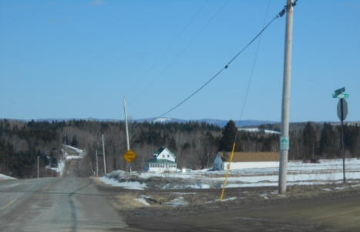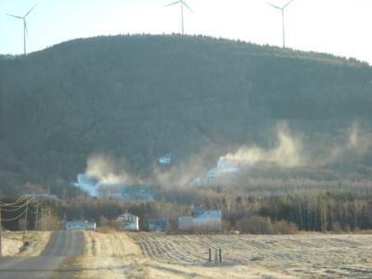
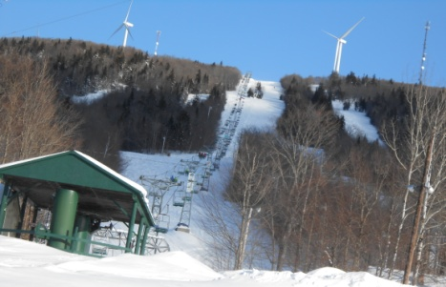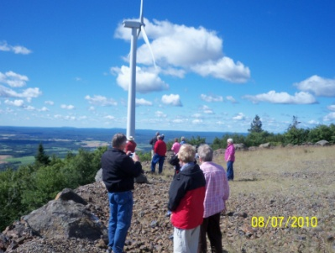


Hikers, bikers, ATVers, and snow machine operators have some of the best scenic views of the region in all directions from the top of the Mountain and the International Appalachian Trail. The owner of most of the top of the Mountain envisioned an auto road, similar to the one on Mount Cadillac in Bar Harbor, for viewing scenery when originally purchased. Views of the ski trails in spring, summer, and fall then in winter with lighted trails at night are highly valued as are views from trails when skiing and hiking. Views from the Mountain looking west toward the valley with the village nestled at the bottom are also outstanding. The wind generation towers are scenic to some and an eye sore to others.

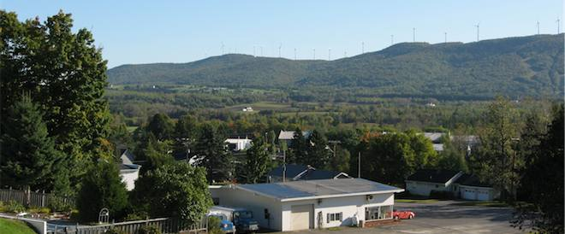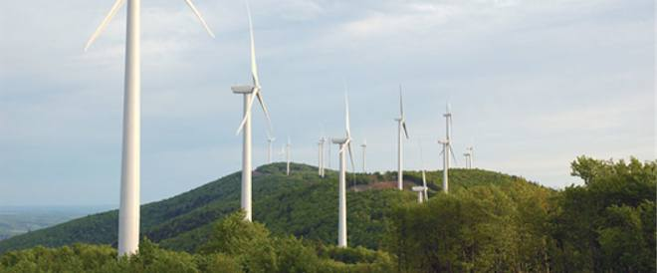
The Prestile Stream runs through Mars Hill. Views of the Prestile downstream from the bridge and from Mill and Pleasant Streets are scenic as are views observed from canoe and kayak travelers on the Stream from Westfield to Blaine.
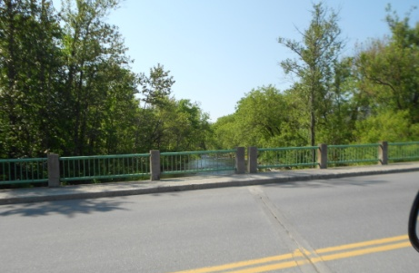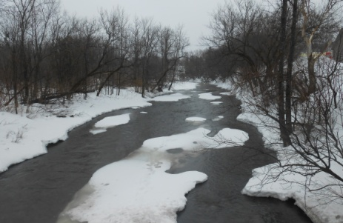
Distant views of the mountains, hills, and fields to the west of Mars Hill are striking. These views can be compromised and negatively impacted by the actions and developments of other towns and unorganized territories. Over 100 wind turbines are planned for the Number 9 Lake area which can be viewed to the southwest of Mars Hill. There is a line of hills/mountains within several miles of Town to the west called the Green Mountains which, if developed, would sandwich Mars Hill between two nearby wind farms.
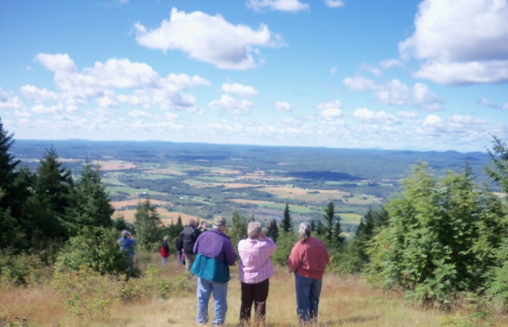
As noted, when asked what the Town values, members of the community repeatedly reference the community’s rural landscape (defined by active farms, various water resources, and Mars Hill Mountain) and the various outdoor recreation opportunities (hiking, snowmobiling, hunting, fishing, birding, canoeing, and kayaking), including the area associated with the Mars Hill Park, Dam, and Pond. Rather than identifying specific views to be protected from development, the FLUP presents a far more thoughtful approach of providing protection for the community’s general and traditional development pattern (compact village surrounded by an active and passive rural landscape and a mountain that is actively used for downhill skiing and electric power generation). The fundamental basis for economic development and increase in population in Mars Hill, to preserve the community’s traditional pattern of a compact village surrounded by rural hinterlands, will do far more to preserve scenic views than targeting particular resources as there are so many and so little development pressure.
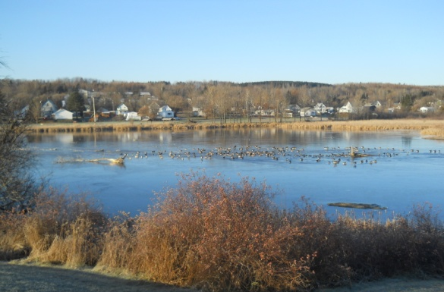
Within this context, the Town has designated the scenic views in Figure 69 as particularly important.
Figure 69. Mars Hill Designated Scenic Views
These areas are described more fully below.

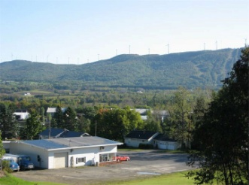
- Panoramic views from ridge on Clark Road west of the village looking east toward golf course, Mars Hill Mountain, and ski trails

- Distant view of Mars Hill Mountain to the east from the Aroostook Health Center parking lot.
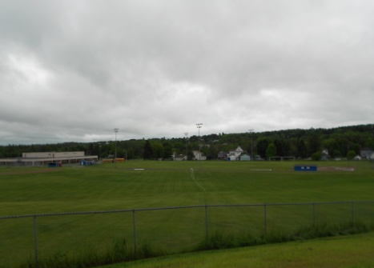
- Mars Hill Park and Pond – views from the Park; the east side of bridge; from Fort Road up to the elementary school; from canoes and kayaks on the Pond; observation of the Pond and open water, the wetland/cattail waterfowl nesting area, and water flowing over the Dam from the Park’s parking lot; the head of Pond behind the elementary school; waterfowl viewing from hatching to their trip south; eagles/hawks; views from canoes and kayaks on the Pond
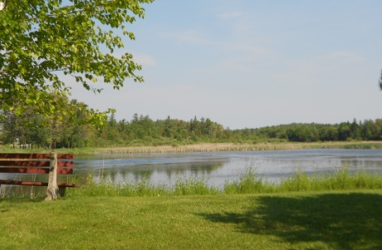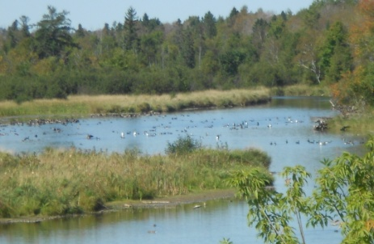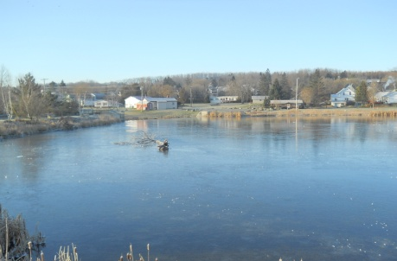

- Close up views of the Prestile Stream from the south side of the bridge on Route 1A
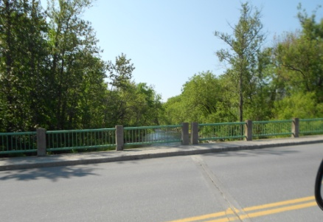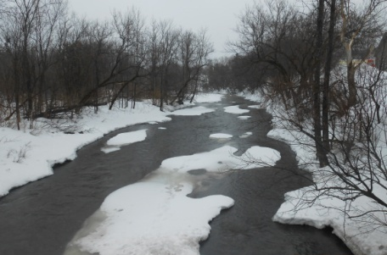
- Panoramic view of Central Aroostook High School with playing fields to the south, agricultural fields to the east, and the village nestled in the valley to the west
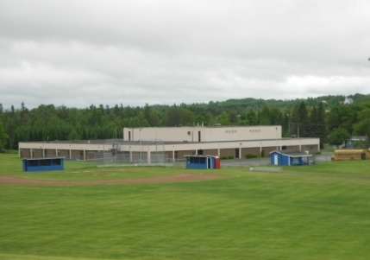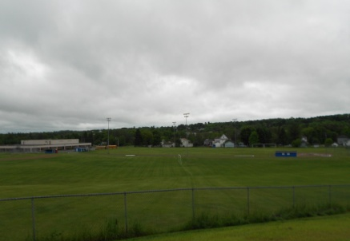
- Views from Boynton Road of ski trails and wind generators on Mars Hill Mountain
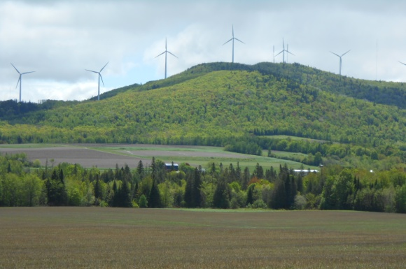

- Golf course at the base of Mars Hill Mountain – close views of golf course from Country Club Road and from afar, views to the west from the golf course specifically the tee on the side of the Mountain
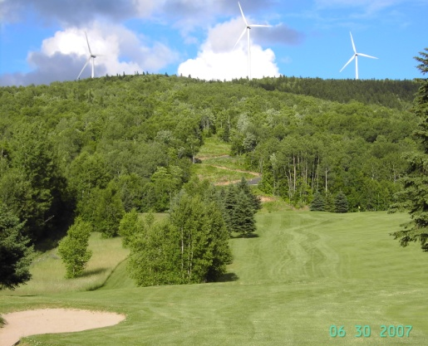
- View of the St. John River Valley to the east from behind the north end of Mars Hill Mountain
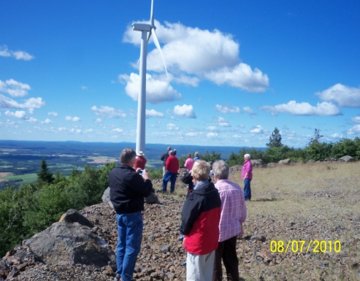
- Distant view of the Mars Hill Mountain and agricultural fields from Smith Road

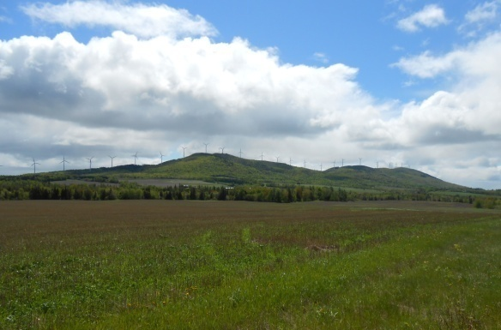
- Special buildings and sites – oldest cemetery in Town on Clark Road, Masonic Hall on Main Street (Katahdin Bank Building), Seth Snow House on Church Street
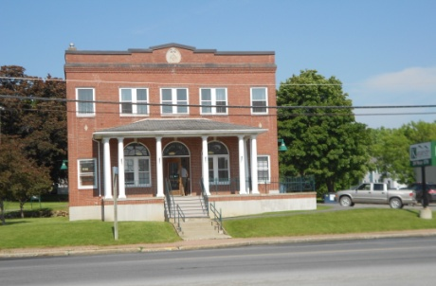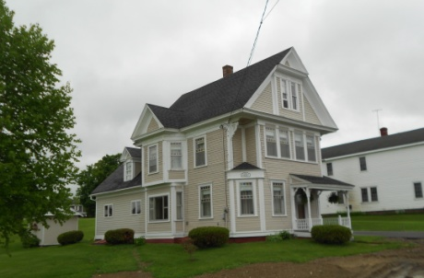
Mars Hill is facing little development pressure and most development that does occur does so within the traditional compact downtown area. The most balanced approach to protecting scenic views in the community is to:
- Continue to preserve the Town’s traditional village and working rural landscape pattern of development, laid out in the Town’s Future Land Use Plan and
- When development is proposed in areas identified with important scenic views (see Scenic Views Map), the Planning Board will consider the impacts of the proposed development on the views and encourage the developer to adjust his or her development plans to minimize negative impacts on the views.
- Periodically monitor impacts of development on scenic landscape of Mars Hill and, if negative impacts are observed, undertake a more rigorous scenic views inventory and consider stronger regulatory protections as appropriate.

- Lodging
A 2006 Global Resorts, Inc. Feasibility Study and Development Assessment found that the County has all the attributes for resort development and cluster like smaller projects. Mars Hill, located, is in the center of the County and at the gateway to Northern Maine and Aroostook County, is an ideal home base for those who come for outdoor activities. The Global Resorts study indicated that the Big Rock Ski Area, together with its nearby golf facilities, offers promising development opportunities if the hotel component can be addressed.
With the abundance of natural beauty in Mars Hill, another alternative to provide lodging might be a campground near the base of the mountain. Many folks use large self-contained campers to travel to destinations. Mars Hill may want to endeavor to make Mars Hill one of these destinations. The Amish settlements in the region could be part of a tour package as well as the wind farm. The Town might seek grants to study the feasibility of creating a hotel, campground, or other lodging businesses and services to capitalize on this opportunity.

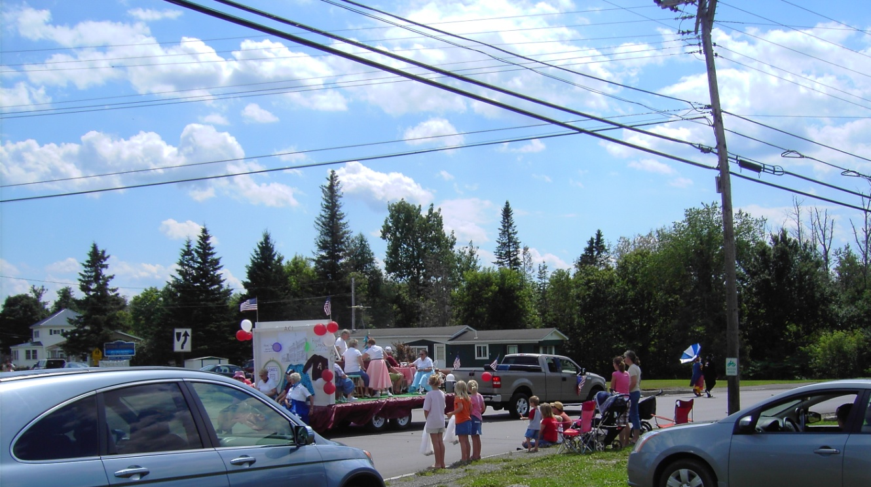
- Archaeological Resources
Figure 70. Mars Hill Archaeological Resources
The Maine Historic Preservation Commission (MHPC) has identified one prehistoric archaeological site in the northeast quadrant of Mars Hill (site 168.2). Limited areas of the Town have been surveyed by professional archaeologists, including the top of Mars Hill for the windpower project and a corridor along the western town boundary for a powerline/utility corridor. The MHPC notes that archaeologically sensitive areas that need survey in advance of construction include the Prestile Stream valley and areas around Rocky Brook.
The MHPC indicates that there are no historic archaeological sites are documented for the Town to date. The MHPC notes that no professional surveys for historic archaeological sites have been conducted to date in Mars Hill and recommends that future archaeological survey should focus on the identification of potentially significant resources associated with the Town’s agricultural, residential, and industrial heritage, particularly those associated with the earliest Euro-American settlement of the town in the 18th and 19th centuries.

- Historic Resources
According to the MHPC, there are no historic buildings, or objects documented in Mars Hill. The MHPC recommends that a comprehensive survey of Mars Hill's above-ground historic resources should be undertaken to identify those properties that may be eligible for nomination to the National Register of Historic Places.

- Historical Society
The Central Aroostook Historical Society was established in January 2010 with the formation of a committee of local individuals. The Mars Hill Rotary Club sponsored the start up of this group which includes the communities of Mars Hill, Blaine, Robinson, E-Plantation, and Westfield. After a great deal of work, the organization was designated as a nonprofit by the Internal Revenue Service. In May 2013 the Town of Blaine gave the Society the former Blaine Grange building and land located adjacent to the Blaine Town Hall as a home for the new group and will house documents, photographs, and artifacts important to the history of the area.

- Issues and Implications

- Should Mars Hill invest in restoring the pond and the dam operated to make it a community focal point and center of beauty and recreational activity? Should the building on the site be used for community purposes?

- Is access to Prestile Stream and the pond adequate? Should access be improved? Where are opportunities to create or improve access?

- Should the Town promote use of the Stream and pond for canoeing, kayaking, and fishing? If so, should the Town work with MIF&W to review, and potentially modify, catch and keep regulations to maintain fish stocks?

- Should the Town approach organizations such as Trout Unlimited, Ducks Unlimited, Pathways to America, Maine Department of Conservation, and others to help define and fund a study of the Stream and pond to explore potentials for the future?

- Should the Town plan for and create a system of trails, boardwalks, and amenities along Prestile Stream and the pond to create a destination to draw others to the Town and to provide additional facilities for the community? Should the Town promote, support, and/or encourage the development of trails elsewhere in/beyond Town, such as north to Westfield and Easton and south to Blaine and Bridgewater? If so, where? Should the existing walking trail between the High School and the Mountain be expanded to include cross-country skiing?

- Should Mars Hill develop a fitness center for its student athletes?

- Global Resorts notes the opportunity for Mars Hill to expand its tourism offerings around the Big Rock Ski Area and nearby Golf Course. Should Mars Hill investigate and promote the development of lodging – a hotel, B&Bs, and/or a campground, with or without a “resort” or a package of amenities, to capitalize on potential expanded tourism opportunities? How can this development be pursued in such a way as to promote a four, or at least expanded, season tourist attraction?
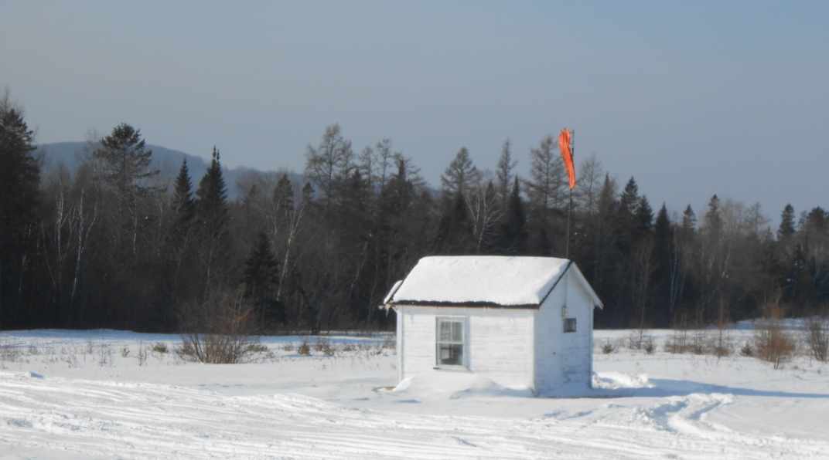

See photos of scenic views on the following pages of this Comprehensive Plan – 4 photos on cover (fields, Mars Hill Mountain, Pond, Aroostook Health Center Parking Lot), acknowledgements page (view from the Mountain), pages I.1- 1 (ballfield, village from Church Street hilltop), I.2-1 (Pond), I.2-3 (2 of the Mountain), I.2-4 (Dam), I.2-5 (Dam), I.2-8 (agricultural field, Pond), I.3-2 (the Mountain), I.3-3 (the Mountain from Aroostook Health Center), 1.3-13 (view from top of the Mountain), I.3-15 (view from top of the Mountain) , I.4-1 (agricultural fields), I.4-5 (golf course, the Mountain, wind towers), I.5-2 (village from Church Street), I.5-3 (Pond with marsh in background), I.6-1 (agricultural fields, the Mountain, wind towers), 1.6-8 (Pond, village from elementary school), I.7-1 (Pond, the Mountain, wind towers), II.1-1 (the Mountain, wind towers), II.2-1 (the Mountain, village, wind towers, ski trail from Clark Road), II.2-5 (ski trail close up, Christmas trees), II.2-15 (agricultural activity), II.3-1 (village from Church Street hill), II.5-1 (Dam, Pond), II.5-6 (memorial at Park), II.6-5 (the Mountain ski trail), II.6-6 (Pond, Park), II.6-7 (Pond), II.6-7 (Pond), II.6-11 (Pond), II.7-9 (Dam, Park), II.8-1 (agricultural activity), II.9-1 (Pond, Park, the Mountain, wind towers, ski trail), II.10-5 (Snow House on Church Street), II.10-9 (the Mountain, wind towers), II.10-10 (Christmas trees, the Mountain).

