SECTION 5. PUBLIC FACILITIES AND SERVICES

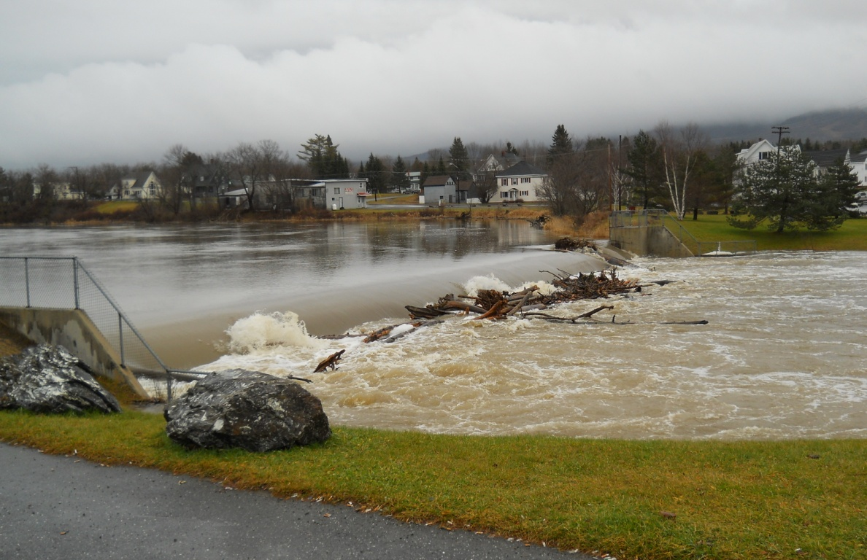

- Mars Hill Public Facilities
Figure 56. Mars Hill Pubic Facilities
Most public facilities and services are within or near the Downtown.

- Drinking Water and Wastewater Disposal

- Utility District
The Mars Hill and Blaine Water Company, as part of the Mars Hill Utility District, provides pubic water to approximately 1,800 customers in Mars Hill and portions of Blaine and Westfield. District customers consume approximately 64 million gallons per year.

The source of water continues to be Youngs Lake, where no significant land use threats have been identified in the District’s 2003 Maine Public Drinking Water Source Water Assessment Program Mars Hill and Blaine Water Company Youngs Lake Watershed prepared for the Maine Source Water Assessment Program at the Drinking Water Program in the Maine Department of Human Services. The primary land use in the watershed, which is primarily in Westfield and E-Plantation, is timber harvesting. Occasional harvesting should not pose a significant thread to water quality as long as reasonable harvesting practices are followed. Public access to the lake and reservoir is limited by a gate and sign; therefore, recreational activity is infrequent and primarily limited to camp owners. Portions of the watershed are also protected by a conservation easement.

The District has undertaken an ambitious upgrade of its transmission and distribution system. A water filter plant was constructed in 1993. A new water treatment plant, with a minimum life expectancy of 50 years, went on-line in 1995. By 1995, 72% of the District’s transmission and distribution system was new since 1985, with a life expectancy of 80-100 years and by 1999, the District had installed all new water lines from the water plant to the standpipes. The District installed a new 500,000 standpipe in 1995 and removed a 250,000 gallon standpipe from service in 2010. A second standpipe also may be needed sometime after the planning period on the east side of the Stream at a cost of approximately $500,000.

In 1995, the District used grant funds to purchase 138 acres from Great Northern Paper Company around Youngs Lake to help protect the District’s source water.
By 2003, the District was warning customers about changes to federal standards to treatment methods, source water protection, and other standards governing small public water systems. In response to new standards, the District identified two options for new wells on the water treatment plant property in 2004. The District received a 75% grant package to undertake improvements from the Maine Drinking Water State Revolving Loan Fund and completed the project in 2005 ($331,000 project). Benefits of the project are lower use of disinfectants, better tasting water, improved color during summer months, smaller withdrawals from Youngs Lake, and greater security for source water in the event of surface water contamination.
In December 2011, the Mars Hill and Blaine Water Company entered a Taste Test competition in Freeport and placed third.

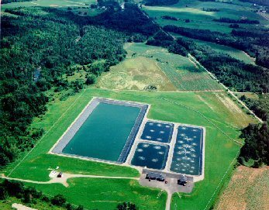
The Utility District also provides a public sewer system and waste water treatment for the village area of Mars Hill. In 1993, the Legislature expanded the boundaries of the service area of the Sewer Utility District into a portion of Blaine. Currently, the system is licensed for 1 million gallons per day of discharge (designed for a maximum of 1.6 million gallons per day). The District has 32 million gallons holding capacity. Average daily use is 80,000-100,000 gallons per day. There were 583 Mars Hill households in the public sewer system and 623 households in the public water system in 2010.
A new sewer treatment plant, with a minimum life of 50 years, and two pump stations were constructed in 1993. Over 49% of the sewer collection system was new or replaced between 1975 and 1993. If properly maintained these improvements should last 50-100 years.

The District has worked with its member towns to optimize the use of Community Development Block Grant funds to meet the multiple purpose of upgrading public water and sewer lines while reconstructing roads and improving associated streetscapes. Reconstruction and expansion projects were undertaken for Grove and Institute streets, South Main Street, Silver Street, Mill Street, Old Houlton Rd as far as the Pierce Rd (in Blaine), Highland Avenue, Benjamin Street, Bowery Road (Blaine), Hansen Street, School Street, Miller Street, Gilman Street, and Church Street.

In 1997, the Utility District received two awards for its wastewater treatment plant – the Regional Outstanding Facility Award from the Maine Wastewater Control Association and the EPA Region 1 – New England for Most Improve Wastewater Treatment Plant in NE.
In 2002, the District undertook a complete camera assessment of most underground wastewater pipes to guide systematic upgrading of older sections to eliminate clay pipe, which are cracked and taking on groundwater which increases operation and maintenance costs. In 2010, the District began to replace 10,000’ of cast iron water mains and 2000’ of clay sewer mains with $2.5 million in grants and $1million in loans for a combined cost of $3.5 million.
In 2011, the Utility’s total capital assets, net of depreciation, totaled $13.3 million for both water and wastewater processing.
While the wastewater treatment system operated beyond expectations for a few years, unusually high inflow of wastewater, due to higher than normal precipitation for a couple years, and an unintentional discharge of a pollutant into the collection system in 2007 temporarily upset the treatment system. Operational problems have been resolved and the system continues to operate without significant problems.
- On-site Water Systems
Mars Hill has 2 water systems that the state defines as “community” public water systems. They provide water for the Mars Hill Country Club and Big Rock Ski Area/Restaurant. Both are bedrock wells with thickness of overburden unknown, drilled to depths between 260 and 360 feet. The Maine Drinking Water Program identifies contamination risk for these water systems based on:
- well type and site geology (thickness of overburden);
- existing and future risk of acute contamination from bacteria, nitrates, septic systems, and animal feedlot or manure piles; and
- current and future risk of chronic chemical contaminants or significant sources of contamination from parking lots, fuel storage tanks, landfills, or industrial waste disposal sites.

The well at the Country Club is at “moderate” risk based on well type and geology and for existing risk from acute contamination, but is listed as “low” risk for future risk from acute contamination. While testing found no bacteria, no nitrates greater than 5ppm, and no animal feedlots/manure piles within 300 feet of the well, it did find septic system(s) within 300 feet of the well. Because the proprietor owns land within 300 feet of the water supply source, it is listed as low risk for future risk of acute contamination.
The well at the Big Rock Ski Area/Restaurant is also listed as “moderate” risk based on well type and geology, but is listed as “low” risk for existing and future risk from acute contamination because there are no septic systems or feedlots/manure piles within 300’ of the well and because the proprietor owns land within 300 feet of the water supply source.
A new state law enacted in 2000 (PL 761) gives pubic water suppliers “abutter status” for certain proposed activities that require a permit within a given source protection area, including automobile recycling facilities or junkyards, expansion of structures using subsurface waste disposal systems, conditional and contract zoning, subdivisions, and other land use projects.

- Stormwater

Stormwater drainage systems were upgraded as part of street reconstruction projects, including Main Street and School Street.
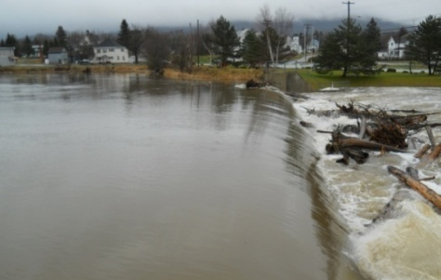
The remnants of Hurricane Irene created some storm drainage issues throughout the community in the fall of 2011, although according to Ray Mersereau, Town Manager in Mars Hill for 20 years, the Town did not have serious road erosion problems and those that occurred were handled by Town employees. The Town cleans storm drains blocked with ice and snow in late winter/early spring to protect bridges, culverts, and roads rom flooding. A professor and students from the University of Maine Presque Isle recently worked with Mars Hill high school students to map the community’s entire storm drain system.

- Community Development

Mars Hill has been quite successful in securing Community Development Block Grants (CDBG) to reconstruct public facilities, including reconstruction of:
- Grove and Institute streets (1990-1991)
- Silver Street (1995)
- Park Street (1997)
- Highland Avenue and Benjamin Street (2000)
- School Street (2002)
When the previous Comprehensive Plan was adopted, the Town employed a Community Development Director. His title was changed to Economic Development Director in 1992 when the focus of his efforts shifted to concentrating on improving public facilities and enlarging the Town’s commercial area. In 1993, he left the Town’s employ and the position was not filled.

- Solid Waste Management

In 1993, the Town stopped accepting waste at its landfill and began trucking it to an offsite disposal facility for a “tipping fee.” The Town adopted a pay per bag, municipal curbside collection system. The Town crew built a licensed Transfer Station and Recycling Center off Route 1 south of Downtown and in the vicinity of a tributary to Rocky Brook. The Town also adopted an agreement with Penobscot Energy Recovery Company (PERC) to handle municipal garbage and recyclables. It also disposed of 82 tons of stockpiled tires and designated a leaf composting area on the Utility District’s property. In 1998 the Town signed an agreement to extend its solid waste disposal contract with PERC until 2018.
PERC is a private partnership that owns and operates a waste-to-energy facility in Orrington. The facility accepts municipal solid waste, which it processes into refuse-derived fuel that it burns to produce steam to run turbine-generators that generate electricity. In 2010, the PERC facility accepted and processed over 311,000 tons of MSW and generated over 166,000 megawatts of electricity, enough to power 16,600 homes and the equivalent of 1,232 billion cf of natural gas of 14.2 million gallons of #2 fuel oil. The partners in PERC include the general partner, USA Energy Group, LLC, based in Minneapolis, MN; a private partner with limited partnership interests, PERC Holdings, LLC, also based in Minneapolis; and 86 Maine municipal entities that have limited partnership interests .

Pine Tree Waste, a division of Casella Resource Solutions, provides curbside pickup for Mars Hill. The cost of waste removal to the citizens is $2 per bag. Pine Tree also provides dumpster services and operates the Town transfer station which is open on Saturday and Wednesday evening during the summer. Pine Tree also provides transportation of waste from the Transfer Station to the PERC facility for the Town.
Figure 57. Recycling Summary
Base Rate |  | Return Bottle Credit |  | Compost Credit |  | 2010 Adjusted Recycling Rate
18.6% | + | 5.0% | + | 0% | = | 23.60%
Source: Maine State Planning Office, 2010 Municipal Recycling Report

Figure 58. Municipal Recyclables
 | Tons |  |  | Tons |  |  | Tons
 | Res. | Com. |  | Res. | Com. |  | Res. | Com.
Office Paper | 0 | 0 | Mixed Metals | 0 | 0 | Mixed Plastics | 0 | 0
Mixed Paper | 0 | 0 | Alum Cans/Foil | 0 | 0 | PETE/PET (#1) | 0 | 0
Cardboard (OCC) | 101.71 | 0 | Tin Cans | 0 | 0 | HDPE (#2) | 0 | 0
Newspaper (ONP) | 0 | 0 | WTE Metal | 32.46 | 0 | PVC (#3) | 0 | 0
Magazines (OMG) | 0 | 0 | White Goods | 72.59 | 0 | LDPE (#4) | 0 | 0
Mixed News/Mag. | 0 | 0 | Clearing Debris | 0 | 0 |  |  | 0
Mixed Glass | 0 | 0 | (compost) | 0 | 0 | Comingled Paper | 0 | 0
(beneficial) | 0 | 0 | (energy) | 0 | 0 | Comingled Cont. | 0 | 0
Clear Glass | 0 | 0 | Leaf/Yard | 0 | 0 | Single Stream | 38.57 | 0
(beneficial) | 0 | 0 | (compost) | 0 | 0 | Sheetrock | 0 | 0
Green Glass | 0 | 0 | Mixed CDD | 0 | 0 | (beneficial) | 0 | 0
(beneficial) | 0 | 0 | (beneficial) | 0 | 0 | Shingles | 0 | 0
Brown Glass | 0 | 0 | (energy) | 0 | 0 | (beneficial) | 0 | 0
(beneficial) | 0 | 0 | Wood CDD | 75 | 0 | Cooking Oil | 0 | 0
Car Batteries | 0 | 0 | (energy) | 0 | 0 | Reuse Tons | 0
Tires | 6.92 | 0 | Carpet | 0 | 0 | Other:
(beneficial) | 0 | 0 | Ash (beneficial) | 0 | 0 | _ | 0 | 0
(energy) | 0 | 0
Source: Maine State Planning Office, 2010 Municipal Recycling Report
According to the former State Planning Office (SPO), Mars Hill’s municipal adjusted recycling rate was 23.60% in 2010. All of the municipal recycled materials were generated by residential households. The majority of municipal recycled materials was cardboard, tires, WTE metal, white goods, and single stream waste.
Figure 59. Universal Waste
 | Tons |  |  | Tons |  |  | Tons
 | Res. | Com. |  | Res. | Com. |  | Res. | Com.
Monitors & TVs | 2.42 | 0.1 | Mercury Therm. | 0 | 0 | Other:
Computers | 0.11 | 0.12 | Other Mercury | 0 | 0
Mercury Lamps | 0 | 0 | Batteries | 0 | 0 |  | 0 | 0
CFLs | 0.003 | 0.0177 | Intact PCB Ballasts | 0.0018 | 0.0088 |  | 0 | 0
Source: Maine State Planning Office, 2010 Municipal Recycling Report

Both residential households and commercial entities contributed to Mars Hill’s universal waste stream and included monitors & TVs, computers, CFLs, and intact PCB ballasts.

Figure 60. Municipal Solid Waste
 | Tons |  | Tons
 | Res. | Com. | Res. | Com. | Subtotal Recycled 4 | 327.24
 | Landfilled |  | Incinerated |  | Reused Materials | 0
MSW | 397.38 | 0 | 985.34 | 0 | Universal Waste | 2.78
Mixed CDD | 36.47 | 0 | 0 | 0 | Total Recycled | 330.03
Ash | 25 | 0 | 0 | 0 | Total MSW | 1444.19
Source: Maine State Planning Office, 2010 Municipal Recycling Report

Mars Hill landfilled about 1/3 of its residential waste (31.8% or 4458.86 tons) and incinerated nearly 2/3 of its residential waste (68.3%).

- Police Protection

Mars Hill continues to rely on the State Police and County Sheriff’s Department for police services, as it has for the last 20 years. Two sheriffs are assigned to Mars Hill which is working well. The Town paid Aroostook County $103,000 for services in 2011.
There has been some discussion about the need and/or desirability a local police presence. Recently Mars HiIll agreed to provide office turn around space for the assigned sheriffs in Town Hall. The presence of police vehicles parked near or on Main Street is viewed as a deterrent for potential problems. This arrangement is working well and is a win win for both sides.

- Fire Protection

The Fire Department built and moved to a new Fire Station on Market Street in the Downtown area in 2005. By 2007, the Town had completed a park around the Fire Station.
There are 30 part-time paid volunteers. The Fire Department serves the towns of Mars Hill, Blaine, E Plantation, and Robinson and has mutual aid agreements with Bridgewater, Presque Isle, and Westfield. The ISO rating is 5 for Downtown and 8B for the more rural areas of Town, an improvement from a previous designation of 9.

The Town purchased the following equipment since adoption of the current Comprehensive Plan:
- Pumper (1991)
- High bank radio equipment (1993)
- 4 new Scott Air Packs with voice enhancers (1998)
- Initial purchase, then replacement of thermal imaging camera (1999, 2012)
- 1995 Ford Diesel Tractor to pull tanker
- Mounted 3,000 gallon tank that was on the old 1965 Chevy onto 1980 International Tractor previously used to haul the tanker (2002)
- Unsuccessful in search for grant money to build Fire Station
- 2003 4X4 King Cab Chevrolet Pickup to transport firefighters and equipment to/from fire scenes (2003)
- AED machine (2003)
- Personal protective equipment and self-contained breathing apparatuses
- 2010 E-One 1250 gallon per minute pumper truck with a compressed air foam system (2009)
- 4X4 pickup for jaws of life (2009)
- Narrow band radio system (2012)
The 2009 equipment purchases put the Department in good shape for major equipment needs for the foreseeable future, though the Chief notes the need for a new pumper to replace the 1991 pumper by 2016 at an estimated cost of $250,000 and a 2,500 gallon tanker by 2020 at an estimated cost of $100,000.
The following improvements have been made to Department facilities since adoption of the current Comprehensive Plan:
- Repaired roof of old Fire Station (1995)
- Update 5,000 gallon water tank to 6,000 gallon aluminum tank (1997)
In 1994, the Town moved fire dispatch to the County Sheriff’s Office in Houlton.
In 1996, the Town’s E-911 Committee began renaming streets and the GIS survey in Mars Hill. E-911 addressing was completed in 2000.

- Ambulance Service

Ambulance and rescue services are provided by Crown Ambulance, a department of the Aroostook Medical Center since 1988. Crown Ambulance was recently named EMS Service of the Year by the Mid-Coast EMS. “This is the third time Crown has received this state-wide award in the last 20 years,” said Jim McKenney, TAMC’s Vice President of Ancillary Patient Services. “It is a tribute to Crown’s employees and the effort they have put forth to make the service one of the best in the entire state.”

Mars Hill contracts with Crown Ambulance for emergency ambulance service at an annual cost of $17,500 with no per call charge. Service is quick and excellent. Two vehicles are garaged at the Mars Hill Health Center next to the nursing home.

- Schools

- Public Schools

Figure 61. Description of School Facilities, 2012
School | Date Built | Latest Addition | Acres | Current Enrollment | Enrollment Capacity
Fort Street School | 1955 | 1988 | 11.5 | 204 | 300
Central Aroostook Junior-Senior High School | 1976 |  | 104 | 195 | 400
Source: SAD #42 Superintendent’s Office, 2012

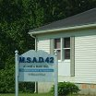
The two school sites are used for a variety of student activities. The Fort Street School has a playground, an outdoor basketball court, two outdoor volleyball courts, a world fitness center, and a multipurpose athletic field. The Junior-Senior High School includes a baseball field, softball field, three soccer fields, large agricultural field used by the FFA for crop production, and 40-acre forested area which is used for wood lot management.

Other District facilities include a 1,628 square foot central office building and 2,240 square foot, 2-story storage facility. Located adjacent to the high school, these facilities were completed in 1988 and 1989, respectively.

While the District has addressed two of priorities expressed in its current Comprehensive Plan, a regulation softball field and paving needs at the High School, development of a greenhouse for use by the science and agriculture departments at the high school has not been achieved.

Figure 62. Fort Street Elementary School Enrollment
 | Pre-K | K  Grade | 1st Grade | 2nd Grade | 3rd Grade | 4th Grade | 5th Grade | 6th Grade | Total
1989ª | 0 | 27 | 29 | 28 | 35 | 37 | 35 | 24 | 215
2006 | 20 | 34 | 29 | 27 | 28 | 16 | 27 | 30 | 211
2007 | 28 | 24 | 35 | 26 | 262 | 30 | 17 | 30 | 216
2008 | 30 | 27 | 26 | 31 | 24 | 26 | 31 | 15 | 210
2009 | 19 | 35 | 29 | 32 | 36 | 21 | 27 | 32 | 231
2010 | 33 | 21 | 40 | 30 | 35 | 39 | 28 | 27 | 253
2011 | 26 | 36 | 19 | 38 | 30 | 30 | 40 | 31 | 250
2012 | 29 | 30 | 26 | 16 | 26 | 20 | 30 | 27 | 204
ª – In 1989, Fort Street Elementary School included Pre-K through 8th Grade. Total in chart includes enrollments from Pre-K through 6th Grade.
Source: SAD #42 Superintendent’s Office, 2012

Enrollments at the Fort Street Elementary School have declined over the past seven years, though they are relatively consistent with enrollment figures for 1989. Preliminary figures for the 2011-2012 school year indicate that 229 students are enrolled in Pre K through 6th Grade, a 12.3% increase from the previous year.

Figure 63. Central Aroostook Junior-Senior High School Enrollments
 | 7th Grade | 8th Grade | 9th Grade | 10th Grade | 11th Grade | 12th Grade | Total
1989ª | 24 | 21 | 20 | 18 | 26 | 33 | 142
2006 | 30 | 46 | 39 | 47 | 23 | 45 | 230
2007 | 42 | 28 | 44 | 38 | 41 | 23 | 216
2008 | 34 | 35 | 28 | 45 | 36 | 37 | 215
2009 | 20 | 31 | 36 | 26 | 46 | 27 | 186
2010 | 41 | 22 | 35 | 43 | 28 | 40 | 207
2011 | 33 | 41 | 29 | 35 | 34 | 29 | 201
2012 | 31 | 34 | 40 | 27 | 32 | 31 | 195
ª – In 1989, the Central Aroostook Junior-Senior High School included Grades 9-12. The total in this chart includes enrollments from Grades 7 and 8 that were then housed at the Fort Street Elementary School.
Source: SAD #42 Superintendent’s Office, 2012.

Enrollments at the Aroostook Junior-Senior High School have declined significantly over the past seven years, though the current enrollment level is higher than it was in 1989. Preliminary figures for the 2011-2012 school year indicate that 196 students are enrolled in Grades 7 through 12, essentially the same as in the previous school year.

Figure 64. NWEA Achievement Status and Growth Summary Report Results, SAD #42, 2008-2012
 | 2008-2009 % |  |  | 2009-2010 % |  |  | 2010-2011 % |  |  | 2011-2012 %
Grade | Reading | Math | Lang | Reading | Math | Lang | Reading | Math | Lang | Reading | Math | Lang
3 | 33.3 | 36.4 | 30.3 | 33.3 | 75.9 | 39.3 | 60.7 | 43.3 | 66.7 | 38.7 | 21.9 | 29.0
4 | 50.0 | 57.9 | 42.1 | 75.0 | 62.2 | 74.3 | 64.3 | 60.7 | 71.4 | 50.0 | 67.9 | 48.1
5 | 39.1 | 34.8 | 39.1 | 70.8 | 66.7 | 83.3 | 56.8 | 57.1 | 58.3 | 48.4 | 33.3 | 58.1
6 | 42.9 | 37.0 | 29.6 | 48.0 | 72.0 | 88.0 | 53.8 | 61.5 | 66.7 | 60.0 | 51.4 | 54.3
7 | 25.0 | 40.0 | 21.4 | 41.4 | 40.2 | 59.0 | 17.2 | 48.3 | 46.7 | 64.0 | 23.1 | 73.1
8 | 30.7 | 25.0 | 41.9 | 43.8 | 50.0 | 33.3 | 28.9 | 37.8 | 44.4 | 85.2 | 44.4 | 71.4
9 | 38.7 | 34.8 | 38.7 | 55.2 | 73.1 | 57.1 | 65.2 | 52.2 | 43.5 | 94.1 | 67.6 | 53.1
10 |  |  |  | 21.5 | 81.3 | 82.1 | 84.4 | 66.7 | 74.2 | 66.7 | 52.4 | 52.4
Note: Shaded area indicates test results exceeded District’s 55% goal.
Source: Northwest Evaluation Association, 2008-2012

Each year, the State administers the Northwest Evaluation Association (NWEA) assessment Test to students in the 4th, 8th, and 11th grades. The Fort Street School scored below the state averages in reading in 2011-2012. The Junior- Senior High School continued to improve its performance in critical reading and mathematics over the two previous academic years, but still score below the state average. Scores in writing and science were the same as the previous year, still below the state average. Overall, the District consistently exceeded its 55% goal in reading in all grades and exceeded its goal in math and language in some grades.

Figure 65. MSAD #42 Enrollment Projections for Fort Street Elementary School
Year | Pre K | K | 1 | 2 | 3 | 4 | 5 | 6 | Total
2013 | 28 | 31 | 29 | 27 | 18 | 27 | 22 | 30 | 212
2014 | 31 | 31 | 32 | 30 | 28 | 19 | 28 | 26 | 225
2015 | 30 | 34 | 30 | 30 | 31 | 27 | 18 | 18 | 218
2016 | 26 | 33 | 33 | 31 | 29 | 29 | 26 | 28 | 235
2017 | 19 | 29 | 32 | 33 | 29 | 31 | 30 | 27 | 230
2018 | 24 | 22 | 28 | 31 | 31 | 31 | 30 | 29 | 226
2019 | 26 | 26 | 21 | 29 | 30 | 32 | 30 | 29 | 223
2020 | 27 | 28 | 25 | 20 | 27 | 31 | 32 | 28 | 218
2021 | 25 | 31 | 27 | 24 | 21 | 28 | 32 | 33 | 221
Note: Based on annual averages of past 10 years.
Source: SAD #42 Superintendent’s Office, 2012.

Figure 66. MSAD #42 Enrollment Projections for Junior-Senior High School
Year | 7 | 8 | 9 | 10 | 11 | 12 | Total
2013 | 28 | 32 | 35 | 40 | 28 | 33 | 196
2014 | 32 | 30 | 31 | 36 | 39 | 29 | 197
2015 | 21 | 33 | 32 | 30 | 34 | 40 | 187
2016 | 27 | 20 | 32 | 30 | 31 | 34 | 175
2017 | 18 | 28 | 22 | 31 | 31 | 32 | 162
2018 | 27 | 19 | 29 | 21 | 32 | 30 | 158
2019 | 31 | 28 | 22 | 27 | 22 | 32 | 162
2020 | 30 | 32 | 30 | 21 | 26 | 21 | 157
2021 | 29 | 29 | 30 | 29 | 21 | 27 | 165
Note: Based on annual averages of past 10 years.
Source: SAD #42 Superintendent’s Office, 2012.

Figure 67. School Enrollments & Projections, 2006-2021
Source: SAD #42 Superintendent’s Office, 2012.

The Superintendent’s Office provided simple projections of school enrollments, based on an average of the past 10 years. These projections suggest that elementary school enrollment will grow from 2012 levels, but will be less than 2011 levels. They also suggest that junior-senior high school enrollments will continue to decline below 2012 levels. While these are not scientifically generated futures, they reflect the general trend of the last seven years.

During the last ten years, major capital improvements were completed in both school buildings. All lighting fixtures were retrofitted with low energy fluorescent lights and motion sensors manage all gymnasium lighting. In addition, the floors in both gymnasiums were sanded and refinished and the bleacher seating was completely refurbished.

In the Junior-Senior High School, the underground heating oil tank was replaced with an EPA compliant tank that is monitored and inspected annually. In addition, the two oil fired boilers were replaced with new high efficiency boilers. Both flues were replaced at the same time. Domestic hot water was also supplied to the kitchen through two on-demand LP gas hot water heaters to allow the boilers to be shut down in late April until mid-October. The main entrance doors at the Junior-Senior High School were been replaced, which greatly reduces heat loss and improves energy efficiency.

The infrastructure in all school buildings should be positioned to meet the District’s educational needs for the next 10-15 years with general maintenance.

Several years ago, the District joined efforts with several members of the community to install state of the art field lighting on one of the District’s soccer fields. The field is situated in such a way that vehicles can park and spectators can watch form the comfort of their vehicles. It has become a community focal point during the fall soccer season.

- Private Schools

There are four nursery schools in Mars Hill. The largest is operated in the former high school building which is now the Town’s Community Center. A private nursery school operator rents space in the former school from the Town and serves between 15 and 20 children. Another private operator serves 7 to 8 kids in a Fort Street nursery school. A new nursery school recently opened on Boynton Street and serves 3 to 4 children. There is also a small nursery school on Silver Street.

Mars Hill’s Head Start Program is operated out of the Town’s grade school on Fort Street.
Mars Hill also hosts Northern Lighthouse, a small residential care facility for children that require out of home placement. In 2012, Northern Lighthouse employed 85-90 employees and offered the following services to assist families and children that have varying disabilities – Home and Community Treatment, Case Management, Residential Treatment, Outpatient Therapy, and Section 28 Services.

- Highway Department

Since adoption of the current Comprehensive Plan, the Highway Department acquired the following equipment:
- International Wheeler all season sander body for the 1989 plow truck (1995)
- Converted old stainless steel sander from wheeler to single axle truck to apply salt/calcium to plow town streets, reverse-a cast plow to improve plowing capacity in (1995)
- Caterpillar loader to replace 1967 Hough Loader with new Caterpillar Loader (1996)
- Snow blower that attaches to the bucket on payloader to open and widen roads; also completed major overhaul on grader (1998)
- 2002 single axle plow truck, designed for urban area of town (2001)
- New sand/dump body for 1995 plow truck (2004)
- New plow truck (2007)
- New pickup truck and plow (2010)
- New plow (2013)
- New grader (2013)
New equipment needs include:
- New loader in 2021, approximately cost of $200,000
- New plow in 2022, approximately $200,000

The Town Garage, located on the West Ridge Road, is actually a structure relocated from the Loring Air Force Base. It is not in good shape and will need to be upgraded or replaced in the next five to ten years. The cost estimate for its replacement in 2015 is $850,000.

The following improvements have been made to the Town Garage since adoption of the current Comprehensive Plan:
- Connecting the Town Garage to the public sewer system to meet DEP/EPA mandates for floor drains (2003)
- New hot air furnace for Town Garage (2003)
- Replaced furnace in Town Garage (2010)
According to the state, the Highway Department needs a salt shed, estimated to cost $200,000, though it is not required to provide it until the state provides funding for a new facility.

- Municipal Buildings

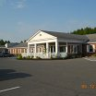
In 2005, the Town Office moved from West Ridge Road to 37 Main Street to take advantage of the availability of the former People’s Heritage Bank building. The building is in fair condition and is expected to meet the Town’s needs for the foreseeable future.
In 2011, a new electronic sign was installed at Town Office to help improve communications about town activities. A new town website was also developed to actively promote Mars Hill and expand the ability of residents to communicate with Town officials.

- Health Care Facilities

The Mars Hill Health Center, next to the Mars Hill Pharmacy on Main Street, joined The Aroostook Medical Center in July, 1996, when it was known as the Mars Hill Primary Care Center. This convenient location offers patients easy access and patient privacy.

The Aroostook Health Center, located on Highland Avenue, provides long-term care and rehabilitation services to 72 residents. The staff takes a holistic approach to providing care. This includes creating a plan of care that fits the unique needs of every resident, including the physical, mental, emotional, social, and spiritual aspects of health.

The Center’s Rehabilitation Program allows residents to relearn activities of daily living, recover sooner, and regain the ability to care of themselves upon returning home. Rehabilitation services help bridge the gap between hospital and home. The Center also cares for residents who can no longer perform everyday tasks.

- Communications

The Town’s contract with Frontier Vision for cable service was negotiated in 1998. The contract extends until 2013.

- Cemeteries

There are a number of cemeteries in Mars Hill, including:
- Kings Grove on Bell Hill Road,
- Pierce on Fort Road, and
- Snow, the oldest cemetery in Town, on Clark Road.
The town has budgeted significant funds over the past several years to straighten and reset stones as part of a maintenance push.
In 2002, the Highway Department installed 500 gallon water tanks at both King’s Grove and Pierce cemeteries.

- Social Services

Mars Hill has an active Meals On Wheels program which is operated through the Aroostook Agency on Aging. There is a local coordinator. Hot meals are prepared at the Nursing Home five days per week. The Agency attempted to move to a frozen meal program several years ago but local folks who deliver and operate the program would not hear of it. Hot meals and personal daily contact are now subsidized by private citizens.
The Community Food Cupboard and WIC program operate out of the Town’s Community Center. Counseling services are available through the health center or the Aroostook Medical Center. The Aroostook Community Action Program (CAP) is active in Mars Hill.

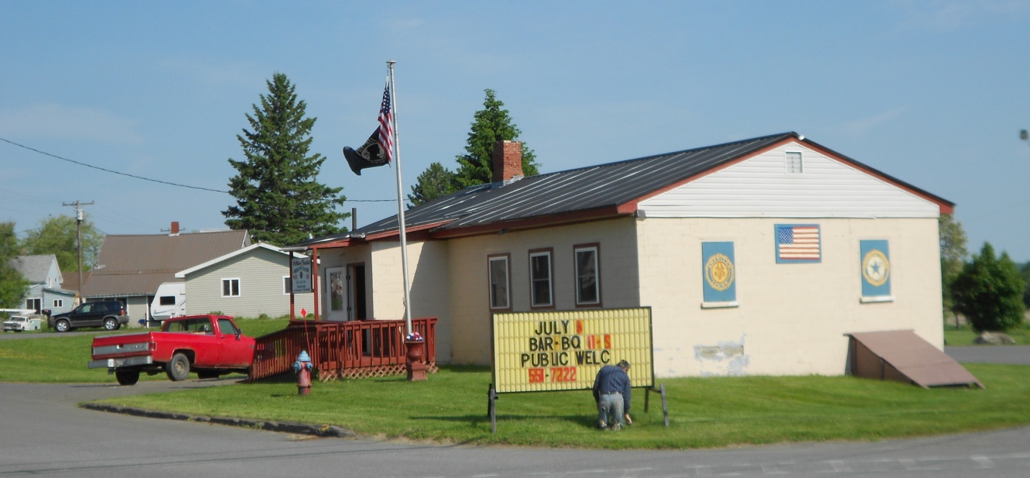
- Energy


In 2003, Evergreen Wind Power proposed to locate a 28- turbine, 50 megawatt wind farm on Mars Hill Mountain, the first utility scale wind project in New England. In 2005, the Town Council approved a tax increment financing (TIF) district agreement to help finance the facility. In 2006, Evergreen Wind Power completed a $50 million plus wind farm on Mars Hill Mountain. See discussion about tax benefits of the facility in the Fiscal Capacity Chapter. The TIF with First Wind, the current owner of the facility, expires in 2024.
High energy costs put Mars Hill and the region at a disadvantage in maintaining and attracting businesses with high energy demand, such as back room computer services. If the Town can develop ways to work with First Wind and others to reduce energy costs to benefit local businesses and homes, this disadvantage might be transformed into a competitive advantage. This opportunity may require changes to state utility law.
In addition to opportunities with wind power, the Town might look to opportunities provided by access to compressed natural gas. McCain’s potato processing plant in Easton is in the process of converting to compressed natural gas, bringing six trucks through Mars Hill daily. Similar changes may be in store for other potato processors like Naturally Potatoes in Mars Hill.

- Issues and Implications

- Before 1994, Mars Hill employed a community or economic development director, who was very successful in securing grants to replace or provide public infrastructure and facilities. Should the Town re-create this staff position or is current staffing adequate?

- There has been some discussion about the desirability of a local police presence. In recent years, some counties have identified and located an officer in a specific community in direct response to municipalities’ request for assistance. The communities pay for the service without the need to create an entirely separate department. Should the Town explore the pros and cons as well as various alternative arrangements, including working with the County, to provide a local police presence?

- It appears that the Town Garage may be in need of replacement. In addition, the Town does not have a salt shed. Are there other public facility needs? Should the Town undertake a study of facilities and yards to identify and prioritize building and improvement needs?

- Apart from encouraging residential development, what can the Town do to stem the decline in school enrollments? A number of options were identified in other chapters of this inventory that might come into play in this discussion.

- Are there gaps in the mix of health care professionals and services in Mars Hill? How might the Town best draw key individuals to the community?

- What elements or concerns should be addressed in negotiating the upcoming contract with Frontier Vision?

- Should the Town explore opportunities for MH to expand access to wind power and/or compressed natural gas, including ways to reduce the cost of energy for existing and new businesses?

The adjusted rate is the base rate plus a credit for returnable beverage containers.
Tax increment financing, or TIF, is a financing mechanism available to Maine municipalities and the Unorganized Territory to capture and leverage new property taxes within a district and invest part of all of those taxes into locally-approved activities and projects to provide new employment opportunities, improve and broaden the tax based, and improve the general economy of the State. Each district and related development program requires approval of the local legislative body and may include a credit enhancement agreement (CEA) between the eligible entity and a company or developer. Following approval by council, town meeting, or commissioners, the state Department of Economic and Community Development (DECD) reviews the proposed district and development program for statutory compliance. After approval by DECD, management of the district and program is the sole responsibility of the eligible entities.
The term of the TIF was 20 years, expiring in 2025. As part of the TIF, the Town bills First Wind annually and keeps $500,000 of the revenue paid by First Wind, which is used to “enhance” the tax rate. The Town then cuts First Wind a check for the remainder, which is used to pay down the debt service for the project.

