SECTION 4. TRANSPORTATION

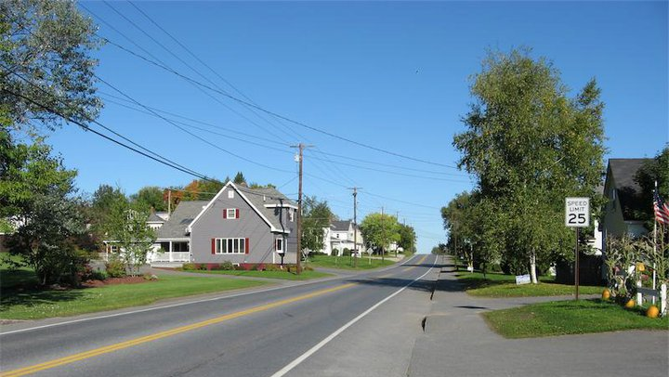

- Mars Hill Transportation
Figure 48. Mars Hill Transportation
Figure 49. Accidents
State Highways, Route 1 and Route 1A, continue to make up 9.02 miles in Mars Hill.

State Aid Highways have decreased mileage from 13.39 to 8.1 miles, continuing to include Boynton Road, West Ridge Road, and Westfield Road. Since 1992, a portion of East Blaine Road became a state aid highway and East Ridge Road became a local road.

Local roads, maintained entirely by the Town, have increased mileage from 23 to 27.78 miles.

The Legislature has discussed an extension of I 95 from Island Falls to Fort Kent, bypassing Mars Hill, for some time. While Senator Collins secured funds to extend the interstate, construction plans for the Presque Isle/Caribou corridor were required to undergo an environmental impact assessment (EIS). The EIS found that a 2-lane, much less a 4-lane, controlled access road is not needed and recommended improved access management in the corridor between the two communities. Segments 9 and 11, which would bypass Mars Hill, have been postponed for lack of need and federal funds. There is no reference to extension of I 95 in the State’s 2010-2015 Multimodal Six-Year Transportation Capital Improvement Plan.

Figure 50. Route I 95 Extension Proposals, Federal Environmental Impact Assessment

- Accidents
Figure 51.Crash Locations in Mars Hill, 2008-2010
MDOT Code | Locations | # Accidents
Node ID 8376 | Route 1 | 6
Node ID 8372 | Route 1 | 1
Node ID 8378 | Route 1 | 1
Node ID 8374 | Route 1 | 1
Node ID 8579 | Route 1A | 1
Node ID 8581 | Route 1A | 1
Node ID 8586 | Route 1A | 1
Node ID 8822 | Route 1A | 1
Element 181839 | Route 1 | 12
Element 182100 | Route 1A | 3
Element 178168 | West Ridge Road | 3
Element 178171 | Route 1A | 3
Element 178176 | West Ridge Road | 3
Element 181844 | Route 1 | 3
Element 181849 | Route 1 | 3
Element 182096 | Route 1A | 3
Element 182102 | Route 1A | 3
Element 182248 | Route 1A | 3
Source: Maine Department of Transportation

There were 53 accidents in Mars Hill between 2008 and 2010. All but 6 of the accidents were on Route 1 or Route 1A.

There were 9 accidents at intersections with Route 1, all but 1 in the core of the community south of the intersection with Route 1A. There were also 12 accidents along the length of Route 1 in the same area. Another 6 accidents occurred on Route 1 close to the town boundary with Westfield. There were 4 accidents at intersections with Route 1A, 3 south of the intersection with West Ridge Road and 1 at the intersection with Smith Road. There were also 15 accidents along the length of Route 1A, 12 between the intersection with West Ridge Road and Smith Road and 3 south of West Ridge Road. There were 6 accidents along the length of West Ridge Road. None of the accident locations meet the Maine Department of Transportation’s (MDOT) criteria to be designated a High Accident Location.
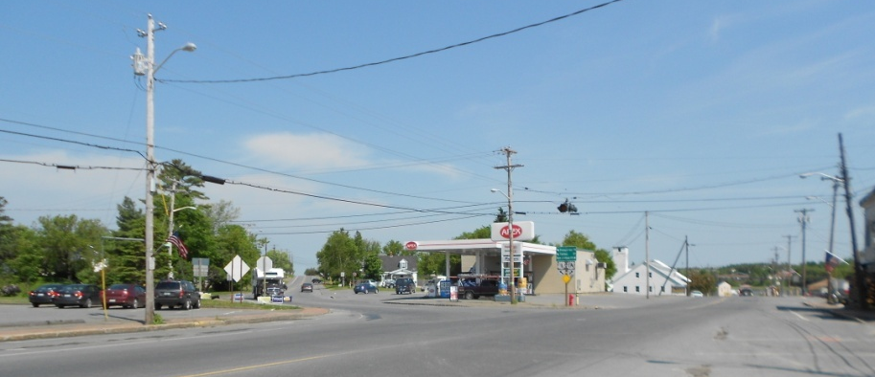

- Road Conditions

The Town invests approximately $50,000-$ 100,000 a year in roads. Many Town roads are in good and some are in very good condition. There are several gravel roads in Town that require constant vigilance. Mountain Road, the road behind Mars Hill Mountain, requires regrading and new gravel each year. White Road, running from West Ridge Road to Rt 1A toward Easton, is also requires regular regrading. Clark Road is unpaved and is fairly rough, which helps reduce travel speeds. Both Clark and White roads become very soft in the spring and in some years, Clark Road has to be closed for a while. There is also a short gravel road between West Ridge Road and Rt 1A, near the Town Garage and East Ridge Road that often needs attention and regrading. Field Road, which also runs between West Ridge and Rt 1A, is a seasonal road that is not kept open in winter except for a small section for two homes near West Ridge Road.

Figure 52. Mars Hill Road Conditions
Street Name | Date Rebuilt | Comments
POOR CONDITION
Ackerson Road |  | Discontinued field road
Clark Road | 1994 | Needs rebuilding, gravel road breaks up badly in spring, closed some years, requires improvement in sections with homes
Cross Road |  | Needs overlay, short 100 yard connector of Rt 1A to West Ridge Road, needs reconstruction and paving
Nutter Street | 2000 | Town hot top
POOR TO GOOD CONDITIONS
Silver Street | 1996 | CDBG/storm drains and sidewalk resurfaced 2008, south half Good/north half Poor (not crowned)
FAIR CONDITIONS
Field Road | 1998 | Partial rebuild/discontinued field road
Industrial Street | 2000 | Top gravel added
Mill Street | 2000 | Town hot top over binder
Rideout Lane |  | Private road, 150 feet
FAIR TO GOOD CONDITION
Fort Road | 1998 | State resurfaced in 2008, south section Good, north section beyond pallet factory Fair
Kearney Road | 2006 | Resurfaced sections 2003 and 2006, 1 mile overlay in south in 2012, Good in south, Fair in north
GOOD CONDITION
ACI Street | 1992 | CDBG/storm drains and sidewalk
Adelmen Street | 2008 | Hot top length of Park
Bell Hill Road | 1994 | Resurfaced in 2011
Benjamin Street | 2003 | State rebuilt
Boyd Road | 2000 | Town rebuilt gravel in 2008
Boynton Road | 1996 | State overlaid; possibility State may return to Town
Boynton Street | 1996 | State resurfaced in 2009; possibility State may return to Town
Church Street | 2005 | Resurfaced but patched from sewer/water work in 2012
Country Club Road | 2000 | Town hot top/resurfaced 2009
East Blaine Road | 2000 | Town hot top/overlaid 2007
East Ridge Road | 1998 | State overlaid
Fletcher Road |  | Gravel road, little use
Gilman Street | 1995 | Town hot top overlaid in 2010, patched for sewer/water work
Graves Road | 2000 | Rebuilt with hot top/overlay 2007
Grove Street | 1991 | CDBG/storm drains and sidewalks
Hallett Street | 2006 | Hot top, overlaid in 2011
Hansen Street | 1980 | Resurfaced in 2002
Hawksley Road | 1997 | Town rebuilt/gravel, little used field road
Highland Avenue | 2000 | CDBG/storm drains and sidewalks
Hillside Street |  | Private ownership
Lincoln Street | 1995 | Town hot top
Main Street |  | State road/sidewalks need work, patched, state plans to repave Main Street from Blaine to north end of Town possibly in 2015-16
Main Street/US 1 |  | Overlaid in 1998, need sidewalks, see note above
Maple Street | 1981, 1993, 1997, 2006 | Resurfaced in 2006
Market Street | 1994 | Town hot top/resurfaced in 2004
Miller Street | 1995 | Town hot top
Mt. View Street |  | Private ownership
Mountain Road | 1994-1998 | Town rebuilt, gravel 2008-09
Orser Street |  | Private ownership
Park Street | 2000 | Town hot topped over binder in 1995
Pleasant Street | 2005 | Resurfaced, patched for sewer/water work
Presque Isle Road | 1995 | State rebuilt
School Street | 2002 | Rebuilt/storm drains and sidewalks, overlay in 2009
Scovil Street | 1998 | Town hot topped/resurfaced 2008
Shaw Street | 2001 | Town hot topped/resurfaced 2008
Smith Road | 2000 | Town rebuilt/gravel
Sylvester Street | 2001 | Town hot topped/resurfaced 2008
Tower Road |  | Private road, rebuilt 2006
US 1 North |  | State Highway
West Ridge Road |  | State overlaid in 2012, possibility State may return to Town
Westfield Road |  | State overlaid in 2012, possibility State may return to Town
White Road | 2000 | Town rebuilt/gravel 2009, breaks up badly in spots in spring
York Street | 1986 | Overlaid in 2010
Source: Town of Mars Hill, 2013

- Bridges

There are five bridges in Mars Hill, three are owned and maintained by the State. These bridges include the bridge over the:
- Prestile Stream on Route 1A near the intersection with Route 1,
- Rocky Brook on Boynton Road, and
- Tributary to Prestile Stream on Route 1 at the Town boundary with Westfield.

The Town is responsible for maintaining the Rocky Brook Bridge (Kings Grove) on East Ridge Road and Customs House Bridge (two culverts) which spans the Gizoquit Brook in the northwest area of the community. This bridge formerly served a Customs House, which has been removed. Currently, the bridge crosses Gizoquit Brook to a gated roadway that leads to a single family home in Canada.

Figure 53. Condition of Bridges in Mars Hill
Bridge | Condition | Comments
Prestile Stream on Route 1A near the intersection with Route 1 | Satisfactory | Abutment spalling under beams
Rocky Brook on Boynton Road | Good
Rocky Brook on East Ridge Road | Fair
Tributary to Prestile Stream on Route 1 at Town boundary with Westfield | Fair | Slab spalling with exposed rebar  Spalling of wings
Customs House Bridge which spans the Gizoquit Brook | Serious | Pipes are distorted
Source: Maine Department of Transportation, 2012

The Town’s Customs House Bridge is in poor condition.

- Airport

There is a privately owned airport in Mars Hill on the West Ridge Road which is used for light aircraft and other flying craft on occasion. It is available for public use at the user’s own risk. The airport is registered with the Federal Aviation Administration.

- Rail

Figure 54. Maine Railroad Network
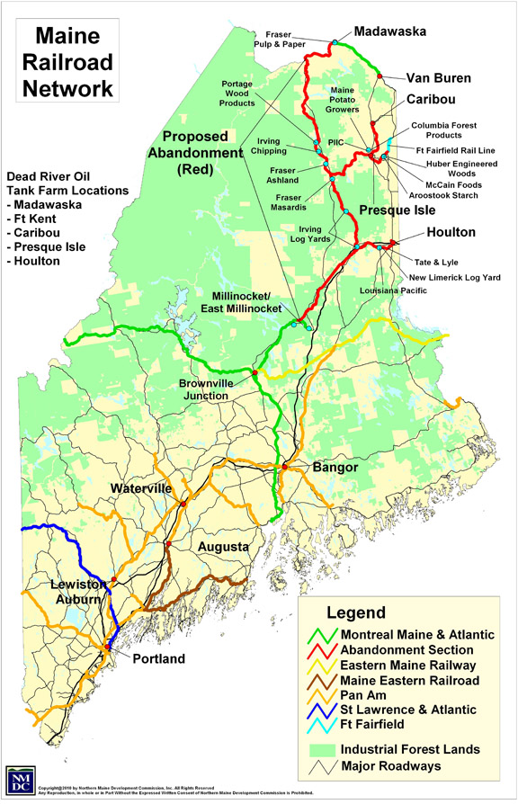
The State of Maine recently purchased the Montreal, Maine and Atlantic Railway, LTD (MMA)to avoid its discontinuation and to continue to provide dependable transportation of products into and from the Aroostook region. According to the Due Diligence Report: Montreal, Maine & Atlantic Railway, prepared for MDOT in 2010, if the State can provide consistent and reliable service, the rail line operations, upon which the forestry industry depends, can be profitable. Based on a conversation with Rob Elder, Director of Freight and Rail for MDOT, the State has arranged for the Northern Maine Railroad (NMR, an Irving company) is operating what is left of the MMA line and is providing considerably improved service. NMR is reliably running 100 car trains 4 times a week. While currently the primary user of rail transport is the forestry industry, the State’s goal is to encourage more transport of agricultural products by rail.

While Figure 46 indicates a rail line parallel to the Prestile Stream, the Town’s 1992 Comprehensive Plan indicates that the Bangor & Aroostook tracks in Mars Hill were taken up in 1987 and the line does not appear on MDOT’s maps.

MDOT offers an Industrial Rail Access Program (IRAP) to encourage the development of access to rail. The program is a 50:50 match, with the State providing half and either the rail company or a manufacturer providing the other half of the cost of building spurs. Fort Fairfield participated in the program and though its project was not initially successful when the rail was owned by MMA, the State took back the line and it appears to be working well under NMR’s management. The State is about to announce another 10 projects and there will be other rounds in competition for State funds for this program.

- Pedestrian Ways

The 1992 Comprehensive Plan indicates that there are sidewalks on Main Street, Route 1A almost to the Town Office, Pleasant Street, York Street, ACI Street, Highland Avenue, part of Benjamin Street, and Grove Street.

To support Mars Hill’s brand as “the healthiest Town in the County” and improve traffic safety by slowing the speed of traffic and traffic noise and by encouraging more people to walk on Main Street, the Town might work with the Maine Department of Transportation to reduce the width of travel lanes and widen sidewalks in the town center. Slowing traffic and widening sidewalks would improve pedestrian safety and comfort and provide an opportunity to expand the street life and liveliness of Mars Hill’s Downtown.

There is a walking path from the High School to the base of the Mountain, though conditions are inconsistent along its pathway.

- Public Transit

Figure 55. Maine Transit Districts
The Aroostook Regional Transportation System, Inc. (ARTS) – provides service to Mars Hill. ARTS provides general public transportation throughout Aroostook County with service for each town to the nearest commercial center at least once a week. Services are available to all members of the general public and pick-up services are available for the elderly and handicapped.
There are two establishments in Mars Hill that either serve sizeable populations or employ a significant number of staff – the Aroostook Health Center and Northern Lighthouse. The Aroostook Health Center provides long term care and rehabilitation services for 72 residents and other out-patients. Northern Lighthouse employs 85-90 people who serve families and children with varying disabilities. Yet employees and families of those served by these facilities live in many other communities besides Mars Hill. According to Grow Washington-Aroostook Counties (Gro-WA), “Nearly 80% of people in Aroostook County drive alone and 8.6% carpool...The occupation and industry of workers in the region often require long commutes to jobs that are not conducive to carpooling… The ARTS transportation service does not meet the demands of persons who must attend medical appointments and therefore they must travel to and from appointments in single vehicle runs.” Gro-WA recommends that “ARTS should work with the region’s largest employees to develop schedules that accommodate employees living in outlying communities. At a minimum, ARTS should develop centralized drop-off and pick-up locations in the region’s service centers [Mars Hill is a service center.] and along transportation corridors. The development of Park-and-Ride lots should also be accomplished.” It also recommends that the MaineCare brokers and provider system needs to be improved to ensure that MaineCare clients are able to attend non-emergency medical appointments. Additional recommended actions include:
- Increase demand and use of public transit through better marketing of the service available in the region.
- Provide additional service from small, rural communities to the region’s service center.
- Obtain funding through the BoP process for capital improvements and infrastructure for ARTS.
- Seek alternative funding opportunities, such as the New Freedom grant, to provide service to non-traditional users of the system.
- Review schedules from service centers to employment centers and determine if van pooling/commuter services can be implemented and/or increased.
- Develop an “information highway” to facilitate services, scheduling, and ride-sharing.
Gro-WA also recommends that homebuyers consider home and work locations. Mars Hill’s demographic and economic strategies should include work with major employers to help provide information about the financial as well as the cultural and recreational benefits of both living and working in Mars Hill.
The Aroostook Health Center has a dedicated, wheelchair accessible, bus which is used daily for doctor's appointments, treatments, and activity trips (about twice a month, residents are taken to Presque Isle or Houlton for lunch, shopping, scenic drives, and other activities. This bus provides the primary share of patient travel, though some travel (about 10% of travel activities) is provided by family members. On rare occasions, patients have hired the Aroostook Regional Transportation System (ARTS) service for a small feel. Taxi service is generally not used by patients.

Many patients have mobility issues or medical conditions with require the specially equipped bus as well as patient handling lifts from the Health Center.

Employees of the Health Center travel to and from work, largely by individual vehicle. The Manager of the Health Center, Kelly Lundeen, has on occasion offered to coordinate schedules so that folks can car pool but there is little demand (two employees from Presque Isle do car pool). On rare occasion employees use a taxi when they are in a pinch.

Northern Lighthouse provides counseling and training for troubled families and children. Most of its 200 clients are located throughout Aroostook County and most of the services are provided in the home. While there are 90+ employees who live in communities ranging from Fort Kent to Houlton, most work in the field and come together in Mars Hill only once every month or two. Residential clients housed in Mars Hill include up to 6 young people, who are transported to local schools by Northern Lighthouse. Because of the problems faced by these clients, they are quite tightly controlled and supervised. Transportation, if needed, is provided by Northern Lighthouse. The only public transportation available to clients is the Aroostook Regional Transportation System or private taxi, which are not used to great extent.

On site staff include 12 to 18 people, depending on scheduling, who generally commute in individual vehicles. Monthly meetings gather staff from afar which makes car pooling difficult.
- Roads and Wildlife

Roads can be a hazard and barrier for terrestrial wildlife species moving across the land and to aquatic species traveling up and down streams. Wildlife needs to be able to freely move across the landscape and waterways to find food, mates, and different habitats and to adapt to range shifts as a result of a changing climate. Town road maintenance and construction projects (i.e., culverts) often inadvertently impede fish and wildlife passage. For more information on the effects of roads on wildlife visit: http://www.maine.gov/doc/mfs/fpm/water/docs/stream_crossing_2008/MaineStreamCrossingsPoster.pdf and http://www.beginningwithhabitat.org/pdf/Conserving_Wildlife_in_MDF.pdf.

- Issues and Implications

- Mars Hill is located at the intersection of two major transportation routes, Route 1 and 1A. While some traffic travels north on Route 11 to the East, most traffic uses the roads through our town. A major ATV and snowmobile trail goes through town also located on the old Bangor & Aroostook Railroad bed. Upon leaving Route 95 in Houlton and skirting the actual city of Houlton, the first major population the traveler sees coming north is Mars Hill. How can the Town capitalize on its position as a “Gateway to the Northern Aroostook?”

- If the State extends I 95 and bypasses Mars Hill, it will be important that the Town establish itself as a destination beforehand or it will lose the economic advantage that its current location on the highway system provides.

- Many Canadians come across the border at Bridgewater, up the back road, then along the front of the mountain to get north to Presque Isle, Fort Fairfield, and Caribou. They also follow this route to get to Mars Hill’s golf course, ski tow, and groceries. Many shop at Walmart in Presque Isle. However, the first mile or so, in Bridgewater, is a dirt road, rough, and muddy in wet weather. The road continues to be somewhat rough as it goes through Blaine. The poor condition of roads along this route may be a detriment to business. Should the Town work with Bridgewater, Blaine, and MDOT to improve this route and develop a consistent signage strategy to guide travelers to Mars Hill and other destinations along the route?

- MDOT indicates that the condition of the Customs House Bridge is “serious;” however, there is no longer a need for this bridge since it only leads to a blocked gate in Canada unless the Town is concerned about the damage to the culvert under the road from frost heaving.

- What can and should the Town do to promote use of the air strip as an economic asset?

- Should the Town work with local farmers to explore the value of a rail siding to provide access for Mars Hill’s agricultural products?

- Many younger people focus much of their recreational activity on walking, hiking, and biking. As part of promoting Mars Hill as the “healthiest place to live” should the Town invest in upgrading existing sidewalks and trails and constructing new ones to support efforts to cast the Town as a destination for incoming tourists and travelers?

- What should Mars Hill do to encourage large employers to promote car pooling, improvement of services and use of ARTS, or other approaches to reduce the number of miles traveled in individual vehicles to access employment, goods, and services?

Grow Washington-Aroostook Counties, Component C: Housing and Transportation. 2014.

