SECTION 3. HOUSING

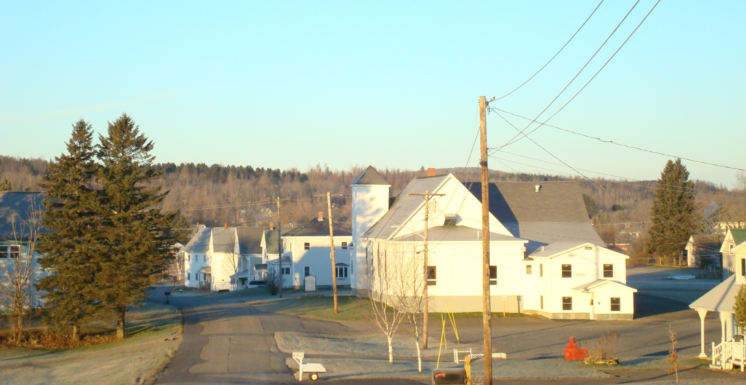

- Changes in Housing Stock

Figure 38. Changes in Total Housing Stock
 | Total Housing Units |  | % Change | # Change
 | 1990 | 2010 | 1990-2010 | 1990-2010
Blaine | 326 | 293 | -10.1% | -33
Easton | 560 | 458 | -18.2% | -102
Fort Fairfield | 1,614 | 1,602 | -0.7% | -12
Mapleton | 780 | 742 | -4.9% | -38
Mars Hill | 691 | 687 | -0.6% | -4
Presque Isle | 4,345 | 4,019 | -7.5% | -326
Westfield | 229 | 175 | -23.6% | -54
Aroostook County | 33,638 | 30,672 | -8.8% | -2,966
State of Maine | 550,431 | 551,125 | 0.1% | 694
Source: US Census

Figure 39. Changes in Total Housing Stock, 1990-2010

Source: US Census, 1990 & 2010
There were 687 housing units in Mars Hill in 2010, approximate 0.5% (4 units) fewer than in 1990. This loss of housing is comparable to the loss experienced in Fort Fairfield and the State of Maine and less than what Aroostook County and many surrounding towns have experienced.

There has been very little subdivision activity in Mars Hill in many years. In the mid-1990’s, the Town approved 9 residential lots off the Bell Hill/Country Club roads and another 3-4 residential lots north of the Bell Hill Road intersection with Country Club Road in the first decade of the 2000’s. In 2012, the Town approved a 14-lot subdivision off Clark Road.

- Selected Characteristics of Housing Units

Figure 40. Selected Housing Characteristics, 2010
 | Total Housing Units | Occupied Housing Units |  | Vacant Housing Units |  | Home owner Vacancy Rate | Rental Vacancy Rate | Year-round |  | Seasonal
 | # | # | % | # | % |  |  | # | % | # | %
Blaine | 360 | 299 | 83.1 | 61 | 16.9 | 4.2 | 14.0 | 342 | 95 | 18 | 5.0
Easton | 596 | 536 | 89.9 | 60 | 10.1 | 1.7 | 3.5 | 578 | 97 | 18 | 3.0
Fort Fairfield | 1,674 | 1,494 | 89.2 | 180 | 10.8 | 2.9 | 6.1 | 1,634 | 98 | 40 | 2.4
Mapleton | 864 | 816 | 94.4 | 48 | 5.6 | 1.7 | 4.0 | 854 | 99 | 10 | 1.2
Mars Hill | 687 | 614 | 89.4 | 73 | 10.6 | 3.5 | 5.2 | 461 | 97 | 22 | 3.2
Presque Isle | 4,608 | 4,201 | 91.2 | 407 | 8.8 | 2 | 8.5 | 4,540 | 99 | 68 | 1.8
Westfield | 240 | 216 | 90 | 24 | 10 | 1.1 | 0.0 | 231 | 96 | 9 | 3.8
Aroostook County | 39,482 | 30,672 | 77.7 | 8,810 | 22.3 | 4 | 8.1 | 34,083 | 86 | 5,399 | 13.7
State of Maine | 714,270 | 551,125 | 77.2 | 163,145 | 22.8 | 2.3 | 7.5 | 595,960 | 83 | 118,310 | 16.4
Source: 2010 US Census

Nearly all of Mars Hill’s housing stock is year-round (97%), which is essentially unchanged since 1990. This percentage is considerably higher than that of the County (86%). Owner occupied units represent the vast majority of the housing stock (nearly 90%). In 2011, Mars Hill had a vacancy rate of 4.6% for homeowners and 5.8% for renters.

Data on the number of housing units on public water and sewer were not available through the 2010 Census. Given the small number of new homes constructed since 1992, the 1992 figures for homes on public water (nearly 75%) and sewer (just over 70%) may still be fairly accurate.

The 2010 Census includes limited data about the type of structure. The six new housing units identified in 2006 were single family homes. In 1992, nearly 70% of all occupied housing units were single family; 7.5% were duplexes, and 17% were multifamily.

- Age and Condition of Housing

Figure 41. Housing Conditions, 2010
 | Total Dwelling Units | Lack Complete Plumbing |  | Lack Complete Kitchen
 |  | # | % | # | %
Blaine | 293 | 5 | 1.7% | 9 | 0.03
Easton | 458 | 0 | 0.0% | 0 | 0.00
Fort Fairfield | 1,602 | 15 | 0.9% | 20 | 0.01
Mapleton | 742 | 10 | 1.3% | 13 | 0.02
Mars Hill | 631 | 5 | 0.8% | 0 | 0.00
Presque Isle | 4,019 | 19 | 0.5% | 23 | 0.01
Westfield | 175 | 0 | 0.0% | 7 | 0.04
Aroostook County | 30,672 | 243 | 0.8% | 159 | 0.01
State of Maine | 551,125 | 4,915 | 0.9% | 4,890 | 0.01
Source: 2010 Census

The 2010 Census provided limited information about housing condition. Less than one percent of all housing in Mars Hill did not have complete plumbing facilities, which was comparable to the County as a whole in 2010. All housing in Mars Hill had complete kitchen facilities in 2010.
Figure 42. Housing - Age of Home by Tenure, 2010
 | Mars Hill |  | Aroostook County | Maine
 | # | % | # | #
TOTAL | 631 |  | 30,672 | 551,125
OWNER OCCUPIED | 343 |  | 22,116 | 402,907
Built 2005 or later | 25 | 7.3 | 408 | 13,266
Built 2000 to 2004 | 4 | 1.2 | 867 | 29,036
Built 1990 to 1999 | 23 | 6.7 | 2,108 | 57,429
Built 1980 to 1989 | 18 | 5.2 | 2,440 | 64,584
Built 1970 to 1979 | 33 | 9.6 | 3,957 | 59,968
Built 1960 to 1969 | 59 | 17.2 | 2,019 | 29,963
Built 1950 to 1959 | 28 | 8.2 | 2,455 | 30,388
Built 1940 to 1949 | 24 | 7.0 | 2,005 | 19,509
Built 1939 or earlier | 129 | 37.6 | 5,857 | 98,764
RENTER OCCUPIED | 288 |  | 8,556 | 148,218
Built 2005 or later | 0 | 0.00 | 89 | 3,375
Built 2000 to 2004 | 9 | 3.1 | 154 | 6,026
Built 1990 to 1999 | 0 | 0.0 | 581 | 12,633
Built 1980 to 1989 | 50 | 17.4 | 1,560 | 19858
Built 1970 to 1979 | 89 | 30.9 | 1,429 | 22,752
Built 1960 to 1969 | 47 | 16.3 | 685 | 10,958
Built 1950 to 1959 | 15 | 5.2 | 991 | 11,226
Built 1940 to 1949 | 3 | 1.0 | 604 | 8,172
Built 1939 or earlier | 75 | 26.0 | 2,463 | 53,218
Source: 2010 US Census

Figure 43. Age of Owner Occupied Housing

Source: 2010 US Census
More than half of Mars Hill’s owner occupied homes were built before 1960. Nearly another 20% was built between 1960 and 1969.
Figure 44. Age of Renter Occupied Housing

Source: 2010 US Census
Nearly half of Mars Hill’s rentals were built before 1970. Nearly another 20% of Mars Hill’s rentals were built between 1970 and 1979.

- Housing Affordability

Figure 45. Housing Affordability
 | Affordable at Median Income | Income Needed for Median Price | Median Sale Price | Average 2Bdr Rent with Utilities
Mars Hill | 83,659 | 16,398 | 44,500 | 493
Aroostook County | 101,305 | 27,810 | 80,000 | 594
State of Maine | 137,198 | 61,568 | 185,900 | 847
Source: Maine State Housing Authority
Based on the Maine State Housing Authority data, the current homeowner housing market is affordable for those households that have or exceed Mars Hill’s median income.
Today, there are approximately 11 houses for sale in Mars Hill ranging in price from $25,000 to $279,000. Houses that sell now are in the $80K to $140K range. In Presque Isle there are 70 houses on the market from $17K to $315K and in Fort Fairfield there are 33 houses for sale ranging from $28K to $370K. The higher priced home in Fort includes farm land.

While there are an adequate number of homes in Mars Hill that have an affordable purchase price, the Town is concerned about the cost of ongoing operation for many residents. Smaller, more tightly constructed homes will reduce the cost of heating during the long winter season and make the household more affordable for their residents.
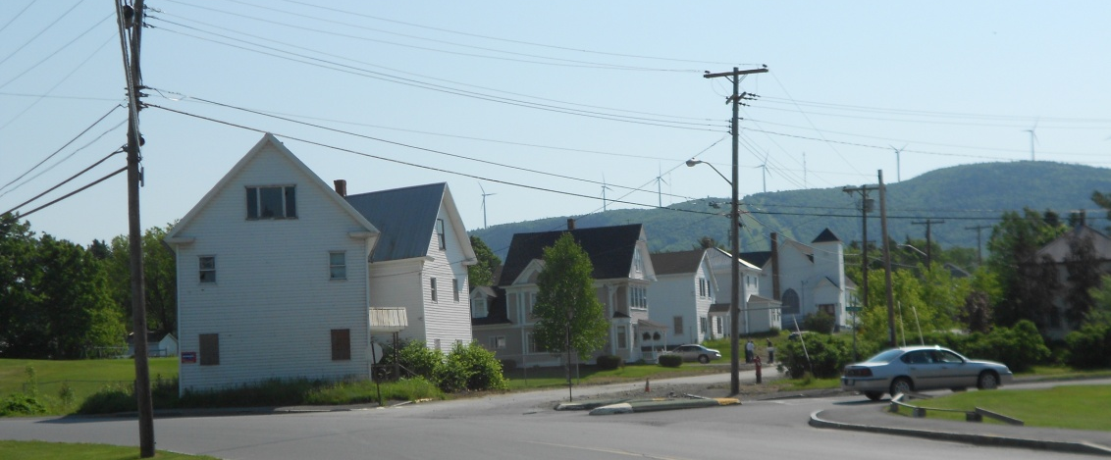

Figure 46.
The affordability of the rental housing market is another story. Nearly half of Mars Hill’s households (48.3%) were unable to afford the average 2-bedroom rent in 2008. While the median income of renters in Aroostook County increased by 9.2% between 2000 and 2009, the average rent for a 2-bedroom rental increased 38.1%.

Figure 47. Subsidized Housing Units, 2008
 | Mars Hill | Aroostook County | Maine
Disabled Units |  | 56 | 460
Family Units | 44 | 650 | 11,517
Housing Choice Vouchers | 29 | 886 | 11,369
Senior Units | 52 | 1,406 | 14,073
Special Needs Units |  | 47 | 1,846
Total | 125 | 3,045 | 39,265
Source: Maine State Housing Authority
There are 125 housing units that are subsidized in some fashion.

- Issues and Implications

- While the development of owner occupied housing has been fairly consistent from one decade to the next, there has been very little rental housing development since 1990. In fact, nearly 65% of the Town’s rental housing was developed between 1960 and 1990; another 26% of Mars Hill’s rental housing was developed before 1940. If Mars Hill wants to draw younger residents to the community, does it need to promote the development of additional, new rental units?

- Given the lack of affordable rental housing, should the Town encourage the development of additional rental units? How do unaffordable rents affect the Town’s interest in drawing and/or retaining younger residents? How can the Town assure that these units are built in areas served by public water and sewer? Should the Town undertake a study to assess how to best attract and provide for young residents who cannot afford a home, but who could afford a rental unit in Mars Hill?

- The lack of data on housing conditions makes it difficult to determine whether there is a need for resources to support housing rehabilitation. Would some type of low interest loan fund be useful? What about loan interest weatherization loans to tap into the County’s new wood pellet heating initiative and help reduce homeowners’ heating bills? Should the Town try to establish a renovation and/or weatherization loan program?

- If the Town wants to attract new professionals and other residents to Mars Hill, does it need to invest in housing rehabilitation and/or encourage new residential subdivisions? If so, how can the Town encourage the creation of new neighborhoods on public water and sewer close to downtown? There are few homes in the range of $80K to $140K available and there are few house lots. If a new business were to be attracted to our community, where could the employees build a home if they so wished? Should the Town encourage residential subdivisions in the area located between Benjamin Street (Route 1 toward Presque Isle) and Clark Road located to the west over a hill and generally parallel to Benjamin Street? Are there areas near downtown that might be appropriate for residential subdivision?

- There was discussion about the possibility of constructing a 55+ development made up of small energy efficient duplex ranches. Since the Town has an above average number of seniors, this might be an attractive opportunity. What might the Town do to encourage this development?

- If Mars Hill is interested in branding itself as the “healthiest place to live,” should the Town promote the development of new housing, owner occupied and rental, within walking distance of the community core and downtown?

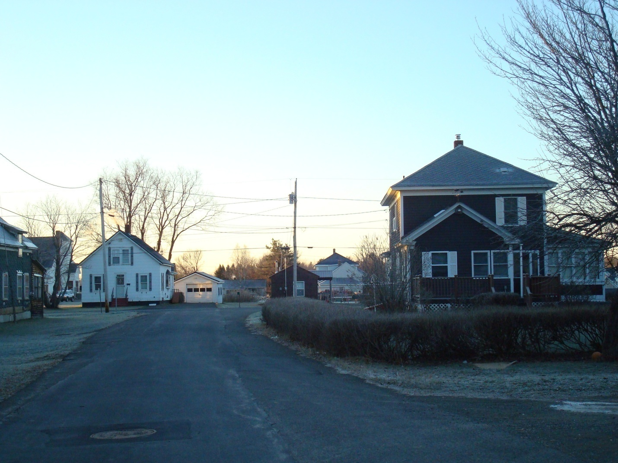

Mars Hill Comprehensive Plan Committee, 2012.

