SECTION 2. ECONOMY

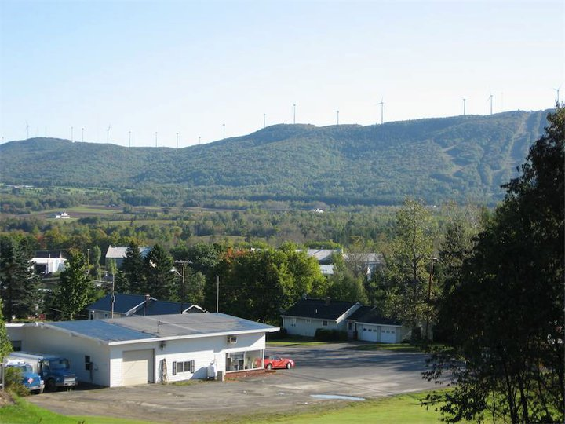

- The Regional Economy
Figure 17. Sources of Earnings by Selected Sector, Aroostook County and US, 2001
Sector/item | Earnings by industry ($1,000) | Share of earnings Aroostook | Share of earnings US
Farm earnings | $24,959 | 2.5% | 0.6%
Nonfarm earnings | $973,310 | 97.5% | 99.4%
Private earnings | $747,432 | 74.9% | 83.4%
Fishing, hunting, & trapping | $4,693 | 0.5% | 0.0%
Agriculture & forestry | $3,889 | 0.4% | 0.4%
Utilities | $1,963 | 0.2% | 0.2%
Construction | $38,359 | 3.8% | 6.3%
Manufacturing | $162,160 | 4.4% | 13.3%
Wood product manufacturing | $44,059 | 2.8% | 0.3%
Food manufacturing | $28,076 | 6.6% | 0.9%
Paper manufacturing 2 | $66,089 est.¹ | 6.6% | 0.5%
Wholesale trade | $33,133 | 8.9% | 5.3%
Retail Trade | $88,663 | 1.0% | 6.8%
Gasoline stations | $9,927 | 1.0% | 0.3%
Transportation & warehousing | $39,622 | 4.0% | 3.3%
Rail transportation | $2,787 | 0.3% | 0.2%
Truck transportation | $27,705 | 2.8% | 1.0%
Information | $30,173 | 3.0% | 4.5%
Finance & insurance | $26,261 | 3.6% | 7.4%
Credit intermediation | $24,507 | 2.5% | 2.2%
Real estate & rental & leasing | $5,755 | 0.6% | 1.8%
Professional and technical services | $24,240 | 2.4% | 9.2%
Management of companies | $12,307 | 1.2% | 2.2%
Administrative & waste services | $19,577 | 2.0% | 3.8%
Educational services | $1,872 | 0.2% | 1.2%
Health care & social assistance | $155,734 | 15.6% | 8.8%
Ambulatory health care services | $31,153 | 6.1% | 4.2%
Hospitals | $39,443 | 4.0% | 2.8
Nursing & residential care services | $35,456 | 3.6% | 1.1%
Social assistance | $19,682 | 2.0% | 0.7%
Arts, entertainment, & recreation | $1,760 | 0.2% | 1.2%
Accommodation & food services | $30,330 | 3.1% | 3.2%
Accommodations | $5,680 | 0.6% | 0.8%
Food services & drinking places | $24,650 | 2.5% | 2.4%
Repair & maintenance | $15,839 | 1.6% | 0.9%
Government & govt enterprises | $225,878 | 22.6% | 15.9%
Federal, civilian | $44,687 | 4.5% | 3.0%
Military | $8,663 | 1.9% | 1.3%
State & local | $172,528 | 17.3% | 11.6%
State government | $46,149 | 4.6% | 3.3%
Local government | $126,379 | 12.7% | 8.3%
¹ Employment and income for paper manufacturing in Aroostook County are not reported because there are too few firms to disclose the data. The 1997 Economic Census reported paper employment in the 1,000 to 2,499 range. While employment is certainly lower today because of known plant closings, dependence on these three sectors remains high. The earnings for paper manufacturing are estimated based on national averages of the earnings to employment ratio applied to the midpoint of estimated Aroostook employment.
Source: Planning Decisions, Inc. Aroostook County Economic Cluster Report; Part 1: Analysis; for Northern Maine Development Commission, 2003; US Department of Commerce, Bureau of Economic Analysis
Aroostook County is heavily dependent on natural resource based manufacturing, including its associated support structure and an aging population that has created a service economy dependent on transfer payments. Over 80% of manufacturing income and employment in the County is derived from paper, wood products, and food processing (13% for US as a whole). Aroostook is highly specialized and dependent on these industries. Combined, they provide 28% of all earnings in County (the national average is 5%).

Figure 18. Sales per Dollar of Payroll
Sector | Aroostook | US | Aroostook/US
Manufacturing | $7.14 | $6.72 | 106.3%
Food | $11.30 | $11.00 | 102.7%
Wood | $6.52 | $6.19 | 105.3%
Paper (estimated) | $6.76 | $6.76 | 100.0%
Source: Planning Decisions, Inc. Aroostook County Economic Cluster Report; Part 1: Analysis; for Northern Maine Development Commission. 2003; US Department of commerce, 1997 Economic Census

The sectors where Aroostook’s share of earnings exceeds that of the US are those with above average concentrations (bold in Figure 17). Sectors where Aroostook has some sort of competitive advantage relative to the rest of the US include wood products and paper (highest) and food processing (next highest).
This productivity data highlights the dilemma facing Aroostook County. To remain competitive in the increasingly global economy, Aroostook’s key industries must continually invest in new equipment. This often means replacing traditional jobs with machines and creating new, more highly technical jobs, that are generally fewer in number than the traditional jobs. In short, the core of the County’s economy cannot be counted on to provide a continuing supply of new jobs for the natural growth of the labor force. That task must be accomplished by related support businesses and entirely new businesses in entirely different sectors.
The second major characteristic of the Aroostook County economy is its aging population. Between 1990 and 2000, the County suffered a decrease in its working age population, an even greater decline in its future working age population (those under 18), and an increase in its elderly population that exceeded the national rate. Aroostook’s natural resource based industries and their support structures have not generated sufficient employment opportunities to maintain the population and, as a result, a supportive economy dependent on transfer payments, mostly medical, has developed to serve the aging population.
Aroostook County has had a long involvement in economic development efforts, since at least 1969. The Economic Development District Council (EDDC) was established by the Northern Maine Development Commission (NMDC) in 1992 to increase local involvement in forming and implement a Comprehensive Economic Development Strategy (CEDS). With assistance of the EDDC, the County developed a strategic plan and was designated a Rural Champion Community in 1999 and then an USDA-Rural Development Empowerment Zone (EZ) in 2002. The EDDC, now called the Northern Maine Empowerment Council (NMEC), is the central organizing force that ensures a cohesive and comprehensive strategic plan for the region, incorporating requirements of both the CEDS and EZ programs.
Recognizing that the County must address the major issues of outmigration, increasingly elderly population, and need to maintain the quality of life, in 2009, the NMDC updated its CEDS to provide a more holistic and integrated strategic plan, not just a focus on job creation/retention, but on all issues influencing economic growth (social services, healthcare, education, natural resources, Native Americans, youth services). The strategy calls for resources to be focused on four goals:
- Goal I – Support business success by creating an environment that supports the success of existing as well as new businesses,
- Goal II – Develop a well-educated and well-trained work force through educational and training opportunities,
- Goal III – Improve health and social services by providing comprehensive programs for the enrichment of all residents, and
- Goal IV – Steward Aroostook’s natural resources and way of life by balancing development with the need to protect valuable natural resources and the rural character of its communities.
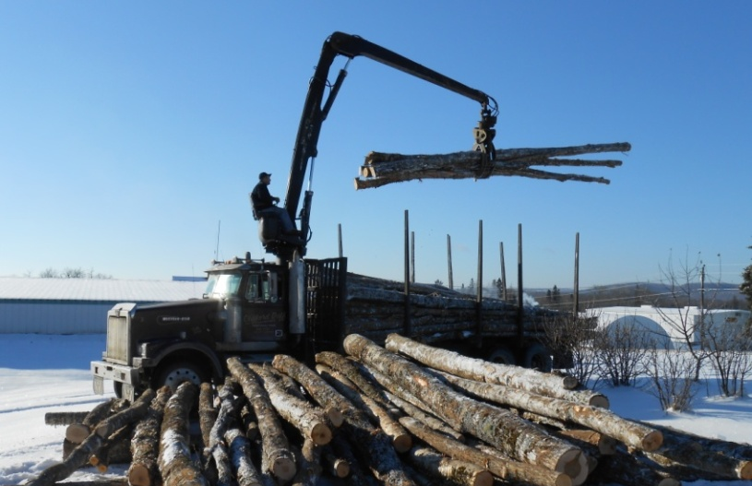
Much of Northern Maine’s potential for growth and sustainability lies in one of its five existing and potential economic clusters – forest products, agriculture, tourism, information technology/telecommunications, and precision manufacturing. From 2006 to 2008, 26% of the County’s significant business growth was related to woods products, 12% were call-center related, food processing associated, back office services, and military-related production/repair.
The forest products industry employs about 3,500 people in timber harvesting, lumber and paper mills, biomass plants, trucking and railroad transport, equipment and chemical supplies. The industry is at a down point in its economic cycle because of weak overall demand and international competition (largely from Canada). The bright spots are hardwood veneer production, panel products, and cedar wood products. In the short term, this cluster would be helped by cost relief and in the longer term, by strengthening the rail system and diversifying new products and markets.
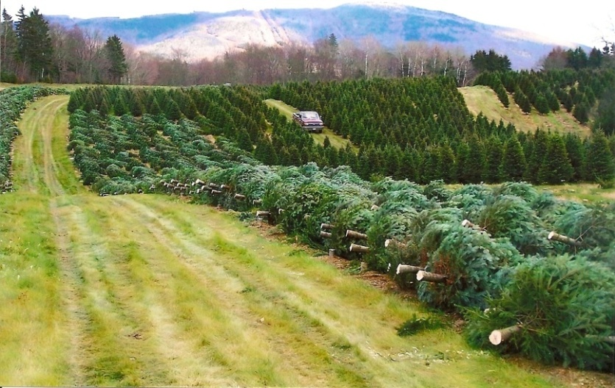
The agriculture cluster employs 3,000 on farms, in equipment and chemical supplies, wholesaling, transportation, and food processing. Nearly ¾ of production is in potatoes; the rest is in vegetables like broccoli and oats. Livestock, like beef, holds great promise. The County’s potato cluster could strengthen its competitive position by increasing irrigation, building new storage facilities, rotating crops and by adding new potato processors and diversifying the farm industry by increasing the production of organic products and beef. The food processing industry has invested heavily in modern equipment and increased productivity, while farmers’ investments vary widely depending on the operation. NMDC notes that if the approximately 400 growers now cultivating approximately 64,000 acres make a commitment to increasing their yields and growing the product their customers want, the industry can maintain its cluster of support businesses and look forward to a bright future.
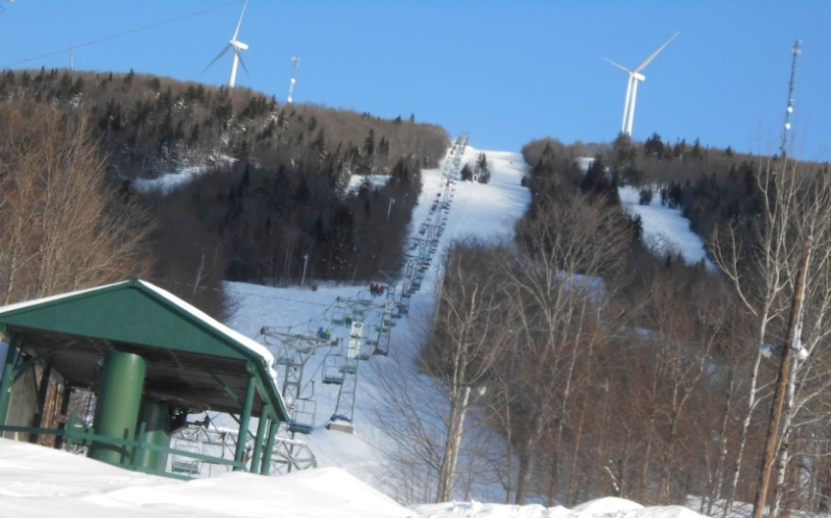
The tourism cluster provides thousands of jobs that create or enhance attractions (such as snowmobile clubs and festivals), lodging, food (restaurants), stores and services that support tourists (crafts, the Mall, fishing gear suppliers, gas stations, marinas, bait suppliers, sports equipment sellers/renters). About ½ million tourists take pleasure trips to the County each year – half for outdoor activities (snowmobiling, cross country skiing, bicycling, fishing, hunting). While fishing and hunting days declined in Maine between 1996 and 2001, nonresidential wildlife watching increased. Aroostook also attracts a significant number of people to family reunions, festivals, and fairs. Strategies to increase tourism include developing new destination attractions, cross marketing to existing tourists to come back during other seasons, drawing tourists from New Brunswick and Bar Harbor, and encouraging existing tourists to lengthen their stays. According to a 2003 Planning Decisions, Inc. study, Aroostook County Economic Cluster Report; Part 1: Analysis, Aroostook County Tourism is an effective regional group, but needs to become stronger in order to market effectively against competitors. To capitalize on opportunities for ski resorts and the summer outdoor dollar, Aroostook needs to become vertically integrated to provide advertising and trip packages that include lodging, food, activities, music and shows to maximize revenue in busy times and encourage visitors during less busy times.
A 2006 Global Resorts, Inc. Feasibility Study and Development Assessment found that the County has all the attributes for resort development and cluster like smaller projects. Mars Hill, located, is in the center of the County and at the gateway to Northern Maine and Aroostook County, is an ideal home base for those who come for outdoor activities. The Global Resorts study indicated that the Big Rock Ski Area, together with its nearby golf facilities, offers promising development opportunities if the hotel component can be addressed. Global Resorts suggests the associated development might take an international spin (Germany, Scandinavia, Europe).
The information technology (IT) cluster includes computer software and web design, database management, internet services, and data backup and disaster recovery services. Jobs in this cluster typically pay twice the average salary within the region and have the potential to be the region’s number 1 growth industry in the next decade.
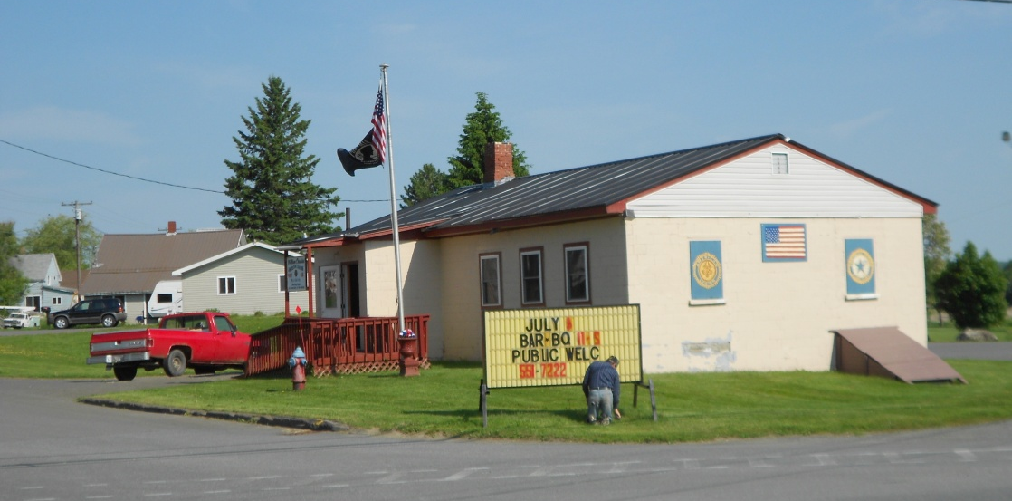

Figure 19. Three Ring Binder Project
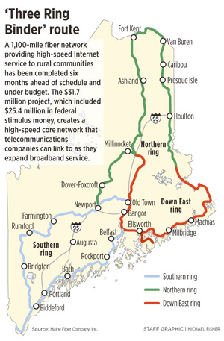
Source: Maine Fiber Company, Inc., 2010

The recently completed Three Ring Binder project created a 1,100 mile fiber optic network in Maine, including 91 miles in Aroostook County. The concept of the system is the creation of three redundant rings of fiber optic cable in Downeast, Southern (to New Hampshire), and Northern (Fort Kent to Danforth) Maine. This “last mile” of high-speed Internet infrastructure extended service and removed an obstacle to improving data transmission in many areas of the state. The physical backbone of the system consists of a ¾ inch black cable containing twelve squares of twelve fiber optic strands (a total of 144 strands). Internet service providers, such as Pioneer Broadband, lease individual strands to in turn provide high speed internet connection to their customers. Individual companies with sophisticated Information Technology (IT) capability can also lease strands. One fiber optic strand is able to handle 250,000 customers. This new system provides genuine redundancy which is an important business upgrade. The former system was weak in this feature. $25.4 million of federal stimulus money from the Department of Commerce, together with $7 million in matching funds from Maine Fiber Co., were used to construct the new “middle-mile” network and open up new opportunities for economic growth in rural Maine. With these improvements, the County now has excellent access to high-speed internet services, redundant broadband pathways for internet-dependent businesses, and three institutions of higher education – all essential infrastructure for IT. However, the region still lacks in-depth research and development in the field, networking opportunities for local professionals, and high energy costs. To build this industry cluster, the County’s redundant internet capacity should be marketed to the outside world (especially those involved in data backup and emergency services). Local hospitals, banks, and schools should be encouraged to upgrade with local business providers, colleges should build up their IT research and training, and industry networking opportunities should be expanded. Data backup and recovery services provide the County a unique opportunity in software development and data aggregation which could establish it as the disaster recovery Mecca for northern New England and Maritime Canada. The presence of First Wind in Mars Hill suggests potential opportunities for the Town to competitively position itself to attract new computer and software businesses if it can develop cooperative relationships to reduce energy costs.
Precision manufacturing of metal products is a small but important activity in the County. Acme-Monaco in Presque Isle, First Technology in Caribou, Smith and Wesson in Houlton, plus other local metals fabricators serve the agriculture and wood products industries. There are not enough businesses in the County to comprise a cluster, but there are a number of large metals firms just across the border in New Brunswick, which increases the market for developing needed industry supports. Of particular importance is the expansion of the metals technology program at Northern Maine Community College to create a potential source of well-trained (and well-paid) employees for the growing metals industry.
Planning Decisions identified common themes across all of the clusters.
- New Brunswick is a resource for the County’s economic growth. Traditionally Canada is seen as a low cost (and sometimes unfairly advantaged) competitor, and this tension will always exist and must always be managed. But the analysis shows that, in many cases, cooperation with New Brunswick can help businesses on both sides of border. Creating institutions to extend cross border economic cooperation is important to the County’s future growth. Frequent contact and shared projects between industry and government in both areas will likely produce dividends for Aroostook industries.
- The nascent IT industry is important in its own right, but also for other sectors. Tourism is moving to internet and must be used as effectively as it is in New Brunswick. Wood products and agriculture now depend on state-of-the-art communications and control systems to stay ahead of the market.
- The County has three institutions of higher education, which is a great asset that attracts people to come to and live in the County. These schools can provide a trained workforce that is needed to compete in a high-tech economy. They help attract and keep talented people by contributing to the region’s overall quality of life and cultural opportunities.
- Transportation is important across the board. Frequent/reliable air service is essential to businesses that must serve and be in communication with national markets (IT companies, manufacturing firms, producers of agricultural and forest products, and tourism in the long run). Rail is important to natural resource industries, especially forest products. This is an area of weakness for the region which must be strengthened.
Significant factors in the region’s current economy
- Loring Commerce Center is home to 19 organizations that occupy over 1.6 million square feet and employ approximately 1000 people in the aviation, manufacturing, agriculture, education, health care, commercial, financial, and service sectors.
- Forestry – In 2007, there were 168 primary processing mills, 77 portable sawmills, 46 loggers and brokers, 23 concentration yards, and 11 mills that burned some form of wood for energy.
- Agriculture – Aroostook saw an increase of 162 farms between 2002 and 2007, with 16,107 acres being taken out of production and the loss of 50 people with farming as their primary occupation. Farming continues to be sustained for a number of crops in the County because of sophisticated farming equipment, quality farmland (prime farmland soils), and dedicated people. Potatoes remain the top crop with almost 64,000 acres planted in 2007 and 81,803 acres planted with forage, barley, and oats combined, grossing $146.4 million in 2007.
- Tourism – Tourists most frequently come to the County for outdoor trips to experience the natural environment and engage in outdoor activities (camping, hunting, fishing, hiking, rafting); 38% of overnight visitors spend time doing activities in the outdoor while 24% attend special events, 17% visit for business or pleasure, 7% spend time touring.
In addition to the Three Ring Binder project, another initiative that holds promise for Aroostook County and Mars Hill is Mobilize Maine (MM), a program that focuses on four core components of agriculture, forestry, renewable energy, and manufacturing. This proactive, assets-based, grassroots effort was funded by a $1.9M grant from the US Economic Development Administration in 2011. MM builds on the “indigenous strengths and authentic assets of northern Maine people, places, and businesses.” Working with consultants from ViTAL Economy, the Aroostook Partnership for Progress and the Northern Maine Development Commission provide leadership and resources to support regional and local public, private, and nonprofit leaders to form working groups and action teams in the two industry clusters that have been identified to date – renewable energy and information technology. MM’s core principles include:
- Defines regional uniqueness, one strategy does not fit all!
- Is a consistent CED approach across the state
- Integrates existing studies with regional asset mapping
- Enables knowledge transfer to build long term capacity
- Is grassroots-based with a bottom up trajectory
- Is action-driven and results-oriented
- Strengthens and expands local leadership
- Creates linkages, connect assets and resources across EDD regions
MM’s focus on renewable energy resources, including wind, biomass, and excess energy, that are within the region’s control and that can be developed and connected to result in increased wealth and job creation. Wind generation at Mars Hill and the University of Maine Presque Isle, as well as the Northern Maine Community College’s recent creation of a wind technology program, are examples of current efforts that support development of wind energy. Aroostook is also well positioned to take advantage of converting wood byproducts to energy. A related opportunity is to work with businesses that operate wind farms and biomass facilities to use excess energy, though there is a need to improve transmission line capacity. Commercial use of biomass, wood pellets, and other “green” products, which are manufactured in the County, provide an opportunity to heat homes while enhancing the region’s economy, producing the product locally using local labor, and reducing the need for expensive fossil fuel.
Furthermore in 2012, Montana-based Gas Natural Inc., which owns Penobscot Natural Gas Co., acquired a $4.5 million lease for the 189-mile Loring Pipeline that extends from Searsport to Limestone. The company plans to repurpose the liquid pipeline to accommodate natural gas for industries, businesses, and residents in northern Maine. Access to cheaper fuel is expected to bolster industry in the region. Built in the 1950s, the pipeline was once used to send jet fuel from tanks on the coast to Loring Air Force Base. The corridor is owned by the Loring Development Authority.
Challenges that the County continues to face include the impact of the dramatic drop in population between in 1963 and 1997 because of the closure of the Presque Isle and Loring Bases as well as the consolidation and mechanization of agriculture. In addition, there were several difficult years in the potato industry just preceding base closure. The negative effects of Canadian trade policies and exchange rates are of continued concern as is the continuing trend of outmigration of primarily the 18-24 age group leaving region for education and job opportunities.

Figure 20. Average Unemployment
Aroostook | 2003 | 2004 | 2005 | 2006 | 2007 | 2011
Labor Force | 37,840 | 38,715 | 35,090 | 35,540 | 35,400 | 34,542
Employed | 35,970 | 36,873 | 32,780 | 33,210 | 33,140 | 31,266
Unemployed | 1,870 | 1,842 | 2,320 | 2,330 | 2,250 | 3,276
Rate | 4.9% | 4.8% | 6.6% | 6.6% | 6.4% | 9.50%
Source: Maine Department of Labor, Division of Labor Market Information Services

Average unemployment rate in County for 2007 was 6.4%, while state average was 4.7%. In 2011, the County’s unemployment rate was 9.5%
Outmigration of Youth
Aroostook County has been facing the problem of outmigrating youth for decades. A 2004 University of Southern Maine Center for Business and Economic Research analysis, Migration and Youth Migration from Aroostook County: Trends, Factors, and Implications found that
- Aroostook youth more likely to leave for other destinations in Maine than for out-of-state (Penobscot County being most popular),
- migration patterns are not significantly different than trends in other parts of northern, western, and eastern Maine;
- the common perception that youth are leaving in search of better career/income prospects is generally true though there are other factors that determine location decisions (types of careers sought, depths of connections to County, gender to some extent);
- those with lower incomes tend to be the ones to leave;
- Aroostook colleges have already captured important part of those who stay;
- high school and college students report strong preferences to live in rural areas or smaller urban areas.
The principal factor affecting outmigration is the desire for additional education to improve career and income prospects. Where appropriate education is available and offers good prospects, youth will tend to stay. It will be easiest to attract youth to stay for careers in health, social services, education – most attractive to woman who also report slightly higher preference to leave. Where it will be most difficult to retain youth is in the professions, scientific, artistic, and technological occupations. Economic development efforts to grow opportunities in these areas will be most successful in attracting and retaining youth. State programs such as the Creative Economy initiative, support for research and development, Maine Technology Institute, and tourism – in areas key to growth of jobs and opportunities that will retain youth. The attractive features for youth are institutions of higher education, affordable rural lifestyle, and recreational opportunities. But the region cannot overcome perceived lack of career opportunities in certain fields. It may be possible to encourage some youth to return. Strategies that improve the prospects of youth by virtue of improved careers will also be key to attracting youth to return. The attractiveness of small cities and rural areas focuses attention on growth and development in places like Presque Isle, Houlton, Fort Kent, and Madawaska – where urban amenities such as cultural events, night life, shopping, etc. are available will be part of the consideration of youth seeking attractive locations to live and work.
Some of the economic development organizations that are active in the County include the:
- Aroostook Partnership for Progress (APP) – initiated public private partnership to spearhead economic growth with a goal of attracting 1,500 jobs and $50 million in new investment by 2012.
- Maine Manufacturing Extension Partnership – works directly with area manufactures to provide expertise and services tailored to their most critical needs.
- Northern Maine Finance Corporation (NMFC) – enables business development by purchasing buildings and/or properties that have been vacated due to business closure.
- Aroostook Investment Exchange (AIX) – provides entrepreneurs who are seeking risk capital to make brief presentations to audiences of potential investors.
- Small Business Development Center – provides comprehensive business assistance and information services to the small business community.

- The Mars Hill Economy

Figure 21. Mars Hill Major Employers, 2012
 | # Full Time Employees | # Part Time Employees
Aroostook Health Center | 110
Naturally Potatoes | 105
Northern Lighthouse Home for Children | 30 (residents)  75 (nonresidents)
School System (K-12) | 70 | 15
Sargent/Tweedie Truck Brokerage | 70
Big Rock Ski Area at base of mountain | 30 (winter only)
SuperSpuds (McCrum Family) | 25
Al’s Diner | 10 | 5
First Wind (wind farm on mountain) | 10
Mars Hill Pharmacy | 8
Katahdin Savings Bank | 7
Maine Savings Bank | 6
Circle K Convenience/Gasoline (South end of Town) | 6
Convenience Store (North end of Town) | 6
Pallet Mill | 6
House of Pizza | 4 | 2
Source: Mars Hill Comprehensive Plan Advisory Committee

Mars Hill’s largest employers are the Aroostook Health Center, Naturally Potatoes, Northern Lighthouse Home for Children, the School System, Sargent/Tweedie Truck Brokerage, Big Rock Ski Area, and SuperSpuds.
Mars Hill is a service center community, one of 80 municipalities, urban compact areas, or census designated places designated by the state in 2013. Service centers vary tremendously in size and appearance, but share three attributes – they are job centers, that is they host more jobs in the community than can be filled by its residents; they are retail centers, that is they generate sales by more than just its residents; and they offer an array of social, cultural, health and financial services to the surrounding region.

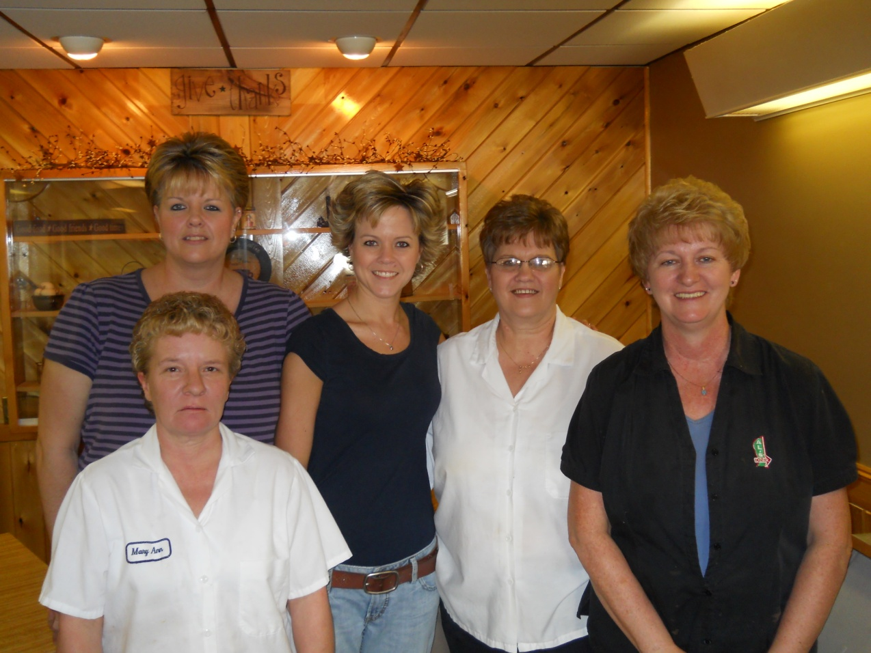

- Labor Force and Unemployment

Figure 22. Civilian Labor Force and Unemployment, 2011
 | Mars Hill | Aroostook | Maine
Civilian Labor Force | 710 | 34,542 | 704,078
Number Employed | 652 | 31,266 | 651.038
Unemployment Rate | 8.20% | 9.50% | 7.50%
Source: Maine Department of Labor

Mars Hill had a labor force of 652 people in 2011 with an unemployment rate of 8.2%, which was lower than that of the County but higher than that of the State as a whole. NOTE: the high unemployment rate is reflective of the slow recovery from the recent “Great Recession.”

Figure 23. Employment by Major Industries, Presque Isle Labor Market Area, 2010
 | Establishments | Average Employment | % Total Employment
Agriculture, Forestry, Fishing & Hunting | 148 | 993 | 5%
Utilities & Transportation | 152 | 936 | 5%
Construction | 168 | 753 | 4%
Manufacturing | 71 | 1643 | 8%
Wholesale Trade | 63 | 482 | 2%
Retail Trade | 328 | 4197 | 20%
Finance, Insurance, & Real Estate | 109 | 796 | 4%
Professional and technical services | 454 | 6203 | 30%
Health Care & Social Assistance | 187 | 4487 | 22%
Arts, Entertainment, & Recreation | 28 | 157 | 1%
Total | 1708 | 20647 | 100%
Source: 2010 US Census

Figure 24. Percent Employment by Major Industrial Sector, Presque Isle Labor Market Area

Source: 2010 US Census

Nearly a third of jobs in the Presque Isle LMA are in some form of professional and technical services industry, which also includes management companies and enterprises, administrative and waste services, educational services, public administration, information, and other services. Health care and social assistance provide slightly more than a fifth of jobs, followed closely by retail trade, which includes lodging and restaurants. Agriculture, forestry, fishing, and hunting make up 5% of Mars Hill’s jobs.

- Occupations

Figure 25. Civilian Labor Force and Unemployment, 2010
 | Mars Hill | Aroostook County | Maine
Service occupations | 28% | 19% | 18%
Management, professional, related occupations | 23% | 29% | 34%
Production, transportation, material moving occupations | 18% | 16% | 12%
Sales and office occupations | 15% | 23% | 24%
Construction, extraction, maintenance occupations | 12% | 10% | 10%
Farming, fishing, forestry occupations | 3% | 3% | 2%
Source: 2010 US Census

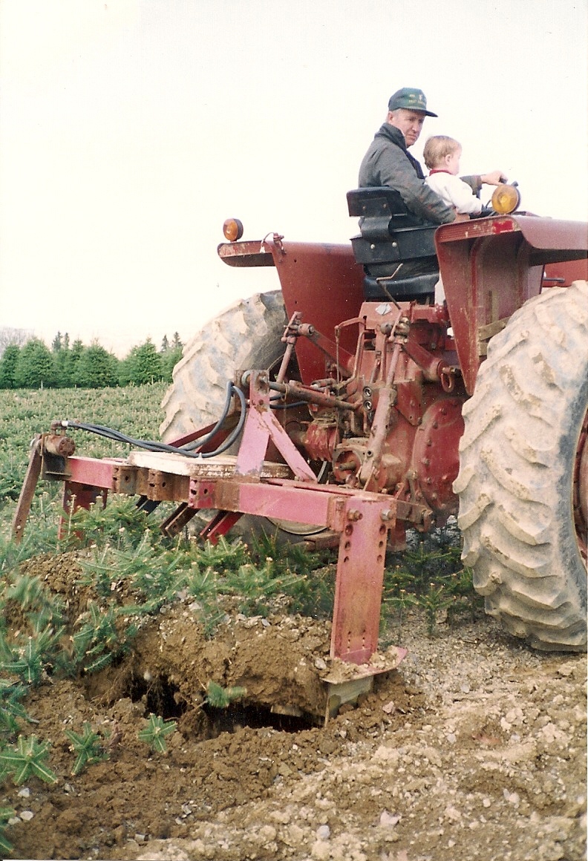
Figure 26. Occupations, 2012
Mars Hill has a significantly higher proportion of service occupations than the County or the State.
Mars Hill has a considerably lower proportion of management, professional, and related service occupations than the County or the State.
Production, transportation, and material moving occupations in Mars Hill is comparable to that in the County and is noticeably higher than for the State.
Source: 2010 US Census
- Income

- Household Income

Figure 27. Median Household Income, 2009
 | Median Household Income | % County Median Income
Blaine | 42,574 | 116.4%
Easton | 38,000 | 103.9%
Fort Fairfield | 32,440 | 88.7%
Mapleton | 50,167 | 137.2%
Mars Hill | 31,898 | 87.2%
Presque Isle | 36,563 | 100.0%
Westfield | 41,125 | 112.4%
Aroostook County | 36,574
State of Maine | 46,933
Source: 2010 US Census

Figure 28. Mars Hill Median Income, 2012

Source: 2010 US Census

Figure 29. Households Below Poverty, 2009
 | Mars Hill | Aroostook County |  | Maine
Households | 631 | 30,672 | 551,125
Below Poverty | 170 | 4,905 | 70,488
% Households Below Poverty | 26.9 | 16 | 12.8
Source: 2010 US Census

Mars Hill’s median household income in 2009 was just over 87% of that of Aroostook County. This was comparable to the median household income in Fort Fairfield, but significantly less than all of the other comparable communities and the State. More than a quarter of Mars Hill’s households have income that is below the poverty level.
- Per Capita Income

Figure 30. Per Capita Income, 2009
 | Income | % County Income
Mars Hill | $18,349 | 90.6%
Aroostook County | $20,251
State of Maine | $25,385
Source: 2010 US Census

Figure 31. Per Capital Income, 2012

Source: 2010 US Census

Mars Hill’s per capita income is just over 90% of that of the County and less than ¾ of that of the State.

- Commute to Work Information

Figure 32. Commute to Work from Mars Hill, 2010
 | Number | Percent
Blaine | 49 | 7.5%
Easton | 26 | 4.2%
Mars Hill | 225 | 34.6
Presque Isle | 224 | 34.4%
Washburn | 26 | 4.0%
Other | 101 | 15.5%
 | 651 | 100.0%
Source: 2010 US Census

Figure 33. Commute to Work from Mars Hill

Source: 2010 US Census

More than a third of Mars Hill’s residents work in another community, most in Presque Isle.

Figure 34. Commute to Work in Mars Hill, 2010
 | Number | Percent
Bridgewater | 61 | 12.4%
Easton | 27 | 5.5%
Fort Fairfield | 45 | 9.1%
Mars Hill | 225 | 45.6%
Presque Isle | 224 | 6.5%
Other | 103 | 20.9%
Source: 2010 US Census

Figure 35. Commute to Mars Hill for Work

Source: 2010 US Census

Nearly half of Mars Hill’s employed residents work in Mars Hill. Just over 20% of employed Bridgewater residents and just under 20% of Fort Fairfield residents commute to Mars Hill for work.
- Canadian Trade
In 2006, the US and Canada agreed to end a large portion of litigation over trade in softwood lumber and to unrestricted trade during favorable market conditions. When the lumber market is soft, Canadian exporting provinces can choose either to collect an export tax that ranges from 5 to 15% as prices fall or to collect lower export taxes and limit export volumes. The agreement also included provisions to address potential Canadian import surges, provide for effective dispute settlement, distribute antidumping and countervailing (anti-subsidy) duty deposits currently held by the US, and discipline future trade cases.
In 2010, the US signed an agreement with Canada on government procurement. The agreement provides for permanent US access to Canadian provincial and territorial procurement contracts in accordance with the World Trade Organization (WTO) Government Procurement Agreement (GPA).
In 2011, Maine exported $3.46 billion to other countries. Maine’s exports grew relatively consistently between 2001 and 2011, with a slight dip in 2005 and a significant decline in 2009 during the Great Recession. Overall from 2001 to 2011, exports increased by 9.38% and between 2010 and 2011, exports increased by 7.64%. Maine’s largest trading partner is Canada.
Figure 36. Maine’s Top Ten Exports to Canada
Description | 2011 (dollars) | % Change 2010-2011
TOTAL ALL COMMODITIES | 1,122,889,118 | 7.64
Fish, Crustaceans, & Aquatic Invertebrates | 245,096,976 | 3.8
Wood & Articles of Wood; Wood Charcoal | 193,100,602 | -9.93
Paper & Paperboard & Articles (including Pulp) | 190,200,513 | 6.49
Vehicles & Parts, Except Railway or Tramway | 64,103,077 | -0.04
Industrial Machinery, including Computers | 53,207,544 | 12.88
Wood Pulp; Recovered (Waste & Scrap) | 45,233,269 | 11.46
Mineral Fuel, Oil; Mineral Wax | 38,633,629 | 236.03
Prep Vegetables, Fruit, Nuts, or Other Plant Parts | 36,504,010 | -12.53
Edible Fruit & Nuts; Citrus Fruit or Melon Peel | 32,259,973 | 42.87
Edible Preparations of Meat, Fish, Crustaceans, etc. | 30,311,174 | 7.04
Source: Maine International Trade Center, 2012

Figure 37. Maine’s Top Ten Exports to Canada

Source: Maine International Trade Center, 2012
78% of Maine’s agricultural exports went to Canada in 2010, totaling $79 million, and including:
- $27 million in prepared chicken
- $14 million in cranberries
- $4 million in frozen fries
- $3 million in potatoes
- $3 million in livestock
In 2010, Maine imported $150 million from Canada, including:
- $40 million in frozen fries
- $16 million in plants
- $11 million in breads and pastries
- $11 million in animal feed
- $11 million in margarine
In 2011, Canada accounted for 32% of the state’s exports and was Maine’s top importer of wood pulp. US exports of agricultural products to Canada, the US’s largest agricultural export market, totaled $19.0 billion in 2011. Leading categories included fresh vegetables ($1.7 billion), fresh fruit ($1.7 billion), snack foods ($1.6 billion), red meats, fresh/chilled/frozen ($1.4 billion), and processed fruit and vegetables ($1.2 billion).
Maine’s export of prepared vegetables, fruit, nuts, or other plant parts declined more than 12% between 2010 and 2011 while edible fruit and nuts, citrus fruit or melon peel increased nearly 43%.

- Issues and Implications

- Before 1994, Mars Hill employed a community or economic development director, who was very successful in securing grants to replace or provide public infrastructure and facilities. Should the Town re-create this staff position or is current staffing adequate?

- To a large degree, Mars Hill’s economy is dependent on the regional economy of central Aroostook County. What can and should Mars Hill do to become better informed about and more involved in regional economic development efforts?

- Agriculture is an important industry in Mars Hill. Have Mars Hill’s farmers kept pace with necessary investments to increase productivity, marketability, and profitability? What can the community do to help support local farmers and associated industries?

- While rail transport is less important for agriculture than it is for forest products, what opportunity does the State’s recent acquisition of the Montreal, Maine, & Atlantic railroad offer? Is rail transport a feasible cost savings measure? What would have to change to make it feasible? Should the Town work with NDMC and MDOT to make sure that Mars Hill’s interests are considered in future improvement and investment plans for the rail line?

- What can and should Mars Hill do to support existing businesses? To draw new businesses and professionals who serve local needs, Mars Hill and nearby communities may have to expand their population and/or rigorously recruit, both difficult tasks. How active does Mars Hill want to be in tackling these problems? Is the community willing to focus energy and funds for such efforts?

- Energy costs in Mars Hill are high; however, the Town potentially has access to several emerging opportunities that could help reduce energy costs for local businesses (and possibly residents) – tapping into wind generation, new natural gas capacity associated with the Loring Pipeline, and pellet fuel, a regional initiative, to take advantage of plentiful local resource. If the Town is able to tap into these and other energy generation sources, it could help reduce operating costs for local businesses and create a competitive advantage in the region. Should the Town explore opportunities associated with these energy opportunities?

- Global Resorts notes the opportunity for Mars Hill to expand its tourism offerings around the Big Rock Ski Area and nearby Golf Course. Should Mars Hill investigate and promote the development of a “resort” or a package of amenities to capitalize on potential expanded tourism opportunities? How can this development be pursued in such a way as to promote a four, or at least expanded, season tourist attraction? Would it be a good idea for representatives of the Town to visit other Maine towns that have ski/golf amenities to discuss how they manage packages, etc.?

- While review of data about Canadian trade suggests limited opportunities for Mars Hill, primarily associated with agriculture, there may be more there than meets the cursory eye. Canadian business could be more important to Mars Hill. Many Canadians come across the border at Bridgewater and up the East Ridge Road along the front of the mountain to go north to Presque Isle, Fort Fairfield, or Caribou. They also some to Mars Hill’s golf course and Big Rock Ski Area or for groceries. Many shop at Walmart in Presque Isle. Note the Global Resorts, Inc. Feasibility Study and Development Assessment found that Mars Hill is located at the gateway to Northern Maine and Aroostook County and is an ideal home base for those who come for outdoor activities. One problem is that the first mile or so of this access route in Bridgewater is a rough and muddy dirt road in wet weather followed by a somewhat rough section in Blaine, which may be a deterrent to business. Should the Town work with Bridgewater, Blaine, and the State to improve this travel route? Besides promoting a “resort” package of amenities (see item 5 above), what else might Mars Hill do to capture business from those heading north for outdoor activities?

- Some residents noted a lot of excitement and business just across the border in places like Bristol and account for it primarily because of young people. Should the Town talk with the Town of Bristol about what it is doing to attract and retain young residents to assess strategies that might be applied to Mars Hill to expand its youthful population and generate more business within the community?

- What else might Mars Hill do to keep Canadian business in mind when progressing through this plan?

Mobilize Northern Maine. http://www.nmdc.org/mobilize/about.html

