DOCUMENT 3. GOALS, POLICIES, AND STRATEGIES

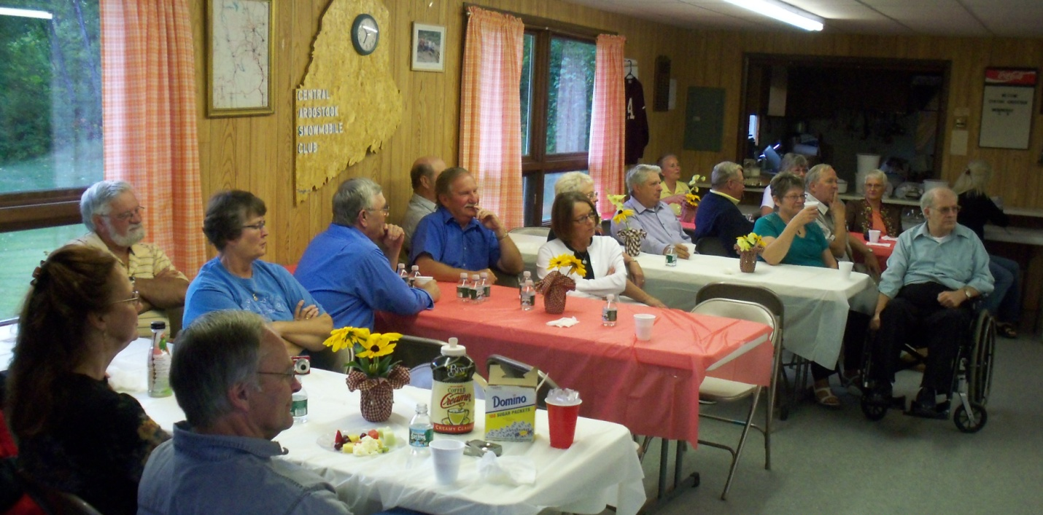

- Population
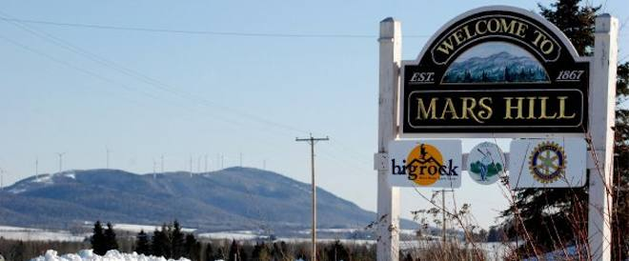
The last decade has seen a dampening of decades of population decline in Mars Hill. Together with continued expansion of Presque Isle’s offerings of retail goods and services, Mars Hill’s loss of population continues to undermine the market that is necessary to support businesses that provide for local needs. Current projections show a stable or slightly increasing enrollment for the elementary school but a declining enrollment for the higher grades, with no explanation for the decline. Continued decline in high school enrollment could eventually lead to loss of the High School in Town.
- GOAL: Increase year round population to the historic peak of 2,000 by 2030.
- Policy: Encourage and generate jobs to support population growth. See II. Economy.
- Market Mars Hill’s numerous assets, including but not limited to the golf course, ski area, nursing home, water and sewer, town center, library, schools, support infrastructure for the potato industry, access to regional transportation routes, the Prestile Stream and Mars Hill Pond, among other natural and cultural resources.
- Policy: Encourage workers to live in Mars Hill.
- Work with new and existing major employers to market the transportation cost savings and cultural and recreational benefits of living in Mars Hill.

- GOAL: Increase the secondary school age population to ensure continuation of the location of both the primary and secondary schools in Mars Hill.
- Policy: Determine what is behind the loss of secondary school students and develop strategies to reverse the trend of declining secondary school enrollments.
- Encourage the School District to either perform an in-house study or hire a consultant to evaluate school enrollments, determine what is behind declining enrollments, prepare enrollment projections, recommend strategies to reverse the decline, and establish realistic goals for future enrollments.
- Implement the recommended strategies.
- Monitor future school enrollments annually and periodically assess the success of implementation strategies in stabilizing/growing enrollments, adjust or replace strategies as needed to achieve desired enrollment goals.
- Policy: Work with middle and high school students to encourage them to stay in or return to Mars Hill when they have completed their education.
- Identify the types of careers Mars Hill youth are interested in and adjust the school curriculum and economic development efforts to provide the relevant education and skills.
- Identify the amenities and community features that would attract graduates to live in Mars Hill. Adjust zoning and programmatic support to develop and maintain cultural events and venues to meet those needs.
- Continue to support an improved agricultural program at the Junior-Senior High School.

- Economy
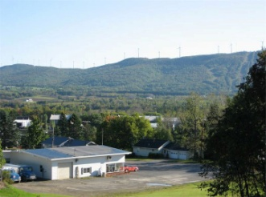
Mars Hill’s local economy continues to be based in agriculture. While an agricultural town, Mars Hill is also a service center within the region. Nevertheless, with declining population trends, Mars Hill businesses have been hard pressed to sustain themselves with a reduced customer and client base and competition from retail and service development in Presque Isle. To a large degree, Mars Hill’s economy is dependent on the regional economy of central Aroostook County. Yet there are some local economic development opportunities that could be pursued, particularly those that take advantage of some areas of strength in the regional economy as well as three recent regional economic development initiatives. The current condition and appearance of several prominent structures in the Downtown is shabby and detracts from the image and appearance of the whole Town. The Town should identify appropriate grant programs to pursue Downtown Revitalization, including continuing to seek Community Development Block Grant funds as they become available.
- GOAL: Maintain and draw businesses to Mars Hill to provide jobs that will meet the daily needs of existing residents and workers and attract new residents to the community.
- Policy: Enhance capacity of Town for economic development.
- Reestablish a full time, municipal economic development position to implement the Town’s economic development strategies, support local businesses, bring new businesses to the community, secure outside funds such as but not limited to Community Development Block Grants, and continue to make strategic investments in public facilities and services that support the Town’s economic development interests.
- Help existing and new businesses reduce energy costs by supporting expanded use of pellet fuel, which will reduce monthly bills and support this regional initiative to recycle as many energy dollars into the local and region’s economy as possible.
- In addition, explore opportunities to work with the new owners of the Loring Pipeline to bring natural gas to the community and/or otherwise take advantage of emerging economic development opportunities that support Mars Hill’s future vision.
- If regulations permit or can be adjusted, work with the owners of the wind towers to explore opportunities to reduce local energy costs for local businesses.
- Seek opportunities to participate in regional economic development organizations, initiatives, and studies.
- Policy: Support existing businesses in Mars Hill.
- Support enhancements for local agriculture to enable farmers to take advantage of emerging opportunities and trends in the industry. See VIII. Agriculture and Forestry M.
- Work with local farmers, Northern Maine Development Commission and County tourism organizations to explore opportunities to create and capitalize on emerging opportunities in agri-tourism.
- Work with local businesses to remedy issues that challenge the continuance of existing businesses.
- Policy: Draw new businesses to Mars Hill.
- Inventory existing buildings in Downtown to assess their condition and need for renovation and/or reuse. Where the need or opportunity exists, work with landowners to improve the safety and appearance of structures. See III. Housing E.12.
- Take advantage of Mars Hill’s access to Maine’s newly expanded high speed internet superhighway to draw new and emerging IT businesses that rely on high speed internet connections.
- Attract a data center and/or other computer-related businesses to locate in Mars Hill.
- Formalize efforts to market the Town’s industrial area.
- Work with major employers to provide car pool and/or other ride share services as well as to support the efforts of the Aroostook Regional Transportation Service. Seek grant funds, use municipal bonding and other authorities, as appropriate.

- GOAL: Use the area’s natural beauty as a base for economic development efforts.
- Policy: Make Mars Hill a “home base” for those who come to the County for outdoor recreation.
- Brand and market Mars Hill as the “Gateway to Northern Maine” and as a four season tourism destination. See II. Economy D.9.
- Create an information center for travelers, possibly at the Town Office, passing through the community to and from points further north and east. Advertise tourism destinations and activities in Mars Hill.
- Support, encourage, and market local businesses and services that appeal to travelers passing through the community to and from points further north and east.
- Use current and emerging social media, as well as more traditional options, to promote and market the community.
- Policy: Expand four season tourism and recreation offerings in Mars Hill, especially focused on the base of the mountain.
- Support and encourage the creation of new destinations and attractions in Mars Hill, including a hotel and campground near the base of the mountain. Work with organizations such as the Libra Foundation to develop new destinations and attractions. If opportunities arise, revise zoning to allow the creation of new destinations and attractions in this location. X. Land Use Q.
- Market Mars Hill’s trail system, ski area, golf course, wind farm, and proximity to Amish settlements, among other local and regional attractions.
- Coordinate marketing efforts with various tourism groups, particularly those associated with skiing and snowmobiling, to create vertically integrated tour packages (lodging, food, activities, music, entertainment, etc.) to maximize revenues during busy times and encourage visitors during less busy times.
- Support cross marketing to encourage existing tourists to extend their stays and come back to Mars Hill during other seasons. Target a portion of marketing efforts to draw Canadian residents and visitors to other parts of Maine to Mars Hill.
- Brand Mars Hill as the “healthiest place to live” in the County. Identify the location for and construct and/or improve and connect snowmobiling, cross country skiing, mountain biking, and walking trails to create new destinations for tourists/travelers and as an attraction for current and new residents.
- Policy: Maintain scenic views.VI.K.22.
- Continue to preserve the Town’s traditional village and working rural landscape pattern of development, laid out in the Town’s Future Land Use Plan.
- When development is proposed in areas identified with important scenic views (see Scenic Views Map), the Planning Board will consider the impacts of the proposed development on the views and encourage the developer to adjust his or her development plans to minimize negative impacts on the views.
- Periodically monitor impacts of development on Mars Hills’ scenic landscape and, if negative impacts are observed, undertake a more rigorous scenic views inventory and consider stronger regulatory protections as appropriate.
- Policy: Seek opportunities to regularly communicate with nearby communities in Canada and create/participate in shared projects.
- Actively look for opportunities to communicate and work with nearby Canadian communities.

- Housing
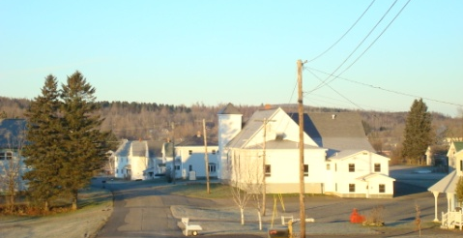
The recent change in housing data collected as part of the US Decennial Census makes it difficult to assess the condition of Mars Hill’s existing housing, though it is likely that there are weatherization and energy efficiency issues. Furthermore, undeveloped house lots are scarce in Mars Hill and this condition is making it more difficult for young people to stay in Town and raise their families. Mars Hill needs housing opportunities in the $80,000 to $140,000 range for those who work for the Town’s major employers (teachers, nursing home workers, processing and potato handling plants).
- GOAL: Meet the housing needs of Mars Hill’s current residents and plan for the housing needs of an expanded population.
- Preserve Mars Hill’s existing housing stock.
- Assess the condition of existing housing, including energy efficiency and weatherization needs.
- Annually, identify unoccupied homes and generally assess their condition as habitable structures (good, fair, poor, or derelict). Create a program to improve housing conditions where the need exists.
- The use of pellet heating has been identified as an economic development opportunity for Northern Maine. When appropriate, link local weatherization efforts with this initiative and/or other alternative heating systems to help reduce household energy costs and support regional economic development efforts.
- Seek public, private, and foundation grants and low interest loans to support rehabilitation and alternative heating efforts.
- Policy: Expand opportunities for new workforce housing to provide homes and house lots for employees of existing and new businesses.
- Designate areas within walking distance of the town center that are on public water and sewer, or where services can readily be extended, for residential development on smaller lots to provide for homes in the $80-140,000 range. See X. Land Use P.
- Promote development of these “in-town” locations within walking distance of Downtown as part of Mars Hill’s brand as the “healthiest place to live” in the County. See II. Economy D.9.e. and X. Land Use.
- Study the feasibility of creating neighborhoods with house lots that would be affordable for an average worker at Mars Hill industries and institutions. Share the results of the study with local developers and landowners.
- Work with developers to address, and where appropriate, modify local, state, and federal regulations to ensure that house lots and homes are affordable for the average workers in the area.
- Where opportunity presents itself, actively engage in supporting the creation of housing and neighborhood development that supports the Town’s housing goals, including but not limited to working in partnership with private landowners, developers, or other appropriate interests; purchasing and/or accepting donation of key properties within walking distance of the town center for future resale and development; seeking public, private, and foundation funds to support the development of compact, walkable, traditional neighborhoods. See X. Land Use P.
- Policy: Expand options for elderly housing.
- Support development of a range of housing opportunities that target the 55+ age group, including a focus on reducing the demands of maintenance and care, cater to particular needs, and include energy efficient design. The purpose of providing a range of options is to enable Mars Hill residents to “age in place,” especially when temperatures dip below zero.
- Strive to make Mars Hill more livable for the elderly in the winter months by providing transportation services, maintenance services, visitation and checking in programs, among others.

- Transportation
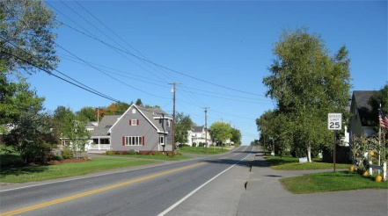
Mars Hill is located at the intersection of two major transportation routes, Routes 1 and 1A and is the first major population center travelers see north of Houlton and could reasonably be branded as the “Gateway to Northern Maine.” Furthermore, many Canadians come across the border at Bridgewater, up the back road, then along the front of the mountain to get north to Presque Isle, Fort Fairfield, and Caribou as well as to get to the Mars Hill’s golf course, Big Rock Ski Area, and groceries. A major ATV and snowmobile trail goes through town along the old Bangor & Aroostook Railroad bed, which should be marketed as economic asset.
- GOAL: Link transportation and economic development efforts.
- Policy: Capitalize on the Town’s location at the intersection of US Routes 1 and 1A. See II. Economy D.
- Monitor currently “postponed” plans to extend I-95, which would bypass Mars Hill. If federal funding becomes available for this extension, it is critical that Mars Hill has secured its position as a “destination” beforehand.
- Policy: Capitalize on the Town’s location along the Canadian border.
- Study Canadian travel routes and business (retail and service) and recreation interests to target and promote economic development efforts in Mars Hill. Work with Blaine and Bridgewater to improve road conditions and coordinate efforts to encourage Canadian exchanges.
- Policy: Support Mars Hill’s brand as the “healthiest place to live” in the County. See II. Economy 9.e.
- Expand and connect the various recreation trails in the community to create new destinations and attractions for tourists, travelers and new and existing residents. Identify, improve connections with the Town’s trail system, and promote the International Appalachian Trail system in Mars Hill.
- Work with major employers to provide car pool and/or other ride share services as well as to support the efforts of the Aroostook Regional Transportation Service. Seek grant funds, use municipal bonding and other authorities, as appropriate.
- Ensure that Town maintenance and construction projects (i.e., culverts) are undertaken in ways that do not inadvertently impede the passage of fish and wildlife.

- GOAL: Manage Town’s finances to ensure adequate investment in road maintenance.
- Policy: Continue to plan for capital investment in local roads.
- The 2013 inventory of road conditions is a good start. Expand the Town’s focus on inventorying conditions and establishing an annual improvement schedule to improve the condition of fair to poor roads and maintain the condition of good to fair roads. Investigate the Maine Department of Transportation’s road maintenance software.

- Public Facilities and Services
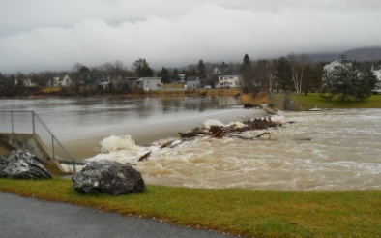
cAs a service center community, Mars Hill has a wide variety of public facilities and services that meet its residents’ needs and those of the numerous workers who commute from other nearby communities to jobs in Mars Hill. Given its historically larger population, Mars Hill has infrastructure to serve more residents and workers than it currently does. Most facilities are in good shape, given ongoing attention and investment over the last two decades; however, there are some facility needs on the horizon, including replacement of the Town Garage and a state-required salt shed. The most pressing public facility issue facing the community is continued declining student enrollments, which may eventually threaten the continued location of the Junior-Senior High School in Mars Hill.
- GOAL: Increase the secondary school age population to ensure continuation of both the primary and secondary schools in Mars Hill. See I. Population A.

- GOAL: Continue to plan for capital investment in public facilities and services.
- Policy: Continue to plan for capital investment in public facilities and services.
- Formalize the Town’s capital investments in an ongoing, multi-year capital improvement planning process. See VII. Fiscal Capacity.
- Plan for replacement of the Town Garage.
- When state funds to support construction of a salt shed become available, construct a new salt shed.
- Create a full time municipal economic development position to secure resources that support strategic investments in public facilities and services. See II. Economy C.5.a.

- Cultural Resources

Mars Hill has a variety of cultural resources that are commonly found in service center communities, as well as some resources, like Big Rock Ski Area and Mars Hill Country Club, that are relatively uncommon. The Prestile Stream and Mars Hill Pond historically have been a significant focus of recreational activities – skating and horse racing on the Pond in winter, canoeing and gathering fiddleheads along its banks in the spring, wild trout fishing in the summer. Mars Hill has the opportunity to market its rich cultural resources in support of its population and economic development goals. Most facilities are in good shape, but the Pond requires attention and investment to reclaim its potential central role in the community. Expanding Mars Hill’s brand as a four-season recreation draw, especially at the base of the mountain, will not only provide improved services for existing residents and workers, but could be a tool to leverage support for the Town’s population and economic development goals.
- GOAL: Restore and market the Prestile Stream, Mars Hill Pond, dam, park, and other cultural resources.
- Policy: Invest in the Prestile Stream, Mars Hill Pond, dam, and park to restore and market an attractive recreational resource and element of beauty to the Town.
- Include investment in the Prestile Stream, pond, dam, and park in the Town’s multi-year capital improvement plan. See V. Public Facilities I. and VII. Fiscal Capacity.
- Create a full time municipal economic development position to secure resources that support strategic investments in cultural resources. See II. Economy C.5.a.

- GOAL: Use the area’s natural beauty and cultural resources as a base for economic development efforts.
- Policy: Expand four season tourism and recreation offerings in Mars Hill, especially focused on the base of the mountain.
- See II. Economy D.9.
- Create a “home base” for those who come to Mars Hill and the County for outdoor activities, including new lodging facilities at the base of the mountain. See II. Economy D.
- Expand, connect, and promote/advertise the various recreation trails in the community. See II. Economy D.9. and IV. Transportation F.17.
- Explore opportunities to increase public access to the top of the mountain.
- Work with the State Departments of Environmental Protection and Inland Fisheries & Wildlife, Soil and Water Conservation District, Trout Unlimited, Ducks Unlimited, Pathways to America, and others to resolve potential conflicts between local goals and state and federal interests in protecting waterfowl nesting habitat.
- Improve Prestile Stream Park with paths and boardwalks to provide a vital and attractive community gathering point, fishing and birding opportunities, and attract people to the Town. Boardwalks and paths should be designed to minimize environmental impacts on important wildlife habitats.
- Policy: Maintain scenic views.II.D.10.
- Continue to preserve the Town’s traditional village and working rural landscape pattern of development, laid out in the Town’s Future Land Use Plan.
- When development is proposed in areas identified with important scenic views (see Scenic Views Map), the Planning Board will consider the impacts of the proposed development on the views and encourage the developer to adjust his or her development plans to minimize negative impacts on the views.
- Periodically monitor impacts of development on Mars Hills’ scenic landscape and, if negative impacts are observed, undertake a more rigorous scenic views inventory and consider stronger regulatory protections as appropriate.

- Fiscal Capacity
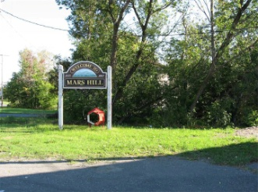
In addition to the wind farm, there is a large proportion of farmland and open space in the community. There are also a number of tax exempt properties that influence the Town’s tax base. Mars Hill’s mil rate decreased 20% from 2000 to 2010, primarily driven by an increase in tax revenue from the wind farm, which will continue to provide the Town with a fixed revenue stream of $500K per year for a 20 year term. The average ratio of assessed value to sales price is 69%, which suggests that a townwide revaluation will be needed in the not too distant future in compliance with state law. The Town has demonstrated a strong ability to self-fund municipal capital improvements, but longer term capital planning will be important to address future anticipated capital needs, including those of the school and utility districts, in a fiscally prudent manner. The Town is currently in the process of completing a capital improvement plan to address future infrastructure needs. The Governor’s recent proposed elimination of state revenue sharing and tax incentive programs will create additional financial requirements for the Town.
- GOAL: Formalize Mars Hill’s ongoing financial management and capital improvements programs to anticipate and stabilize the Town’s fiscal capacity and enable it to better withstand downswings in the local economy.
- Policy: Build on and institutionalize current efforts to create a 5 year Capital Improvements Plan.
- Annually, prepare a 5 year capital improvements plan to anticipate and plan for the creation and upgrading of necessary capital improvements.
- Plan for capital spending associated with road maintenance, the Town Garage, a salt shed, improvements to the park associated with the Prestile Stream and Mars Hill Pond, housing initiatives, and other needs identified in this Comprehensive Plan.
- Continue to fund capital reserve accounts for anticipated expenditures that are part of the capital improvement plan.
- Prepare to undertake a revaluation, as required by state requirements.
- Analyze the potential impact of the wind farm’s tax increment financing agreement ending in 2025, only 12 years from now, and plan accordingly.
- Policy: Continue recent efforts to design and improve systems to professionally manage the Town’s finances.
- Review the Town’s personal property tax records.
- Link the Town’s assessing tax base to its GIS data base. Maintain and update the GIS database whenever the assessor’s database is updated.
- Work with NMDC and/or other organizations to house and update the Town’s GIS database as necessary to keep it current and to support assessments to guide municipal economic development, housing, and other initiatives.
- Create a strategic financial plan with a 5-10 year window to address future capital needs for Mars Hill, containment of operating expenses, and a process for thorough review of school spending.
- Fund a full-time, municipal economic development position.

- Agriculture and Forestry
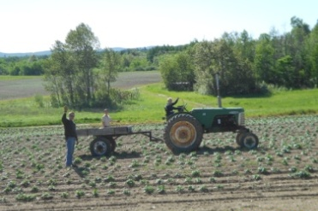
Agriculture plays a major role in Mars Hill both in terms of the amount of land dedicated to agricultural use and in terms of the economic impact of agriculture within the community. Though trends in farming and land ownership patterns are changing, Mars Hill’s community identity has historically and currently continues to center on farming. In recent years, there are fewer, bigger family farms growing mostly potatoes, rotated with grains, soybeans, and broccoli. Some local farmers are nearing retirement and do not have family members who are interested in continuing to commercially farm their land. Generally, farmland in Mars Hill is highly valued and there has not been much conversion to other uses, though there have been some notable exceptions. The availability of land for residential development has become more of an issue in recent years, though farmers generally have been proactive about acquiring land from retiring farmers, leaving little land available on the open real estate market. As the Town seeks additional house lots in support of its population and economic development goals, it will be important to locate such development closer to the town center and public services and to avoid the loss of important farmland.
- GOAL: Support agriculture as the primary economic asset of the community.
- Policy: Support and enhance agriculture.
- Support enhancements for local agriculture to take support farmers in taking advantage of emerging opportunities and trends in the industry. See II. Economy C.6.
- Work with students and the School District to better support the agricultural program at the Junior-Senior High School and increase the engagement of local youth in farming. See I. Population B.4.c.
- Work with the School District, nursing home, health center, other local institutions, and supermarkets to encourage greater use of local agricultural products where possible.
- Continue to work with local farmers to identify and address issues related to the sustainability of agriculture in Mars Hill, including creating and/or expanding local markets, reducing the impacts of stormwater runoff from uncovered winter fields, inadequate stream buffers, and gravel roads, and other issues that may arise from time to time. See IX. Natural Resources N.26.
- Work with local farmers and landowners to address issues related to the provision of future public access to their lands.
- Encourage farmers who are approaching retirement and who do not have family members who are interested in continuing commercial farming on their property to work with organizations such as the Maine Farmland Trust and others to identify potential new farmers and programs to keep the acreage in active production.

- Natural Resources
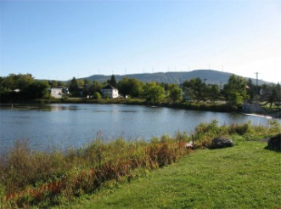
Mars Hill is blessed with a strikingly beautiful natural landscape. The Prestile Stream and Mars Hill Mountain are major natural assets in the community. There is a long tradition of hunting and trout fishing, which is important to many citizens. A major issue is use of the Prestile Stream and the condition of both the Stream and the Mars Hill Pond, including water quality, sedimentation, the trout fishery, and future stream access to preserve its role as the traditional center of Mars Hill‘s recreation in all seasons.
- GOAL: Protect and improve water quality of the Prestile Stream and Mars Hill Pond.
- Policy: Work with the State Departments of Environmental Protection, Soil and Water Conservation District, and other groups to reduce sediment loading and improve water quality in the Prestile Stream. See VI. Cultural Resources K.21.
- Seek an affordable solution to provide winter cover crops, including applying for and securing outside financial support.
- Create a streamside buffer planting program and secure funds to support planting stream buffers along the Prestile Stream and its tributaries in Mars Hill.
- Seek funds to support retrofit of Town and farm roads that are contributing to sediment loading and water quality issues with the Prestile.
- Support the Soil and Water Conservation District’s efforts to improve the water quality of the Prestile.
- Make certain that local citizens are continually involved and Town leaders stay informed as to the progress and direction of water quality improvement efforts.
- Policy: Restore the Mars Hill Pond and improve the associated park for recreation such as fishing, canoeing, kayaking, birding, and other recreational use.
- Work with federal, state, regional, and local public, private, and nonprofit groups to fund and implement a strategy to restore water quality in the Pond and improve the park to address the concerns of current and potential users in support of traditional recreational uses.

- GOAL: Protect Mars Hill’s natural resources.
- Policy: Work with the State Departments of Inland Fisheries & Wildlife and Beginning with Habitat Program to protect natural resources.
- Work closely with the Maine Department of Inland Fisheries & Wildlife and the Beginning with Habitat Program to develop and implement approaches that protect the Town’s natural resources, visit the Beginning with Habitat Online Toolbox (http://www.beginningwithhabitat.com/toolbox/about_toolbox.html), and periodically request updated information in the future to ensure that land use decisions are based on the best available information.

- 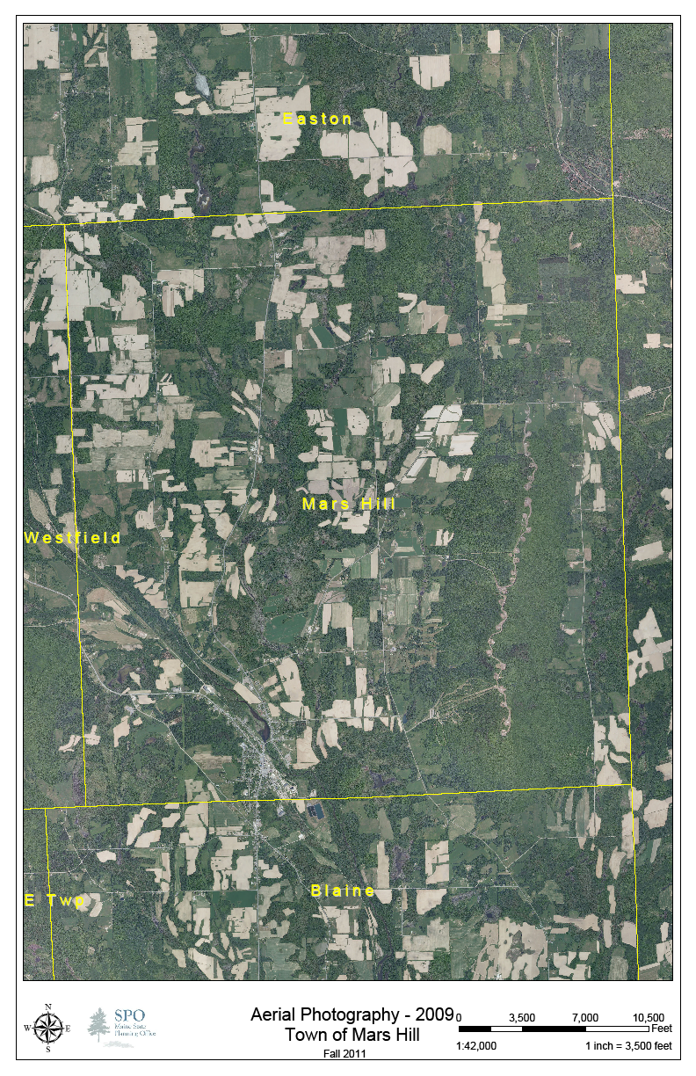Land Use
Mars Hill remains predominantly agricultural, retaining its traditional town center, where most residential, commercial, and service development is located. This has helped Mars Hill control municipal expenses. At the same time, recreation and other developments have expanded on Mars Hill Mountain, shifting the Town’s economic focus to the mountain and its base, with only limited development in the industrial area. There have been very few residential subdivisions since adoption of the 1992 Comprehensive Plan. To support efforts to brand Mars Hill as the “healthiest town in Aroostook County,” new residential development needs to be on small lots in areas that are within walking distance of businesses and institutions in the core of the community.

- GOAL: Continue to support compact residential and commercial development in Mars Hill’s town center.
- Policy: Review and adjust land use regulations in areas that are within walking distance of the town center and areas on public water and sewer, or where services can readily be extended.
- Rezone the large parcel on East Ridge Road that is currently being farmed from Residential 2 to Rural Farm.
- Rezone the remaining smaller parcels in the Residential 2 to Residential 1 and eliminate the Residential 2 District from the Town’s zoning map and ordinance. This rezoning is intended to encourage entry level residential development near the town center to help create affordable workforce housing and promote walking as part of Mars Hill’s brand as the “healthiest place to live” in the County. See II. Economy D.9.e. and III. Housing E.13.
- Amend land use ordinances to require interconnected streets, limiting dead end roads and cul-de-sacs to responding to environmental or safety issues. Amend land use ordinances to require streetscape improvements, including sidewalks and shade trees, to promote the walkability of these new neighborhoods. Provide an exemption for the requirement to interconnect streets if needed to avoid negative impacts on natural systems.

- GOAL: Create new jobs in emerging technological service businesses near the town center.
- Policy: Take advantage of opportunities for emerging technologies to locate in Mars Hill.
- As opportunities arise to draw one or more emerging technology companies (i.e., computer data storage, call center, etc.) to Mars Hill, expand the existing Commercial Zone to include an area extending south of the existing Commercial Zone toward Clark Road.

- GOAL: Support expansion of four season tourism and recreation offerings focused on the base of the mountain.
- Policy: Take advantage of opportunities to expand Mars Hill’s four season tourism and recreation at the base of the mountain.
- As opportunities to expand tourism and recreation offerings at the base of the mountain arise, revise zoning to allow the creation of new destinations and attractions in this location. See II. Economy D.9.a.

- Implementation of the Plan

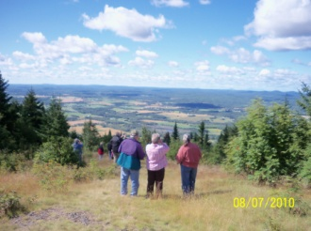
If comprehensive plans are to address major community issues in a manner likely to yield positive results, they must clearly identify desired outcomes. They must also establish a means of measuring performance relative to these outcomes. Without a strong focus on outcomes, there is a tendency to equate success or failure mainly with effort rather than result. Such an emphasis not only hampers current planning efforts, but can also result in the long-term perpetuation of strategies that are ineffective or even counterproductive. The implementation of strong land use measures, for example, is an output that may or may not result in the desired outcome: that of most future development occurring in designated residential, commercial, and industrial areas.

This Plan allows the Town to take a fresh look at its policies and strategies and to place a greater emphasis on identifying positive outcomes and establishing targets or benchmarks to strive for and gauge progress. Setting benchmarks relative to designated residential, commercial, industrial areas, future recreation, and rural areas is essential to gauge the Town’s success at guiding growth. Even for plan goals that do not lend themselves to precise measurement, the exercise of discussing how success will be evaluated is an extremely valuable one.

- GOAL: Ensure there are enough volunteers to participate in Town and community affairs, including implementation of the Plan.
- Policy: Increase volunteer participation in Town and community affairs, including implementation of the Plan.
- Create and maintain a bulletin board of volunteer opportunities and needs at the Town Office and on the Town’s web site.
- Create and maintain a “Wish List” of community needs at the Town Office and on the Town’s website to solicit donations in support of implementing this Plan.
- The Town Council and Town Manager will identify members of the Implementation Committee, which the Town Council will appoint. The Town Council, Town Manager, and Implementation Committee will identify members for and the Town Council will appoint members to a Building Committee to Replace the Town Garage, Economic Development Committee, Housing Committee, Implementation Committee, and Recreation Committee.

- GOAL: Implement and monitor success of the updated Comprehensive Plan.

- Policy: Watch over implementation of this Plan and monitor success in achieving its policies and goals.
- Assign oversight of implementation and monitoring of success to a new Implementation Committee, with support from the Town Council and Town Manager. The Town Council shall appoint committees and task forces and assign specific tasks to ensure that the overall implementation schedule is being followed. In addition, the Implementation Committee, with support from the Town Manager and Town Assessor shall evaluate whether implemented policies are leading to positive outcomes, and specifically track progress on particular steps relative to benchmarks established in the plan.
- To initiate implementation, the Town Council shall appoint an Implementation Committee, as well as the Building Committee to Replace the Town Garage, Economic Development Committee, Housing Committee, Implementation Committee, and Recreation Committee to implement strategies in this Plan. Together with the Implementation Committee, the Town Council shall schedule a kick-off workshop to discuss the logistics of implementation, reiterate the respective roles different parties will play in the process, discuss plan specifics and views on how to best proceed.
- Thereafter, the Implementation Committee will meet annually with each group responsible for implementation in the upcoming year to review and clarify strategies, refine the anticipated schedule for each year’s activities, and work with the Town Council to reassign tasks if the group is unable to complete the task. If it is determined that implementation of certain steps is lagging or key performance benchmarks are not being met, the Implementation Committee and Town Council will develop a plan of action.
- The Implementation Committee will publish each year’s implementation schedule and assess success in guiding growth based on the Future Land Use Plan, Goals and Policies, and specific benchmarks in the Annual Report and regularly post progress on the Town’s website.
- The Implementation Committee will display an enlarged version of the annual schedule at the Town Office and note progress.
- The Town Council will annually acknowledge and celebrate implementation efforts and progress toward achieving policies and goals.

- Policy: Adopt benchmarks for Mars Hill’s ten-year planning period to include:
- 85% of residential growth occurs in designated residential areas,
- 15% or less growth occurs in designated rural farm areas
- 50% or more of new year round housing affordable to those making 80% to 120% of the Town’s median household income
- No more than a 5% decrease in actively farmed acreage

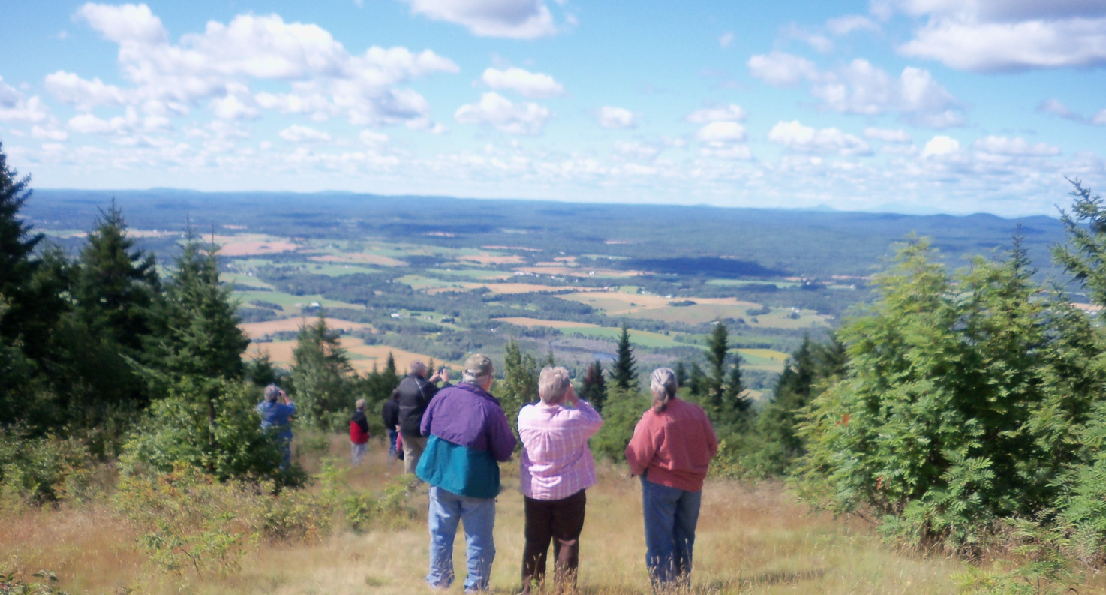
If, by at least the fourth year after adoption of the Comprehensive Plan Update, growth, particularly the percent of growth, is not being directed as desired in the Plan, the Town Council, with assistance from the Implementation Committee and Planning Board, will review the Plan’s strategies and adjust them to increase their effectiveness in meeting the benchmarks.

