DOCUMENT 2. 2023 VISION STATEMENT

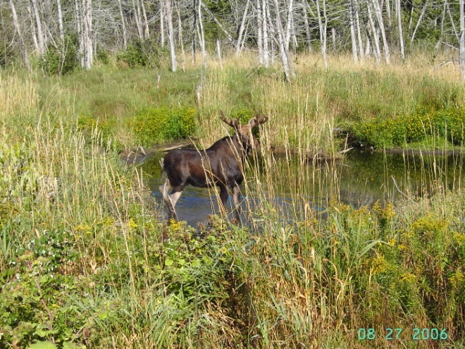
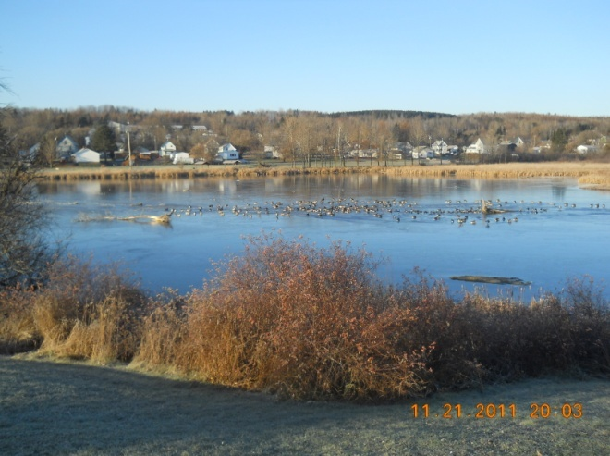

The following description of a vision statement and its relationship to a community’s comprehensive plan is taken largely from the Community Visioning Handbook: How to Imagine – and Create – a Better Future, a publication of the former Maine State Planning Office.

A Vision Statement is a description of what the community’s future will look, feel, and be like. Why envision the future? Because only by imagining where we want to go can we figure out how to get there. Mars Hill needs a blueprint to make sure that its regulations, capital investments, and public facilities all work together and to give clear signals to developers about what is wanted in the community. The blueprint for how to achieve the vision is the comprehensive plan. The vision statement is the driving force behind the comprehensive plan.

A vision that works helps a community reach for goals above and beyond what normally might be expected and discover possibilities that may not have been apparent. A good vision is a stretch, but still in the realm of the achievable. A good vision motivates people to take action together. A good vision makes people feel hopeful, optimistic, and focused.

The vision is the dream. The plan is the blueprint.
The vision describes. The plan analyzes.
The vision is poetry. The plan is prose.
The vision is about possibilities. The plan is about policies.
The vision describes what. The plan shows how.
The vision is an aspiration. The plan is a legal document.
The vision appeals to imagination. The plan appeals to reason.
The vision is striven for. The plan is implemented.

A vision says, “This is where we want to go.” The rest of the plan provides the concrete data necessary to move the community towards its vision. The vision should represent a stretch for the community, but not be impossible to achieve. In sum, the vision and the rest of the comprehensive planning process should feed off of and support one another. Visioning without planning risks being uninspired. Planning without visioning risks being irrelevant. Good visioning and good planning strengthen each other.

In 2023, Mars Hill’s:

Population will grow, with a goal of attaining 500 additional residents to bring us to 2000 residents by 2030. This increased population will provide a built in market to sustain the elementary and junior-senior high schools, the focus and heart of the community. The larger residential population will also attract and grow a wider range of stores, restaurants, services, and recreation/cultural opportunities in the town center. New residents will include those who formerly commuted to existing businesses and who will be drawn to the community because of new job opportunities. A larger proportion of Mars Hill graduates will choose to stay in Mars Hill or will return to the community as young adults and/or parents. Among the new residents will also be retirees, who will be drawn to the community for its excellent senior services and age-in-place facilities as well as for its reputation for and access to healthy living, trails, fishing, hunting, recreation, cultural amenities, and strong sense of community – it’s “Mayberry” feel.

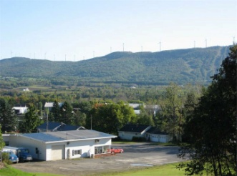
Economy will continue to be based in agriculture, but will also include many familiar local businesses as well as an expanded and more diverse array of goods and services that meet residents’, workers’, and visitors’ needs. By 2023 there will be ten more businesses, including a dentist, bakery, ice cream parlor, and consignment shop, among others on Main Street. By 2030 there will be 200 new jobs in Mars Hill, increasing the total number to 800-900. Downtown will continue to be the Town’s center of business activity, which will be reflected in the well kept and attractive buildings that form a positive image of the community.
Mars Hill’s economic development director and community leaders will be active leaders of existing and new local, regional, and state organizations that promote and coordinate business and economic development interests which are important to the community. The economic development director will also work with local farmers and businesses to support existing businesses and draw new ones to Mars Hill. As a result of planning and economic development efforts, the Town will have worked with public and private interests to create incentives and support that will increase their collective and strategic investment in Mars Hill. The industrial area between Main and Miller streets will be fully occupied with thriving agricultural support facilities, a new computer and data center, and other businesses. The Town, through its economic development director, will partner with Northern Maine Community College to train workers for the new jobs. Mars Hill will partner with bordering towns to help lift the economies of all and will increase business with Canada by promoting the many family connections that extend across the international border.
Mars Hill will be known as the “Gateway to Northern Maine” – Maine’s last frontier. Mars Hill will regularly draw new tourists to the Town’s four season sports and recreation offerings, which will be anchored at the “home base” of Mars Hill Mountain with new lodging, a campground, banquet and wedding facilities, and educational programs that allow Big Rock and the Country Club to offer lodging/ski-golf trip and other packages. Return visitors will be frequent and will expand their visits over the years to include multiple seasons. The ski facilities, golf course, wind farm, nearby Amish settlements, and other attractions will successfully appeal to Canadian and other tourists. Mars Hill’s other brand, the “healthiest place to live” in the County, will be born out of the expanded, interconnected, and well marketed trail network. People will be able to walk in the Town Center or on back roads throughout the community as well as cross-country ski, snowmobile, mountain bike, and hike. Trails and bike friendly routes will be marked and promoted.

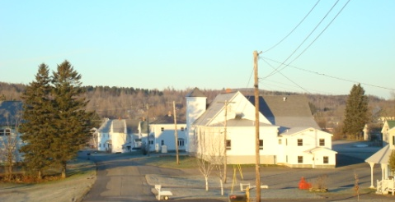
Housing will be in good condition and will be energy efficient to help keep residents’ heating costs down. Compact and modestly sized house lots will support new homes in the $80,000-$140,000 range that will be located on public water and sewer within walking distance of the town center in support of Mars Hill’s brand as the “healthiest place to live” in the County. New residents will work at expanded health and nursing care, teaching, potato processing and handling, and other jobs in Mars Hill. The Town will have worked with landowners and developers of new homes to make sure that new housing is affordable and neighborhoods are walkable, near the town center, and fit into the fabric of and reflect the character of existing intown neighborhoods. New “55+ age” housing and the Aroostook Health Center, which will have doubled in size, that allow the elderly to age-in-place will provide a range of housing options for older residents that require less maintenance and care for those who want to stay and for new residents who will be drawn to the community. The mix of ages of new residents will contribute to the richness of life for all age groups in the community and, in turn, will generate more jobs in Mars Hill.
For a number of years, Mars Hill will have performed an annual unoccupied housing survey with the goal of maintaining more useable, energy efficient homes. The survey will have helped reverse the trend of structures deteriorating to the point of requiring demolition by guiding Town leaders to target assistance and secure outside funding to supplement local funds to improve housing conditions. In 2023, Mars Hill’s well maintained housing will support the community’s image as a good place to live.

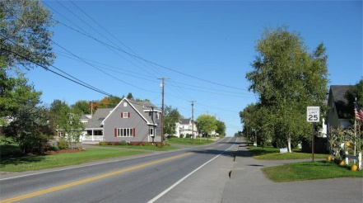
Transportation will continue to be focused on the intersection of Routes 1 and 1A. The back road from Bridgewater that Canadian visitors use to head north of Mars Hill will have been improved and many visitors will stop to take advantage of the golf course, Big Rock, and associated facilities rather than just stopping for groceries and moving on to other venues as they have done in the past. The air strip will be used far more regularly by new businesses that will have located in the industrial area. Mars Hill’s local roads and bridges will be in good shape, thanks to a decade long commitment to capital planning and investment.

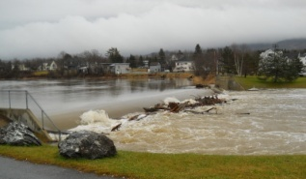
Public Facilities and Services will continue to be diverse to meet the needs of residents and the numerous workers who continue to commute from nearby communities to jobs in Mars Hill. Town government will continue to improve its overall systems to increase efficiencies and will embrace a positive political climate that will encourage more people to run for office with the intent of bettering the community. The Town and Utility District will have continued to plan for and invest in infrastructure to maintain the quality and longevity of their systems and will restrict utility extensions to designated areas for growth close to the town center. Utility costs will be kept in line or below those of surrounding, like communities. There will be a new town garage and salt shed. The crime rate will remain low and Mars Hill’s reputation as a safe community will be an asset the Town markets to draw new residents from away.
School enrollments at the junior-senior high school will have increased from the current 195 students to 300 students, which will ensure its continued location in the community. In part new families will be drawn to Mars Hill because of the school district’s top level performance in many areas, including academics, recreation, technology, and the arts. In part, improvements will be directed by finding out what the kids want; in part, because improvements will be directed by an analysis and strategic plan to evaluate why junior-senior high school enrollments have declined while elementary enrollments remained stable or increased and what could be done to reverse that trend. The economic development director will be successful in securing outside public, private, and foundation funds to support investment in the Town’s infrastructure and the arts.
The Mars Hill Health Center will be expanded to 125 beds and will have extensive physical therapy, lab testing, skilled care, Alzheimer’s care, and other medical and elderly support services appropriate for an aging population.


Cultural Resources will be maintained, improved, and expanded in keeping with the Town’s brand as “the healthiest place to live in Aroostook County.” Among expanded facilities will be tennis, skateboarding, and exercise and other activities to draw young families and senior citizens to the community. In addition, the Town will have developed a well marked and well marketed network of multiuse trails that crisscross the community and link to a bicycle network and walking in the town center. The Town’s trail system will connect with the International Appalachian Trail that goes across Mars Hill Mountain. The Town will have marketed these resources to make Mars Hill a destination that attracts visitors and business. In part, improvements will be guided by an active Recreation Committee that shares ideas, support, and ways for more people to plug in, including the many seniors who would like to be involved but don’t know where or how to begin. The Town Office will maintain a central list of needs and opportunities, though the system will be designed to require little effort on the part of Town staff. Increased volunteers will help the Town with beautification, arts and crafts, theater, music, recreation, fundraising, tutoring, visits to the home bound, among others.
Mars Hill Pond will be restored as a prime recreational resource. Water levels will be maintained about two feet below the design level of the dam. The Town will have worked with the Central Aroostook Soil and Water Conservation Service, state agencies, and others to maintain waterfowl nesting habitat as well as improve pond and stream water quality. The Town will work with farmers and others to reduce sediments and chemicals from running off farm fields and plant buffers along the Prestile and feeder streams. Wild roses will be planted along the banks of the pond to help with erosion and to keep geese off the immediate shores of the community gathering areas in the Park. The Park also will be improved with tree plantings and gardens which, along with the band stand at the Fire Station, will create community gathering places for the annual Christmas tree lighting, flag raisings, veteran ceremonies, among other activities and events. There will be new trails and boardwalks that encourage both residents and visitors to fish, watch birds, walk, canoe, and skate on the Pond. The Town will have created, preserved, and promoted access to wild trout fishing on the Prestile Stream. The Town will have also successfully marketed itself to birding enthusiasts who will come to Mars Hill because of its reputation as a birding capital of Northern Maine. This will be accomplished, in part, by advertising the location of unusual birds on the Town’s web site and other internet locations. In 2023, residents will still be discussing whether they would like to see a roadway to the top of the mountain, much like the one on Cadillac Mountain in Bar Harbor.
In addition to efforts to beautify the Prestile Pond Park, the Town will have sited a Town Clock on Main Street, which will also have been improved with new light posts, flower boxes, and seasonal decorations, among other projects.
There will be more, expanded, and improved community activities, supported by increased volunteer involvement in planning and participating in efforts and events. Mars Hill will support and market itself at the Houlton and Presque Isle Fairs and the 2014 Acadian Festival. In part, this will be accomplished by the increased number of interested volunteers who will be informed about community needs and volunteer opportunities.
Mars Hill will have successfully marketed its rich cultural resources to support its population and economic development goals.

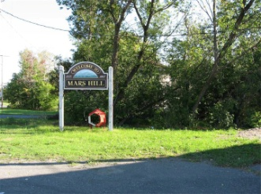
Fiscal Capacity will continue to be a focus of the community. The Town will continue to improve its financial and management systems to ensure that local government is cost effective and the community can afford to make the investments that will be necessary to support the Town’s vision for 2023. Though the TIF agreement with the wind farm will be coming to a close, the Town will have worked with its major financial interests to support arrangements that will be in the Town’s interest, including the coordination and provision of lower cost energy supplies. To attract new residents, Mars Hill’s mil rate will have been reduced somewhat or remain stable and sewer and water rates will be no more than 75% of like communities. These rates will have been primarily driven by sound management practices and an increase in tax revenue from planned new development. The Town will have formed a partnership with the wind farm and others to support desired business expansion and long term energy security. The Town will continue to rely on its strong ability to self-fund capital improvements, but it will have institutionalized longer term capital planning, that was adopted with the current Comprehensive Plan, to address anticipated capital needs in a fiscally prudent manner. The Town’s economic development director will have successfully secured funds from outside sources to supplement local investments to address infrastructure and development needs.
The Town will have continued efforts to design and improve systems to professionally manage the Town’s finances, including reviewing/updating personal property tax records, linking the Town’s assessing tax base to its GIS data base, creating a strategic financial plan with a 5-10 year window to address future capital needs, containing operating expenses, and developing and using a process to thoroughly review school spending, among others.

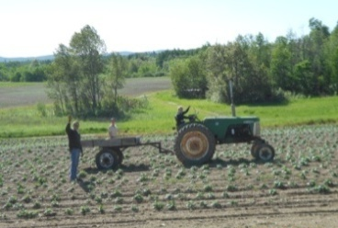
Agriculture and Forestry will continue to play a major role in Mars Hill, both in terms of the amount of land dedicated to agricultural use and in terms of the economic impact of agriculture within the community. Though trends in farming and land ownership patterns will have changed in keeping with changes in the industry, Mars Hill’s community identity will still center on farming. While there may be fewer, bigger family farms, the Town will have worked successfully with organizations like the Maine Farmland Trust to help interested young farmers purchase land from retired farmers whose family members are no longer interested in commercial farming. Farmland still will be highly valued in the community and little farmland will have been converted to other uses. The trend of locating new residential development closer to the town center and public services will be successful in avoiding the loss of important farmland. At the same time, the Town maintains a low overall residential density in the rural parts of Mars Hill.
To encourage more Mars Hill youth to select farming as a profession, the School District will work with students and local farmers to better support the agriculture program at the junior-senior high school. The Town also will have worked with the School District, nursing home, health center, and other local institutions and the grocery store to increase their use and sale of local agricultural products.

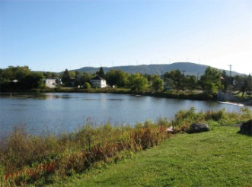
Natural Resources will continue to bless the Town with a strikingly beautiful and healthy natural landscape. The water quality of the Prestile Pond and Stream will be improved due to efforts to reduced contaminated runoff, including affordable ways to provide winter cover crops, restore riparian buffers, and retrofit Town and farm roads to reduce sediment loads. Mars Hill Mountain will continue to be a major natural asset in the community. The long tradition of hunting and trout fishing will still be important to many citizens. The Pond, Stream, and Mountain, as well as targeted improvement of access to facilities associated with these assets will enhance Mars Hill reputation as a center of recreation in all seasons.
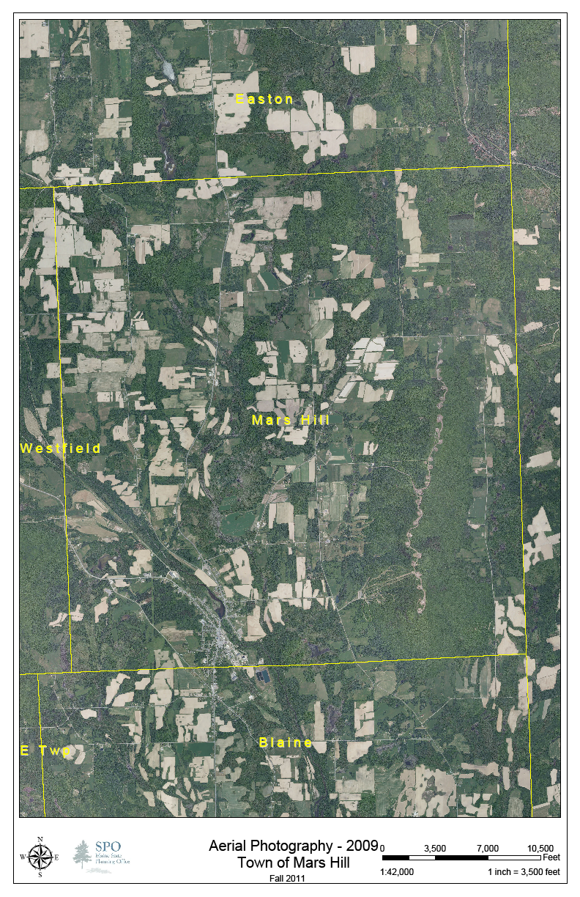Land Use in Mars Hill will continue to include a large, predominantly agricultural area surrounding a traditional, compact town center where most residential, commercial, and service development will be located to help control municipal expenses. At the same time, recreation and other developments will have expanded at the base of Mars Hill Mountain, sharing the Town’s economic focus with the mountain and additional development in the industrial area intown. New, compact residential neighborhoods, similar to those that currently exist, will be located close to the town center and public facilities and services. The trend of most residential development taking place in rural areas of the community will have been largely eliminated, though new farmsteads and limited residential development with a connection to natural resource-based industries will continue to be developed, albeit on smaller lots to preserve more area for farming operations.

What are the different ways a community can use a vision? • As an introduction to the comprehensive plan that describes where the community wants to go. • As a yardstick for determining which goals and policies will best get the community moving in the direction it wants to go. • As an enclosure for grant applications to foundations and government agencies to illustrate how the grant project fits into the community’s “big picture.” • As a guide for reviewing other town plans and documents, such as ordinances, grant applications, budgets, capital improvement programs, etc to evaluate whether they move the community closer to or further away from its vision. • As an annual check-in to assess whether the community is spending too much time reacting to problems and not enough time initiating positive steps towards achieving the vision. • As a stimulus for new initiatives that do not fall into the purview of existing committees or groups. • As the vehicle for an annual community-wide meeting to reassess community’s goals – and progress.

