DOCUMENT 1. INTRODUCTION

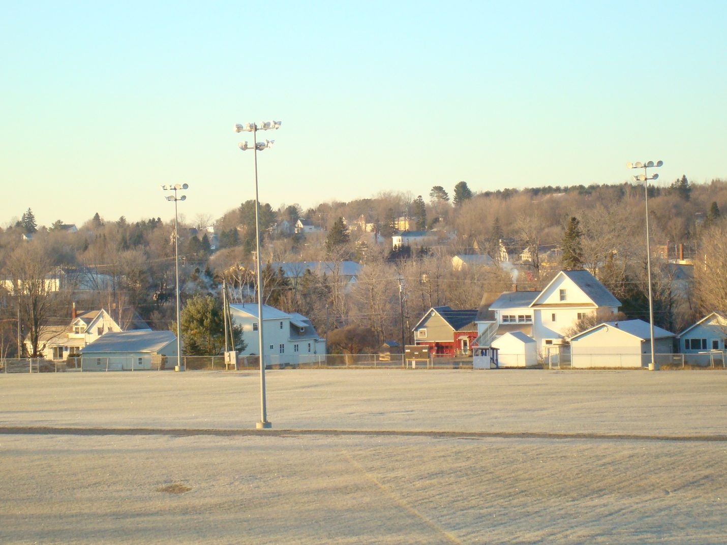

- Planning in Mars Hill
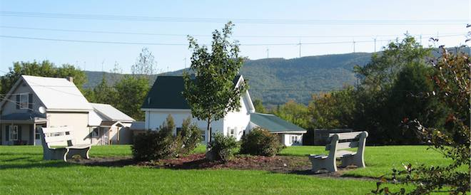
Mars Hill adopted its Comprehensive Plan in 1992 shortly after the State Planning Office (SPO) found it consistent with the Planning and Land Use Regulation Act (also known as the Growth Management Act). In 1996, the SPO found Mars Hill’s zoning ordinance consistent with its Comprehensive Plan. Then in 1998, SPO notified the Town that it had received one of the few Certificates of Consistency awarded as part of the Growth Management Program. More than 20 years have now passed and the Town has now completed a 2013 update of its Comprehensive Plan to provide a path to Mars Hill’s claim as the Gateway to Northern Maine and the Healthiest Place to Live in the County.
In preparing this update, Mars Hill built on the planning foundation it established in its 1992 Comprehensive Plan by examining what goals from that Plan had been achieved, what strategies were implemented, and what had changed in the community. The update explored current trends, assessed the effect of continued decline in population, jobs, and businesses, discussed the issues and implications raised in updating the inventory chapters, and updated the goals, policies, strategies, and various plans to guide community efforts over the coming ten years. It reflects where the Town is now, where it would like to go, and what it needs to do to get there.
Because this document is an update to the 1992 Plan, the inventory builds off of and does not repeat information that is provided in the 1992 Plan, such as the description of environmental features. Most of the policy and plan components are new, though they often reflect past planning directions, for example, the Future Land Use Plan retains most of the designations, with a few adjustments. As a result, where the 2013 Comprehensive Plan updates and builds on data in similar chapters of the 1992 Comprehensive Plan, and has not been updated or changed, it is herein incorporated by reference.
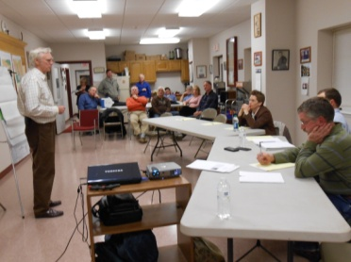
- Preparation of 2013 Update of Comprehensive Plan
The Mars Hill Comprehensive Plan Committee guided the development of the 2013 update. It discussed numerous ways to involve all stakeholders/citizens in the comprehensive planning process and relied on the following approaches to soliciting ideas and keeping the community informed about the progress of its work, including:
- Sharing schedules, agendas, minutes, draft and final versions of inventory chapters and plans on the Mars Hill website. The website also included a way to provide feedback for comment. The Committee also posted a few white papers including What Is A Comprehensive Plan? to provide quick and easy summaries for folks to learn about the comprehensive plan process.
- Personally contacting community members, groups, and organizations to draw them into the process, including Town Councilors, community and business leaders, seniors, teachers, and others. In addition to providing ideas and comments, members of each of these groups were seen as an asset in communicating and promoting the Comprehensive Plan process. Members communicate among themselves and with others a great deal, so keeping them well informed was viewed as a way to involve citizens. If the planning process leads to increased numbers of citizens, then all churches stand to gain.
- Maintaining and sharing regular records of its meetings.
- Meeting with the Town Council to prepare the Capital Investments and Regional Coordination Plan and Implementation Schedule.
- Compiling and sharing a Draft Vision Statement.
- Compiling the draft updated Comprehensive Plan.
- Conducting the required formal public hearing on the updated Comprehensive Plan. (pending)
- Following the hearing, revising the updated Comprehensive Plan. (pending)
- Presenting the update Comprehensive Plan to the Town Council for approval at the July __, 2013 Meeting. (pending)
- Vetting all information, findings, and conclusions numerous times in various formats, including on paper, on-line, in public, at community meetings, and in Comprehensive Plan Committee meetings.

As part of this process, the Mars Hills Comprehensive Plan Committee made presentation to the following groups:
- Town Council (several)
- Planning Board
- Junior/Senior High School Teachers
- Elementary School Teachers
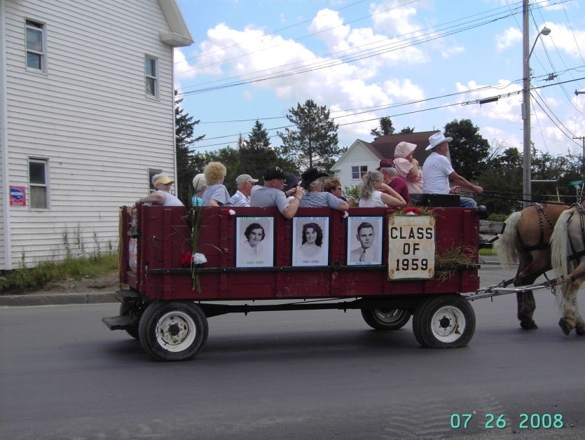
- Rotary (2)
- Public Meetings (2)
- Fire Department
- Sewer/Water District Board
- Senior Citizen Club

- Call to Implement the Comprehensive Plan

Mars Hill is at an important crossroads. If Mars Hill’s population continues to decline, additional jobs and businesses are likely to be lost and the continued viability of some community institutions may become problematic. This visionary and pragmatic Comprehensive Plan lays out a roadmap and way for the community to chart progress toward its goals. Now is the time for Mars Hill residents to step up and get involved in one of the existing or new committees that will be tasked with using this plan to harness the power of the people of Mars Hill to create positive change in the community. These groups include:

- Building Committee for Town Garage (within 2 years of adoption)
- Economic Development Committee (within 2 years of adoption and ongoing)
- Information Technology Committee subcommittee of the Economic Development Committee (within 2 years of adoption and ongoing)
- Housing Committee (within 3 to 5 years of adoption)
- Elder Services Subcommittee of Housing Committee (within 2 years of adoption and ongoing)
- Implementation Committee (within 2 years of adoption and ongoing)
- Recreation Committee (within 3 to 5 years of adoption)
- Trail Subcommittee of Recreation Committee (within 2 years of adoption and ongoing)
- School Advisory Task Force (within 2 years of adoption and ongoing)

Without the involvement of Mars Hill’s community leaders, the updated 2013 Comprehensive Plan will express a nice vision for the community, but it will only remain a collection of hopes and wishes. It needs the hands and minds of the community to foster the changes that are within the Town’s reach.

Editor’s Note: The following statement was added to the 2013 Comprehensive Plan Update after the Town Council’s adoption on September 21, 2013. “The draft 2013 Comprehensive Plan Update was presented to the Town Council on July 15, 2013. A public hearing was held on the draft on August 20, 2013 and minor revisions were made to the document. A public hearing was held and the revised 2013 Comprehensive Plan Update was adopted on September 21, 2013. In addition to those efforts noted above, members of the Mars Hill Comprehensive Plan Committee discussed portions the draft with town officials from Westfield, Blaine, Bridgewater, and E Plantation over the course of preparing the 2013 Comprehensive Plan Update, including workshops, presentations to Rotary, teachers, and other groups, and individual meetings.”

