Town of Mars Hill
2014
Comprehensive Plan Update


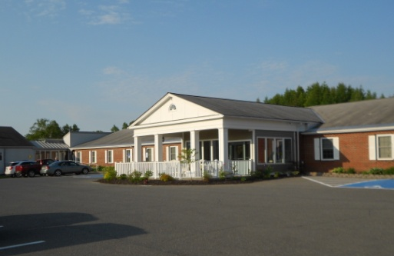

Consultants
Elizabeth A. Della Valle, AICP
Spatial Alternatives, Inc.

